Key issues facing the NSW disability community and advocacy organisations

May 2026

Physical Disability Council of NSW
3/184 Glebe Point Road, Glebe NSW 2037
02 9552 1606
www.pdcnsw.org.au

Introduction and consulted cohort breakdown
PDCN is funded to provide sector coordination for the disability advocacy sector, the NSW Disability Advocacy Network (NDAN). NDAN is a group of disability advocacy organisations that provide systemic, individual and representative advocacy across NSW.
NDAN comes together four times a year to discuss issues and trends affecting people with disabilities across NSW. The network enables the disability advocacy sector to pool resources, share information and risks, and build the capacity of the sector.
Between October and December 2025, PDCN conducted a survey of all NDAN members to understand the challenges faced by the sector and collect valuable insights into the impact the work of the sector has had on the disability community.
The organisations represented in NDAN represent a wide range of disability cohorts including intellectual, physical, psychosocial, sensory and neurodivergence. Of these organisations, 70% provide individual advocacy, 43% provide representative advocacy, and 78% provide systemic advocacy. Another 20% of organisations provide advocacy outside of these categories such as citizen advocacy, legal advocacy, and NDIS appeals. It is important to note that many of these organisations provide more than one type of advocacy.

How NDAN organisations secured positive change
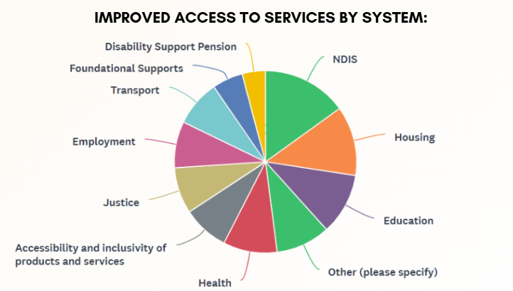

The key findings from the survey show that the NSW disability advocacy sector delivers measurable, positive outcomes for people with disability, with lived experience influencing priorities and strategy. The sector holds deep expertise in systemic reform and service improvement.
Over a 12-month period from October 2024 to October 2025, NDAN organisations were effective in securing change for their communities across a range of areas. The areas that reported the most improved access were regarding disability supports, housing, healthcare, transport and education.
The issue most people seek individual advocacy support for is accessing disability supports through the NDIS, with half (50%) of all organisations reporting that they had been able to secure service and access improvements to the NDIS for their members. This was the largest area in which organisations had achieved success. In particular, 83% of NDAN organisations reported success in complaints, appeals, or tribunal wins. This was closely followed by 78% of organisations successfully securing adjustments for clients they had represented.
Organisations identified housing as the second most successful area through which service and access improvements were achieved, with 41% of organisations achieving wins for their members. Housing wins mostly related to maintenance and modifications of properties, often in social housing settings. Organisations reported an increase in housing related advocacy requests over the past 12 months, highlighting a need for systemic reform in housing policy to address growing concerns from the disability community.
On a systemic level, 63% of NDAN organisations had successfully influenced standards, regulations or the adoption of inclusion frameworks. This was especially prevalent in education, with 36% of organisations achieving success in advocacy that influenced improved access to education through easier enrolment processes, and information for children with disabilities interacting with the schooling system.

Capturing Lived Experience
When asked how organisations capture the voices of people with disabilities and the pressing issues for the communities they represent, 100% reported that they employ or engage people with lived experience as staff or board members. In addition, 91% of organisations conduct targeted consultations with the communities they represent to gather evidence on pressing issues facing the community.
78% of organisations believe that embedding lived experience in policy and design processes is critical to measuring and tracking disability inclusion, and improves disability inclusion practices in both the public and private sectors.
Beyond the NDAN network, 100% of organisations work with government agencies, 96% work with academic or research institutions, and 100% have partnerships beyond the disability sector. These collaborations allow different vectors for advocacy, achieving change for people with disabilities through partnerships across sectors and institutions, and helping to build a strong evidence base of support.
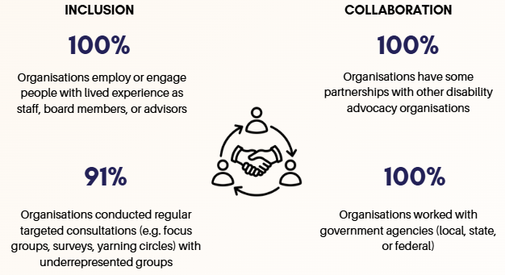

Issues facing people with disabilities
NDAN organisations were asked to rank the issues affecting members of their community, in order of most to least pressing.
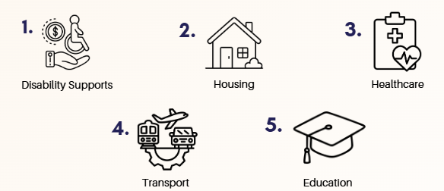
The top issues identified by NDAN organisations for their members were:
- Disability supports
- Housing
- Healthcare
- Transport
- Education

Disability Supports
In the context of this report, disability supports refers to supporting people to access the NDIS, Disability Support Pension (DSP), and foundational supports. The main problems people requested support with was challenging NDIA decisions, plan and fundings cuts and plans not meeting needs. There were also reported concerns around a lack of fairness and transparency from the NDIA especially when supports were rejected.
Organisations also reported a large amount of capacity was dedicated to supporting members through tribunals and appeals processes. Additionally, organisations reported concerns around inconsistencies within the disability supports system and bureaucratic barriers becoming a blockage to accessing vital supports.

Housing
Regarding housing, NDAN organisations identified a lack of accessible, affordable and safe homes for people with disabilities in NSW. This was an issue identified for social housing tenants, and those waiting for social housing. It was reported that issues with social and public housing were regarding the condition of properties, and a lack of accessible properties. In particular, it was noted that Aboriginal tenants are often dealing with poor housing conditions.
Beyond social and public housing, there is a general lack of accessible housing in the private rental market. Organisations highlighted that this is a particular challenge for people who have progressive conditions, and as people age and become less mobile.
In addition, organisations reported issues with group homes for people with disabilities. There were concerns that people with disabilities are being grouped together to live with other people from different disability cohorts that are not suitable to be housed together, leading to anxiety and a lower standard of living for tenants, as well as safety concerns.

Healthcare
Issues identified by NDAN organisations regarding the healthcare system were related to affordability, availability, and accessibility. This was especially pronounced in regional areas, where access to healthcare services can be scarce or not available locally. This is a particular concern for people who require specialist health services, with people with disabilities reporting long travel times to get to specialist appointments. These specialist health services are often vital for people with disabilities, without which would lead to a deterioration of their condition and capacity.
Major concerns were raised for people with disabilities interacting the healthcare system through hospitals, allied health and general practitioners. Organisations identified a lack of disability knowledge from healthcare staff, poor communication and staff being given inadequate time to help patients with complex needs. Organisations noted that healthcare staff often listen to a parent or carer instead of the person with disabilities being treated. Additionally, it was reported that healthcare workers often see the disability of the person being treated and do not properly treat the ailment at hand, instead focusing on the disability that is not of concern in the situation. For those with intellectual and psychosocial disabilities, it was reported by NDAN organisations that many people been refused care due to the nature of their disability. This may be attributed to a lack of understanding of these cohorts of disability by healthcare staff.
Organisations identified that access to information for people with disabilities is lacking, with hospitals often not providing information in accessible formats, including intake forms. For the Deaf community there is a lack of access to interpreters and a refusal of preferred interpreters. This lack of information in healthcare settings is a major hindrance to people with disabilities receiving appropriate and timely care and impacts greatly on health outcomes.
Across all five listed areas there is an identified lack of understanding and awareness of disability from government systems. This has led to an ad hoc approach to implementing accessible systems and an inconsistency of communication methods. Uninformed long-term decisions and unclear consultation and codesign processes have led to poor outcomes for people with disabilities, and a reliance on advocates to step in to assist where systems fail.

Challenges facing NDAN Organisations
Major operational challenges identified by NDAN organisations were short-term and inadequate funding, short funding timeframes and notice periods, and the psychosocial impact on staff.
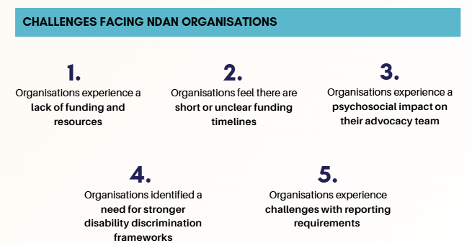
NDAN organisations were asked what the biggest challenges they face as an advocacy organisation. The top five identified challenges were as follows:
- Organisations experience a lack of funding and resources
- Organisations feel there are short or unclear funding timelines
- Organisations experience a psychosocial impact on their advocacy team
- Organisations identified a need for stronger disability discrimination frameworks
- Organisations experience challenges with reporting requirements
Organisations found that short and unclear timelines around funding and reporting, and a lack of funding and resources are the biggest challenges, with 82.6% noting this as a major concern for both categories. It was highlighted that the nature of fixed term funding makes it difficult to plan, with the capacity of the organisation dictated by the often-limited resources available at the time. Poorly timed and unclear timeframes for funding announcements were noted to have a negative impact on organisations, as staff experience anxiety at the lack of clarity on job security, and an inability to plan as ongoing funding is unknown. Additionally, due to short term funding cycles, it is difficult for organisations to retain valuable staff, build long term plans or invest in skill development and training. It is clear disability advocacy organisations do not have adequate funding to meet their demand.
The psychosocial impact on disability advocacy staff within NDAN organisations was identified as a concern, with 65% of organisations noting this as an issue. This was the highest-ranking challenge for organisations unrelated to funding. There was particular concern around the psychosocial risks associated with the lack of support for lone workers, and the limited capacity and resources for NDAN organisations to provide this support. There was an identified need for adequate trauma informed training, work connections, and access to support, however due to limited funds and resources this remains difficult.
Staff who work in disability advocacy are highly passionate, and are often exposed to highly traumatic stories, experiences and topics. Only 35% organisations feel they have adequate resources to support staff when psychosocial hazards do impact them. It is clear that disability advocacy organisations are operating in a sensitive and resource constrained environment, which is having an adverse impact on staff wellbeing, and organisations are not supported through adequate funding.
57% of organisations reported that existing disability discrimination frameworks are not fit for purpose. Organisations noted that NDIS frameworks are not suitable for certain cohorts, in particular the Deaf community, and that a better designed framework would have potential to reduce reporting requirements. A lack of consistency of frameworks across state and federal landscapes was identified as an issue that has a negative impact on advocacy organisations.
Organisations reported dissatisfaction with current reporting requirements, with 52% facing challenges. It was reported that reporting requirements are hard to meet and information sharing is complicated especially in reference to the InfoShare platform. Reporting requirements were described as onerous and overbearing for organisations that are already facing capacity constraints.

Conclusion
From these findings, it is clear that NDAN organisations are deeply engaged with their communities. The sector has a deep understanding of the challenges faced by different disability cohorts and has achieved positive outcomes for and with people with disabilities in NSW.
Organisations have seen success assisting people with disabilities to access disability supports, housing, and successfully influenced standards, regulations and the adoption of inclusion frameworks. Through strong connections with people with disabilities, the NDAN network has identified key areas of concern for their communities. This includes issues across disability supports, housing, healthcare, transport and education as major areas of interest.
The sector is committed to a collaborative and inclusive approach to advocacy, and seeks to achieve long lasting, inclusive change at all levels. It is clear that the main barriers to achieving these positive outcomes are based around a lack of funding and resourcing, leading to capacity concerns and psychosocial risk to the workforce.
To continue the positive impact that NDAN organisations are having on their communities, it is essential that issues with funding are addressed. It is also important that proper supports are implemented by organisations to monitor staff wellbeing and provide assistance when psychosocial hazards occur and impact teams.

