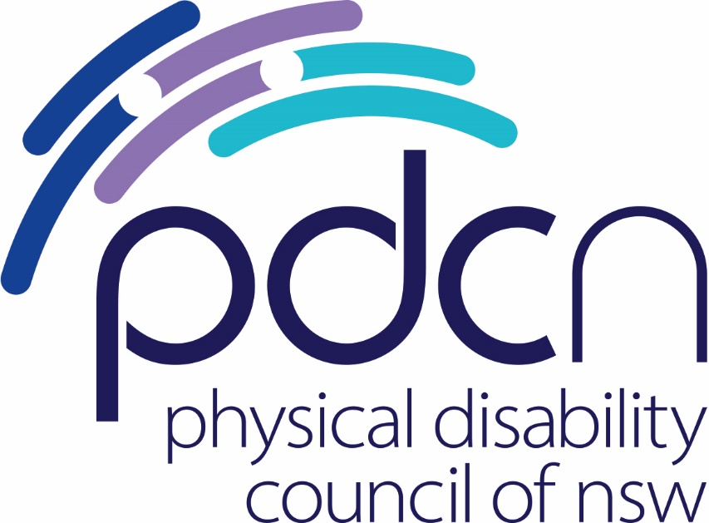

Submission to Portfolio Committee No. 6 – Transport and the Arts

Response to the Inquiry into the use of e-scooters, e-bikes and related mobility options

August 2024

Physical Disability Council of NSW

3/184 Glebe Point Road, Glebe NSW 2037

02 9552 1606

www.pdcnsw.org.au

[alice.batchelor@pdcnsw.org.au](mailto:alice.batchelor@pdcnsw.org.au)

Contents

Who is the Physical Disability Council of NSW? 3

Recommendations 3

Introduction 4

Issues with e-mobility for people with physical disabilities 5

Regulatory arrangements for e-mobility 5

# Who is the Physical Disability Council of NSW?

The Physical Disability Council of NSW (PDCN) is the peak body representing people with physical disabilities across New South Wales. This includes people with a range of physical disability issues, from young children and their representatives to aged people, who are from a wide range of socio-economic circumstances and live in metropolitan, rural and regional areas of NSW.

Our core function is to influence and advocate for the achievement of systemic change to ensure the rights of all people with a physical disability are improved and upheld.

The objectives of PDCN are:

* To educate, inform and assist people with physical disabilities in NSW about the range of services, structure and programs available that enable their full participation, equality of opportunity and equality of citizenship.
* To develop the capacity of people with physical disability in NSW to identify their own goals, and the confidence to develop a pathway to achieving their goals (i.e. self-advocate).
* To educate and inform stakeholders (i.e.: about the needs of people with a physical disability) so that they are able to achieve and maintain full participation, equality of opportunity and equality of citizenship.

# Recommendations

Recommendation 1: Introduce shared e-mobility regulations into the Disability Standards for Accessible Public Transport.

Recommendation 2: Local government should have jurisdiction over the implementation, function and storage of shared e-mobility devices in partnership with operators and providers.

Recommendation 3: Develop a legislative and regulatory framework for active transport which includes micromobility and e-mobility devices.

# Introduction

PDCN appreciates the opportunity to make a submission to Portfolio Committee 6 – Transport and the Arts on its inquiry into the use of e-scooters, e-bikes and related mobility options. The introduction of e-mobility in NSW has been a cause of frustration and concern for many PDCN members, people with physical disabilities, and the community. There is a need for stronger regulatory frameworks for e-mobility to ensure the safety of people with disabilities as active transport becomes a more integral part of the urban landscape in NSW.

E-mobility is a particularly important safety issue for people who are blind or have low vision. For specific comment on recommendations and issues relating to this community, it is strongly encouraged to take note of Guide Dogs ACT/NSW and Vision Australia’s submissions to this inquiry. The focus of PDCN’s concern is around the storage of shared e-mobility devices and its impact on people with physical disabilities broadly.

This submission is also endorsed by:



Vision Australia



Justice and Equity Centre

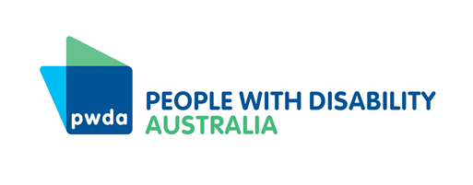

People with Disability Australia

Guide Dogs NSW/ACT

# Issues with e-mobility for people with physical disabilities

Since the introduction of e-mobility devices, in particular shared devices in 2017, there have been considerable safety concerns raised by the physical disability community. While innovations in active transport are generally a positive step for urban areas, there is a lack of cohesion and coordination between councils, government, and private companies in the execution of introducing these mobility devices, and the regulation of their use. This has resulted in e-mobility devices such as e-bikes being left in the middle of paths and walkways, obstructing the clear path of travel for people with disabilities.

In a survey conducted by PDCN in 2024, a common complaint for people with physical disabilities in their local council areas was related to e-mobility. When asked where councils could improve inclusion for people with disabilities, respondents identified the storage of shared e-mobility devices on footpaths as a major issue.

“Footpaths, no electric bikes left in inappropriate places that block access”

“Pathways need to be more accessible … Reduce the amount of table and chairs on pathways which are obstructing access for wheelchair users and those with a vision impairment [and] restrict the amount of share bikes in use on pathways.”

The presence of shared e-mobility devices on pathways and public spaces has become an impediment to the clear path of travel for many people with physical disabilities, and an unnecessary hazard. Abandoned or inappropriately parked shared e-mobility devices actively discourage people with physical disabilities from utilising active transport infrastructure. This sends the message that the safety of those with mobility devices or vision impairment is not a priority in public spaces or to the whole journey experience.

For many people with disabilities, a pathway blocked by a shared bike is more than just an inconvenience, it can mean they are unable to physically access their destination, which may be a place of employment or essential medical appointment. Inaccessible paths of travel actively prevent people with disabilities from safely accessing their community.

A survey of people who are blind or have low vision conducted by Vision Australia in 2021 found that 61% of respondents had encountered a trip hazard by an e-mobility device being left on a footpath, and 35% said the presence of e-scooters and similar devices on footpaths has led to them using footpaths less often[1].

# Regulatory arrangements for e-mobility

Under the Disability Discrimination Act (DDA), it is unlawful for public places to be inaccessible to people with disabilities, this includes public footpaths and walkways[2]. Abandoned and mismanaged shared e-bikes blocking the clear path of travel undermines those rights afforded to people with disabilities under the DDA.

Obligations under the Disability Standards for Accessible Public Transport (2002)

The Disability Standards for Accessible Public Transport (DSAPT) require access paths to allow unhindered passage for a person with disabilities, and a continuous accessible path of travel[3]. To aid in the appropriate implementation of the DSAPT, in 2017, *The Whole Journey Guide* was created by the Australian Government Department of Infrastructure and Regional Development[4]. The Whole Journey Guide strives to create accessible public transport that goes beyond compliance with the DSAPT. This contains guidance on regulatory frameworks around obstacles to paths of travel, acknowledging that this is a significant issue for people with disabilities. The suggestion from this guide is that:

Where required, those with enforcement powers such as local government, should work with stakeholders to maintain unobstructed paths, especially in the vicinity of public transport infrastructure.[5]

This suggests the regulatory responsibility of shared e-mobility devices would fall to local government in partnership with the private operators and companies that own these devices.

While this relates explicitly to public transport, there is cause to argue that shared e-mobility should be considered as public transport and should be included in the DSAPT as they are a publicly used form of micromobility.

Recommendation 1: Introduce shared e-mobility regulations into the Disability Standards for Accessible Public Transport.

Recommendation 2: Local government should have jurisdiction over the implementation, function and storage of shared e-mobility devices in partnership with operators and providers.

Shared Bicycle Management Guide (2018)

As part of the Impounding Act 1993, the NSW Office of Local Government has published the *Shared Bicycle Management Guideline* (2018). While this contains useful and important information on the implementation of shared e-mobility for councils and other stakeholders, there is no regulatory power behind this guideline[6].

The regulatory reach of the Impounding Amendment Act is not robust enough to ensure the safety of people with disabilities and their interactions with e-mobility devices. This act only responds reactively to hazards caused by e-mobility, and often places the burden on people with disabilities to report hazards as they experience them, creating a cycle of complaints that does not necessarily lead to systemic change. It is not good enough that people with disabilities are forced to experience discrimination and report their experience because regulatory frameworks for active transport and in particular shared e-mobility devices are near non-existent and there is no proactive enforcement of compliance.

There is a need for legislation and a regulatory framework around the use of active transport, with specific regulations around shared e-mobility devices. It is essential that as NSW moves forward with its Active Transport Strategy, stronger legislative and regulatory frameworks are developed through appropriate co-design with people with disabilities at each stage, from design to implementation.

Recommendation 3: Develop a legislative and regulatory framework for active transport which includes micromobility and e-mobility devices.

1. Vision Australia (2021), *‘More dangerous than ever’: Blind and low vision pedestrians fear for their safety as e-scooters and bikes take over,* Vision Australia 2024, accessed 8 Aug 2024 <<https://www.visionaustralia.org/news/2021-10-14/WCD-2021>>
2. Australian Human Rights Commission (2024), *DDA guide: The ins and outs of access,* AHRC 2024, accessed 8 Aug 2024 <<https://humanrights.gov.au/our-work/disability-rights/dda-guide-ins-and-outs-access>>
3. Australian Government (2002), *Disability Standards for Accessible Public Transport 2002,* 2nd May 2011 <<https://www.legislation.gov.au/F2005B01059/latest/text>>
4. Department of Infrastructure and Regional Development (2017), *The Whole Journey: a guide for thinking beyond compliance to create accessible public transport journeys,* Australian Government, accessed 8 Aug 2024 <<https://www.infrastructure.gov.au/sites/default/files/migrated/transport/disabilities/whole-journey/files/whole_of_journey_guide.pdf>>
5. Ibid pg. 21
6. Office of Local Government (2018), ‘Shared Bicycle Management Guideline for councils and other impounding authorities, *Impounding Act 1993,* NSW Government, accessed 8 Aug 2024 <<https://www.olg.nsw.gov.au/wp-content/uploads/Share-Bikes-Impounding-Amendment-Act-Shared-Bicycle-Management-Guideline-For-councils-and-other-impounding-authorities.pdf>>