NSW Disability Advocacy Network Submission 17th May 2024
NDIS (getting the NDIS back on track) Bill 2024
About Us - NSW Disability Advocacy Network (NDAN)
We are a network of organisations that work with, and for, people with disabilities in NSW who collaborate through the NSW Disability Advocacy Network (NDAN), which is funded by the Department of Communities and Justice. Collectively we deliver systemic, representative and individual advocacy services across the state.
We commend this Bill for introducing flexibility in budgets and removing the focus on primary and secondary disability. We jointly express concerns about the need for more consultation and detail, especially regarding NDIS rules, supports, and new powers. Disability advocacy ensures community voices are heard for informed decision-making. We urge serious consideration of our concerns and request collaboration and co-design with the disability advocacy sector in amending the Bill before it becomes law.
NDAN’s collective concerns about the Bill.
- There has been a lack of meaningful consultation and co-design in the development of this legislation.
The government has pledged to co-design the NDIS with the disability community. However, as NSW Disability Advocacy organisations, we are not aware of meaningful consultation and co design taking place, which undermines trust and could potentially lead to legislation that does not fully improve the operation of the NDIS for people with disability and risks unintended consequences.
The NDIS Bill introduces supplementary rules detailing access, planning, and budget processes, yet these rules remain undrafted. Legal safeguards are needed for transparent and accountable rulemaking. Meaningful co-design must involve mandatory and resourced co design and consultation with people with disabilities and their representatives (including state disability advocacy organisations).

We recommend that the NDIS Act includes provisions to resource and mandate the Federal Government, State and Territory Governments and the NDIA to conduct and resource meaningful co design and consultation with changes to the NDIS scheme. We also believe there should be a structured feedback mechanism which should be consolidated and considered by Governments to develop different iterations of the Bill until it fits in the new disability landscape and works for people with disability.

- The legislation introduces discretionary powers to the Minister and CEO of the National Disability Insurance Agency without clear transparency and accountability mechanisms in place.

The Bill grants discretionary powers to the NDIS Minister and NDIA CEO. Our primary concern is that discretionary powers could lead to arbitrary decision-making and unfair treatment of NDIS participants without clarity about safeguards and accountability mechanisms.

The Bill allows participants to challenge their statement of participant supports, including the budget, but introduces new processes that cannot be reviewed internally or externally. Importantly, needs assessments cannot be reviewed under section 99 of the NDIS Act, preventing participants from contesting inadequate assessments that may lead to insufficient budget allocations. We are concerned about ensuring the Navigator role is properly equipped with the training and appropriate skills, knowledge and qualifications.

The Bill lacks clarity on when or if participants can request replacement assessments, leaving important decisions to be determined by new NDIS rules without avenues for review or challenge. Clear legislation is needed to ensure participants have timely access to their assessment reports and the ability to request new assessments when necessary to inform accurate budget allocations.
In its current form, the Bill does not address or provide clarity on whether merit review will apply to new decision-making powers.

On 8th May 2024, the Minister for the NDIS Bill Shorten and the NDIA CEO Rebecca Falkingham attended a NDIS Roundtable with NSW Disability Advocacy organisations and responded to our concern about the accountability mechanisms by stating that the right to merit review would apply to new powers and the NDIS Minister said: “In relation to these additional powers, existing merit review continues in the act. The merit review will remain in the scheme; however, I am happy to consider amendments to clarify this in the legislation”.
We request that the draft bill is amended to clarify the right to merit review will apply to any new powers granted to the NDIS Minister or NDIA CEO (including needs assessments).

- There are concerns about the lack of detail in the legislation in relation to the definition of NDIS supports and the use of APTOS principles.
Clause 10 of the Bill marks a significant departure from the current system, potentially narrowing the scope of the NDIS by requiring supports to align more strictly with the 'reasonable and necessary' criteria outlined in the NDIS Act. A narrow definition of NDIS Supports and restrictive Rules could limit choice and control for individuals with disabilities, hindering their access to tailored NDIS funding that meets their specific needs and circumstances. For example, for blind and low vision people, ‘white goods’ that have a speaking function can be the difference between someone being able to cook for themselves independently or not. Therefore, the NDIS Supports list should not be exhaustive, but only provide a guide for decision making.

s10a (iii) states a support is a “mobility aid or device, or assistive technology, live assistance…that will facilitate personal mobility”. But there is no definition of the term ‘mobility’. It is not clear if this only applies physical mobility. Assistive technology should be able to be used for communication needs and this should be clarified in the definition.

The Bill proposes using the APTOS principles temporarily until specific Rules are established to determine NDIS funding allocations versus those handled by State and Territory Governments. However, these principles, developed as broad policy guidance in 2015, were never intended for legislative use and are often unclear and challenging to apply. This ambiguity can lead to confusion over responsibility for supports between the NDIS and State/Territory Governments, resulting in participants not receiving necessary assistance. As a network of disability advocates, we believe that APTOS principles are inadequate as an interim solution and call for collaborative development of alternative Rules between the Commonwealth and State/Territory Governments before altering NDIS funding allocations.

The NDIS Supports list should not be exhaustive, but only provide a guide for decision making.

We request that the Bill includes a definition of mobility under S10a (iii) which includes communication needs.
We request that the proposal to use the APTOS principles is removed and replaced by a requirement for Federal and State and Territory Governments to develop an alternative mechanism.
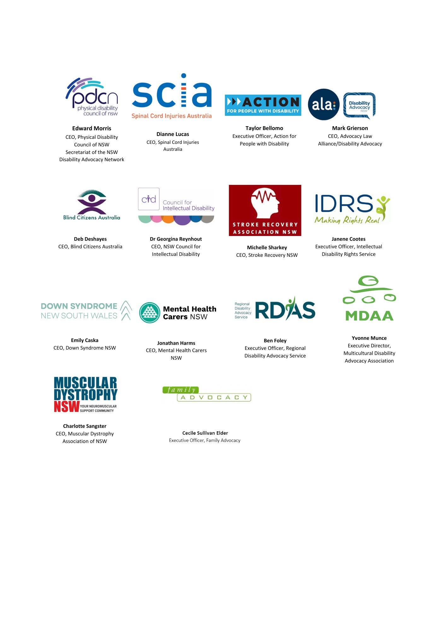

For further details please contact Edward Morris, CEO of Physical Disability Council of NSW on Edward.morris@pdcnsw.org.au or 0421009377.

