NDAN Pre-Budget Submission on Disability Advocacy Funding
8th March 2024
We are a network of organisations that work with, and for, people with disabilities in NSW who collaborate together through the NSW Disability Advocacy Network (NDAN), which is funded by the Department of Communities and Justice.
We are making this joint submission in response to collective concerns from our sector about the lack of funding clarity being provided to the organisations funded under the NSW Disability Advocacy Futures Program (DAFP). We also want the 2024-2025 NSW Budget to provide additional resources for NSW disability advocates and advocacy organisations for co-design and consultation processes as part of the response to the Disability Royal Commission (DRC) Final Report and NDIS Review.
Disability advocacy gives people with disabilities a voice and allows government agencies to make better decisions for our community. Disability advocacy is also crucial for promoting equal rights, preventing and challenging discrimination, improving rules and systems to give people with disabilities choice and control over their lives, improving support services and promoting community integration.
In the 2024-2025 NSW Budget we are calling on the NSW Government to commit to:
Fund the Future of Disability Advocacy in NSW
- Improved transparency and communication about future funding arrangements with funding announced at least 12 months prior to the end of a funding cycle.
Current funding systems are unsustainable and unacceptable, with DAFP funded organisations left in precarious positions due to short funding cycles, transitional funding arrangements and a lack of clarity regarding the continuation of funding. As of 8th March 2024, it is unacceptable that DAFP advocacy funding has still not been confirmed almost three months prior to funding running out (on 30th June 2024).
Lack of advocacy support is leaving people with disability in crisis, with their supports for housing, health, and disability daily living being at risk. Recent reports have estimated that for every $1 spent in advocacy, governments get back $3.5 in benefits across other areas such as health, housing, and justice.
A lack of transparency from government in the funding of crucial advocacy programmes and organisations has created a lack of confidence from existing staff within these areas. As a result, this lack of confidence in job security leads to high staff turnover and a loss of critical services for people with disabilities in desperate need of guidance and support through complex and life changing situations.
We anticipate there may be an imminent announcement 2-year extension to current DAFP contracts, which we welcome and appreciate. We would also like to work with relevant ministers on moving to five-year contracts over the coming 12 months.
- Longer term funding contracts (to 5 years)
Without secure long term funding commitments from the NSW Government, people with disabilities, their families and loved ones may not have local advocates to turn to when they face issues of discrimination, exclusion, or poor treatment including violence, abuse, and neglect. This can happen in any area of life: education, health, housing, justice, transport, employment, accessing infrastructure and community activities.
Without disability advocacy organisations, NSW Government departments would lose access to the input and expertise of disability advocates who participate in departmental and Parliamentary committees and help government make better informed decisions that improve people’s lives. Disability advocacy helps the NSW government understand the needs of people with disabilities and provide early intervention services to prevent escalation and identify issues and service gaps that would otherwise increase the costs placed on other government services.
The disability sector needs to see secure funding with longer timelines of 5 years to mitigate current issues surrounding precarious funding arrangements and short contracts leading to weaker outcomes. To strengthen the work the disability advocacy sector does to improve the lives of people with disabilities, there must be more transparency from government and clarity of funding cycles. It is also important that funding is provided to disability advocacy organisations to develop and implement the outcomes frameworks and processes which DCJ has started work on.
Disability Royal Commission and NDIS Review co design and consultation funding arrangements
- Increase funding for disability advocacy organisations to respond to the Disability Royal Commission and NDIS review to ensure that the expertise and resourcing of people with lived experience is respected.
We recognise that the implementation of the DRC recommendations and the NDIS review will require specific long term budgetary allocations and deep ongoing engagement with the disability community to ensure positive outcomes are achieved.
Since the release of the DRC Final Report, the NSW Government has indicated its intentions to consult with disability advocacy groups with an emphasis on co-design in developing an official response. We are disappointed to not yet have a clear date from the NSW Government indicating when we can expect their response to the DRC Final Report. In the upcoming consultation and co design process, it is essential that the expertise and resourcing required is respected through appropriate remuneration and funding.
In the wake of the Disability Royal Commission (DRC) and the NDIS review, it is imperative that advocacy is adequately supported and funded. Current funding arrangements limit the capacity to achieve advocacy goals for people with disabilities who need it most. Both the DRC recommendation 6.21 and NDIS Review Action 1.5 call for better coordination and increased funding of advocacy programs.
People with disabilities must be included in the decision-making process from the outset of design through to the implementation, practice, and evaluation stages, and must be adequately paid for their expertise. As an ongoing practice, this must be appropriately budgeted for, with transparency of funding cycles and arrangements.

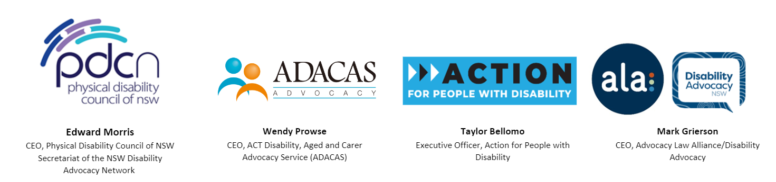
Yours sincerely,

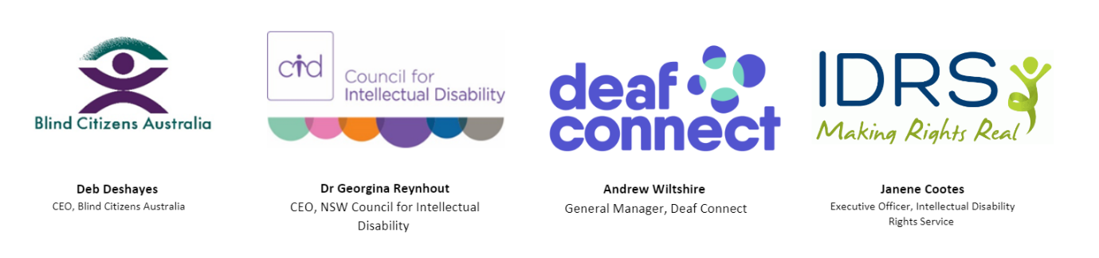

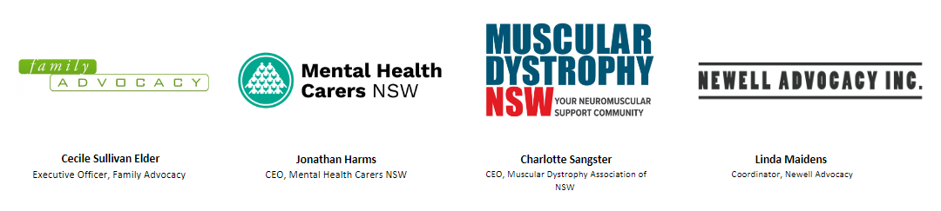

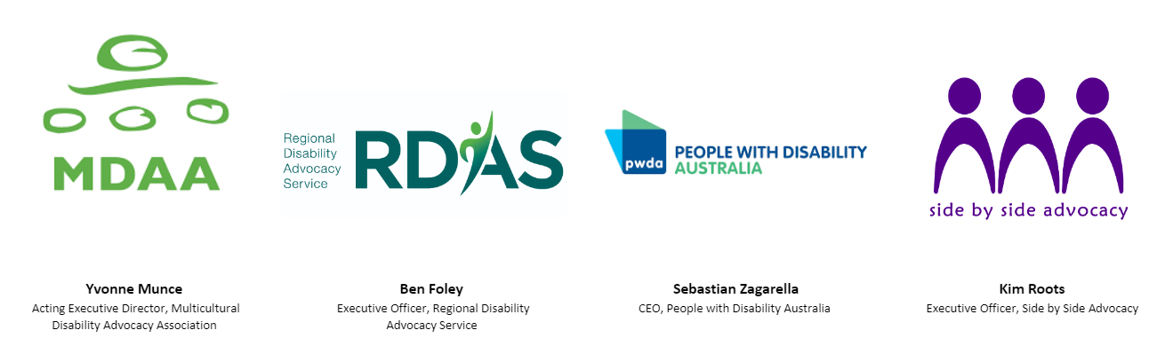

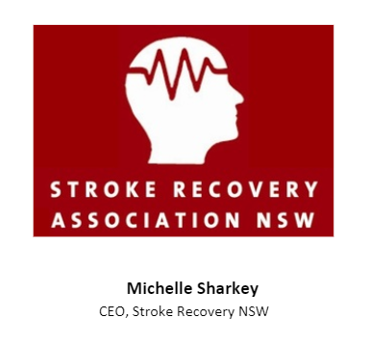
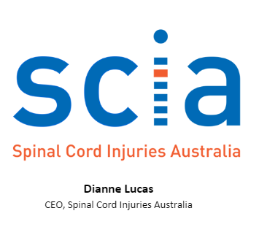

A Cost Benefit Analysis of Australian independent disability advocacy agencies. (Daly, Barrett and Williams) Microsoft Word - Disability advocacy CBA.docx (dana.org.au) p41

