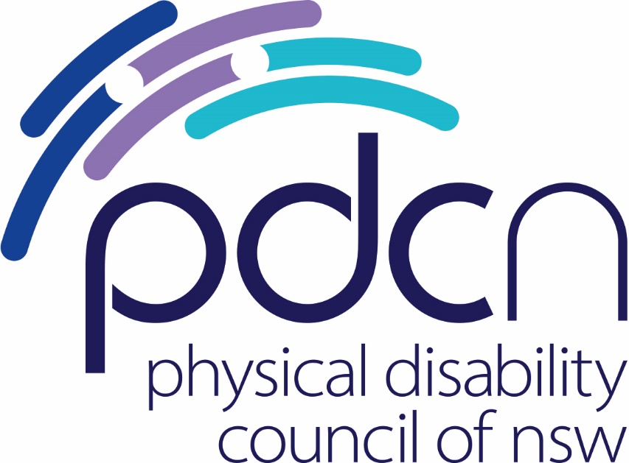

Submission to the City of Sydney Draft Resilience Strategy

August 2023

Physical Disability Council of NSW
3/184 Glebe Point Road, Glebe NSW 2037

02 9552 1606
www.pdcnsw.org.au

alice.batchelor@pdcnsw.org.au

Contents

Who is the Physical Disability Council of NSW? 3
Recommendations 4
Introduction 5
Direction 1: an equitable, inclusive and connected community 5
Direction 5: A prepared community 7
Concluding comments 7

Who is the Physical Disability Council of NSW?

The Physical Disability Council of NSW (PDCN) is the peak body representing people with physical disabilities across New South Wales. This includes people with a range of physical disability issues, from young children and their representatives to aged people, who are from a wide range of socio-economic circumstances and live in metropolitan, rural and regional areas of NSW.

Our core function is to influence and advocate for the achievement of systemic change to ensure the rights of all people with a physical disability are improved and upheld.

The objectives of PDCN are:
- To educate, inform and assist people with physical disabilities in NSW about the range of services, structure and programs available that enable their full participation, equality of opportunity and equality of citizenship.
- To develop the capacity of people with physical disability in NSW to identify their own goals, and the confidence to develop a pathway to achieving their goals (i.e. self-advocate).
- To educate and inform stakeholders (i.e.: about the needs of people with a physical disability) so that they are able to achieve and maintain full participation, equality of opportunity and equality of citizenship.

Recommendations

Implement Silver Level Livable Housing Design across all new housing developments.
All new housing stock to be built to minimum accessibility standards to ensure the full inclusion of people with disability across the housing sector within the City of Sydney.

Adopt the Person-Centred Emergency Preparedness (P-CEP) model in preparing people with disability in the community for disasters and emergencies
Facilitate the implementation and awareness of the P-CEP model for emergency preparedness across the City of Sydney, ensuring people with disability are prepared for future disasters and emergencies.

Introduction

PDCN is the peak body representing an estimated 1,056,440 individuals with physical disability across New South Wales. Many of our members live within the Sydney City Council LGA and have disabilities which impact their capacity to navigate the physical environment, including streets and footpaths. A significant proportion of our members also use assistive aids to travel around their communities, including wheelchairs, motorised mobility devices, walking sticks and frames, or have vision impairment and navigate using guide dogs or cane.
One of PDCN’s key objectives is to educate and inform stakeholders about the needs of people with a physical disability so that people with physical disability can have equal opportunity to connect with the broader community.

PDCN appreciates the opportunity to comment on the City of Sydney’s Draft Resilience Plan. Overall, we are satisfied with the identified directions and priorities outlined in the draft, however, stress the importance of ensuring disability inclusion is apparent within each aspect of the plan. Identified areas for further disability inclusion are noted in direction 1: an equitable, inclusive and connected community, and direction 5: a prepared community.

Direction 1: an equitable, inclusive and connected community

It is acknowledged in the plan that in many cases housing is not fit for tenants with accessibility requirements, and most housing has not been constructed with accessibility features to support people with disability or older people. It must be understood that most people with a physical disability in NSW live in the mainstream private rental jousting market, and specialised housing options such as Specialist Disability Accommodation, social housing, and retirement villages and residential aged care are not preferable or suitable for many people with disability within the community. While it is true that there is a shortage of SDA properties as noted by the resilience strategy, there is an inherent need to move beyond SDA and social housing as accessible housing for people with disability, and for all homes to be built to universal design standards for accessibility.

Modifying homes for better accessibility is often hindered by retrofitting costs and limited (National Disability Insurance Scheme) NDIS or Aged Care funding for modifications. Research shows retrofitting is much more expensive than designing for accessibility initially, with up to 22 times higher costs to retrofit.
People who have renovated their homes often face high modification costs. Some adapt parts of their homes but can't afford further changes or modify them based on immediate needs but require additional adjustments later, as their accessibility needs increase.
People with physical disabilities want homes that support their involvement in the community. Many participants in our research face challenges due to housing accessibility, impacting their ability to live a full life. In severe cases, inaccessible homes lead to isolation and dependency, which negatively impacts people’s health and well-being.

“I have been unable to shower for 7 years, no access to community, bed bound because the house won’t accommodate a wheelchair.”

“In 2016 I was moved to a property with 26 stairs and stayed for three years. I just had to stay up there (in the home) or go down the stairs on my backside. “

Research also indicates a direct correlation between housing accessibility and loneliness, with data from the Australian Bureau of Statistics (2018) finding the most avoided situation for people with disability because of their disability was visiting family and friends, at 39.2%. Multiple studies have found that loneliness has been linked to poor physical and mental health and an overall dissatisfaction with life. We note that loneliness and isolation have been identified as key areas to be addressed in the resilience strategy and stress the importance of accessible housing as a major factor in facilitating these issues.

It is encouraging to see The City requires larger-scale housing developments to incorporate adaptable dwellings and satisfy the NSW Apartment Design Guideline benchmark universal design features under its Housing for All: City of Sydney local housing strategy. This must be incorporated across all housing developments across the City of Sydney. To achieve the goal of a truly resilient and inclusive community there must be commitment to the full accessible and inclusive design of future housing developments in the City of Sydney in line with the NCC approved Silver Level Housing standards for livable housing design.

Recommendation: Implement Silver Level Livable Housing Design across all new housing developments.
All new housing stock to be built to minimum accessibility standards to ensure the full inclusion of people with disability across the housing sector within the City of Sydney.

Direction 5: A prepared community

It is encouraging that there is acknowledgement of the additional support required for people with disability in an emergency situation outlined in the draft plan. In relation to this, it is important that this goes beyond acknowledgement and action is taken to support the needs of people with disability within the City of Sydney in emergency preparedness.
It is important to note the utilisation of person centred emergency preparedness (P-CEP) in preparing for and creating inclusive and resilient communities. The Person-Centred Emergency Preparedness Toolkit (P-CEP) was produced by Collaborating 4 Inclusion as a fit-for-purpose process for people with disabilities to self-assess their preparedness, capabilities and support needs and develop a personal emergency plan for how they will: (a) manage their support needs in emergencies; and (b) act together with their support network before, during, and after a disaster.

The P-CEP toolkit was developed in co-design with the disability community and has been trialled by people with lived experience. PDCN recommends this tool as best practice for addressing emergency preparedness for people with disability and encourages the implementation of this model in the City of Sydney’s Resilience Strategy.

Recommendation 2: Adopt the Person-Centred Emergency Preparedness (P-CEP) model in preparing people with disability in the community for disasters and emergencies
Facilitate the implementation and awareness of the P-CEP model for emergency preparedness across the City of Sydney, ensuring people with disability are prepared for future disasters and emergencies.

Concluding comments

PDCN supports the proposed resilience strategy and recognises this plan as an important step toward safeguarding the future of the City of Sydney and its population. While there is thought given to the experiences and needs of people with physical disability seen throughout the draft, PDCN suggests the inclusion of minimum accessibility standards to be implemented across all new housing developments, and the implementation of the P-CEP model in emergency preparedness. These recommendations will ensure a more inclusive and accessible resilience strategy that wholly supports people with physical disability in the effort to create a more resilient city.

Australian Bureau of Statistics (2023), Disability, ageing and carers summary, 2018 <https://www.abs.gov.au/statistics/health/disability/disability-ageing-and-carers-australia-summary-findings/2018>
This is based on building to Silver Level Livable Housing design at the time of build verses when an unplanned need arises. Livable Housing Design Australia, Livable Housing Design Guidelines, 2017 < Downloads (livablehousingaustralia.org.au)> accessed 25 August 2022.
Access Denied The experiences of people with physical disability across the NSW housing sector H. Stone, A.Batchelor & M.Mead. May 2022 p22
Australian Bureau of Statistics, Snapshot of Australia, 28 June 2022 accessed 9 September 2022
Australian Institute of Health and Welfare, Social isolation and loneliness, Snapshot, 16 September 2021 (aihw.gov.au) accessed 9 September 2022
City of Sydney (2020), Housing for All: City of Sydney local housing strategy, accessed August 2023 <https://www.cityofsydney.nsw.gov.au/strategic-land-use-plans/local-housing-strategy>
Villeneuve, M., Abson, L., Yen, I., & Moss, M. (2020). Person-Centred Emergency Preparedness (P-CEP) Workbook. Centre for Disability Research and Policy, The University of Sydney, NSW 2006 <https://collaborating4inclusion.org/wp-content/uploads/2020/08/2020-08-19-Person-Centred-Emergency-Preparedness-P-CEP-WORKBOOK_FORM_FINAL.pdf>

