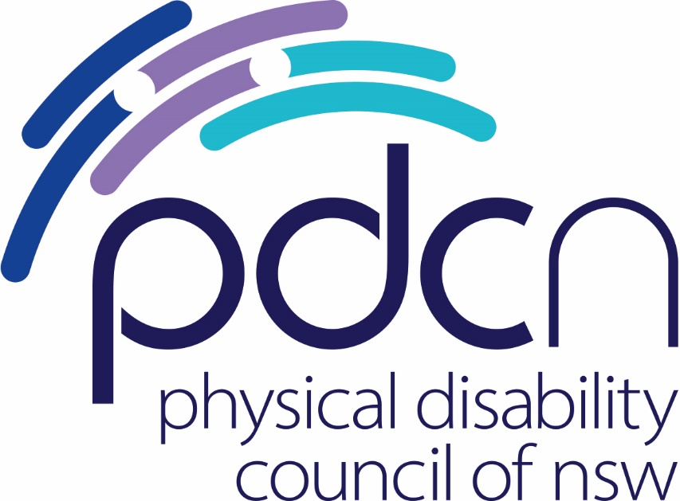

PDCN Submission in Response to the NSW DCJ Disability Royal Commission Consultation

Monday 30th January 2024

Physical Disability Council of NSW
3/184 Glebe Point Road, Glebe NSW 2037

02 9552 1606
www.pdcnsw.org.au

kelley.temple@pdcnsw.org.au

Contents

Who is the Physical Disability Council of NSW? 3
Recommendations 4
Analysis of recommendations 5
Conclusion…………………………………………………………….………………………….……………………………………12

Who is the Physical Disability Council of NSW?

The Physical Disability Council of NSW (PDCN) is the peak body representing people with physical disabilities across New South Wales. We represent people with a range of physical disabilities. We represent people of all ages and sub-groups including children, families, young people and older people; people from Culturally and Linguistically Diverse backgrounds and First Nations people; We represent people who are from a wide range of socio-economic circumstances and live in metropolitan, rural and regional areas of NSW.

Our core function is to influence and advocate for the achievement of systemic change to ensure the rights of all people with a physical disability are improved and upheld.

The objectives of PDCN are:
- To educate, inform and assist people with physical disabilities in NSW about the range of services, and programs available that enhance social participation, equality of opportunity and equality of citizenship.
- To develop the capacity of people with physical disability in NSW to identify their own goals, and the confidence to develop a pathway to achieving their goals (i.e. self-advocate).
- To educate and inform stakeholders (i.e.: about the needs of people with a physical disability) so that they are able to achieve and maintain full participation, equality of opportunity and equality of citizenship.

Recommendations for adoption and implementation by the NSW Government

Priority recommendations for implementation:

Recommendation 7.35: To increase accessible housing through the National Construction Code Silver Level Livable Accessibility Standards.

Recommendation 4.1: Establishing a Disability Rights Act, aligning with calls for a Human Rights Act in NSW.

Recommendation 6.36: Immediate action to provide that certain restrictive practices must not be used.

Additional recommendations for implementation:

Recommendation 6.1: A national plan on accessible information.

Recommendation 6.31: Embed the right to equitable access to health services in key policy instruments.

Recommendation 6.32: Increase capacity to provide supports and adaptations through improved guidance, funding and accessible information.

Recommendations 7.19: Establish specific disability employment targets for new public service hires in agencies and departments.

Recommendation 4.12: A positive duty to promote disability equality.

Recommendation 5.5: Establishing a National Disability Commission.

Recommendation 5.1: Introducing a National Disability Agreement.

Recommendations 6.22 and 12.5: Improved data collection on disability.

Introduction

The Royal Commission into Violence, Abuse, Neglect and Exploitation of People with Disability (hereafter referred to as the Disability Royal Commission (DRC)) has tasked the Federal and State and Territory Governments to provide responses, along with an action plan, to its recommendations by March 2024. PDCN welcomes the opportunity to make a submission to inform the NSW Government’s official response to the final report.
People with disability poured their time, energy and commitment into telling the hard-to-tell and hard-to-hear stories about their experiences of violence, abuse, neglect and exploitation. We appreciate the bravery and strength of those who spoke up to stop others from going through what they went through. We all have a responsibility to turn these recommendations into actions, making sure people’s stories inspire real change that improves the lives of all people with disability.

As housing is one of the main challenges for people with disability, we are glad that housing is a focus in the report and that the Commission recommended that NSW should sign up the National Construction Code Silver Accessible Livable Standards. We also note that the NDIS Review included the same recommendation.
We are concerned that transport is not featured in the report. Transport plays a huge role in the lives of people with physical disability and is often a space where people with disabilities experience abuse and neglect day to day. The state of the Wheelchair Accessible Taxi (WAT) industry in NSW is dire. As of October 2023, there are only 691 WATs registered in NSW and only 258 of those operate outside Sydney.

In 2023, PDCN distributed a survey to our members and asked for feedback from people who had used a WAT service in the past 12 months. Approximately 36% of respondents said they booked a WAT that never turned up. And 25% of respondents said they had waited more than 2 hours for a booked taxi to arrive. When WAT users can get a booking and they experience discrimination or poor treatment by drivers, there are currently very limited options to act by making complaints that lead to systemic change.

The DRC report contains important recommendations, however, our main concern is how and when the NSW Government will form an implementation strategy. Just like the situation with WATs we want to ensure the disability community does not continue to be stuck in cycle of complaints that do not make systemic change.

Our approach

As a membership organisation, PDCN’s work is driven by the issues our members bring to our attention; this includes feedback provided by the Lived Experience Advisory Panel (LEAP). As sector coordinators for the NSW Disability Advocacy Network (NDAN) we also represent the broader disability community is committed to making a positive difference to the lives of the more than one million people with physical disability in New South Wales.
PDCN has consulted with our members through our LEAP and focused on the recommendations that have a direct impact on our members, and people with physical disability in NSW.

Recommendations

Top three priority recommendations that the NSW Government should implement to improve the lives, safety and wellbeing of people with physical disability in NSW.

Housing

Recommendation 7.35: To increase accessible housing through the National Construction Code.

The problem
Most people with physical disability in NSW live in the mainstream private rental housing market yet there is a serious shortage of accessible housing options for people with physical disabilities across the NSW housing market. For the estimated 1.3 million people living across NSW with physical disability, accessibility standards are essential to the ability to live safely and independently.

Approximately 3 in 4 people with mobility issues live in housing that does not meet their needs. Most people with physical disability are neither eligible for, nor would seek to live in, specialist disability accommodation. A lack of accessible housing impacts the visitability of homes and reduces the opportunity for older people to age in place. Limited availability of accessible housing places an extra burden on carers and the health care system due to in-home trips and falls. For people with physical disability, this negatively affects the quality of life, their health and well-being and their ability to participate economically.

The solution
PDCN supports this recommendation as a priority. PDCN have been asking the NSW Government to mandate changes in the NCC for over 2 years as part of the Building Better Homes NSW campaign, which we currently co-chair with Disability Advocacy and People with Disability Australia. Unfortunately, NSW remains one of the last states and territories in Australia to adopt the Livable Housing Design Standard (with Western Australia being the only other jurisdiction not signed up). NSW adopting Livable Housing Design Standards in line with the NCC will make it easier for people with disability, older people, young families and friends and families of these groups to find safe, accessible and comfortable homes.
Adoption of the NCC minimum accessibility standards is consistent with the intent of the NSW Housing Strategy 2041, the National Disability Strategy and the UN Convention for Rights of Persons with Disabilities (CRPD), to which Australia is party. PDCN wants to see this recommendation being adopted in NSW by June 2024. We also note that Action 9.11 from the NDIS Review recommends that "all remaining jurisdictions to sign up to the Livable Housing Design Standards in the National Construction Code".

Human Rights

Recommendation 4.1: Establishing a federal Disability Rights Act.
The problem
Currently, organisations do not have a positive duty to implement disability rights. The burden of proving discrimination currently falls on the person with disability. Without meaningful legislative and regulatory change people with disability are often locked into a cycle of complaints that doesn’t change the systemic cause of the problem. The cyclical nature of the complaints process is demoralising, exhausting and frustrating for people with disability.
PDCN has previously called for the introduction of a Human Rights Act in NSW, as Australia is currently the only liberal western democracy that does not have a Bill of Rights to ensure basic human rights are enforceable in our domestic legal system.

The solution
The Disability Rights Act would give effect to Australia’s obligations under the Convention on the Rights of Persons with Disabilities. The Disability Rights Act should include a set of guiding principles designed to promote and advance the rights of people with disability in Australia.
Under this Act, Commonwealth entities would be required to consult with people with disability and carers, families, and supporters of people with disability in the development, evaluation and planning of new initiatives or major changes to services that impact or are provided to the public.
Complaints mechanisms are important, however governments at all levels should be mindful to develop stronger links between complaints mechanisms and systems reform. It is important that enforcement powers are broader than a complaints system and are able to enforce compliance and promote systemic change.
Health

Recommendation 6.36: Immediate action to provide that certain restrictive practices must not be used.
The problem
Restrictive practices are used in the ordinary management of people with disabilities across many contexts. Restrictive practices are incompatible with the fundamental rights of people with disability – restricting an individual’s physical freedom, their right to personal autonomy and their personal dignity. These practices can be dehumanising, but also potentially physically and psychologically dangerous. These practices can come precariously close to acts of recognised criminality such as physical assault.
The solution
Implementing this recommendation will improve how the health and care settings respond to patients with disabilities by ensuring a more human rights-based approach. PDCN believes that Australia should work towards heavily restricting and regulating the use of any form of restrictive practice.
We believe that the NSW Government should commit to this change. This is consistent with Australia’s international commitments under the United Nations Convention on the Rights of Persons with Disability (the UNCRPD), Article 15, which is freedom from torture or cruel, inhuman or degrading treatment or punishment.

Other recommendations that should be implemented:

Human Rights

Recommendation 4.12: A positive duty to promote disability equality.
The problem
There is currently no legislative obligation for commonwealth entities to promote a positive duty that ensures the equality of rights for people with disability. This means that the burden of proving a breach of rights or disability discrimination rests solely on the person whose rights have been breached. Being locked into a cycle of complaints that do not influence change at the root of the problem is exhausting and frustrating for many people with physical disability.
The solution
Under the Disability Rights Act, there will be a positive duty for commonwealth entities to ensure the rights of people with disability and act consistently with obligations under the Act. This would make it unlawful to fail or refuse to make an adjustment for a person with disability unless the adjustment would impose a valid unjustifiable hardship. It will also ensure that the burden of providing access and upholding the rights of people with disability falls on Commonwealth entities.

Recommendation 5.5: Establishing a National Disability Commission.

The problem
The Disability Rights Act will only be as successful as its implementation strategy. An entity must be established to monitor and enhance the implementation of the Act or else there will be few very ways to enforce compliance with the Disability Rights Act.
The solution
The National Disability Commission would be established to implement and have oversight of the Disability Rights Act.
The National Disability Commission would act as an independent statutory body under the Disability Rights Act. The function of this Commission would be to monitor and have oversight of the Disability Rights Act, monitoring and reporting on outcomes for people with disability nationally and promote best practice and new approaches to improving outcomes for people with disability. The Commission is to be chaired by a person with disability and most commissioners must be people with disability.
The establishment of this Commission will provide independent mechanisms for compliance for the promotion of the right of people with disability. PDCN supports this recommendation but want to stress that it is of great importance that this is established in codesign with people with disability and adequately represents a diverse range of this cohort.
Recommendation 5.1: Introducing a National Disability Agreement.
The problem
There are several disability related policies, programs and systems across Australia. The disability sector is becoming confusing in terms of roles and responsibilities, and it is not operating as effectively as needed.
The solution
A National Disability Agreement between the federal, state and territory governments aims to advance the equality, inclusion and rights of people with disability. This would be achieved through a framework for intergovernmental collaboration for implementing reforms, and Australia’s Disability Strategy and the NDIS.
PDCN supports this recommendation to help harmonise disability related policies and see disability beyond the scope of the NDIS (which while important, only provides support to a minority of people with disability).
Health

Recommendation 6.31: Embed the right to equitable access to health services in key policy instruments.
The problem
There have been instances where people’s carers have not been permitted to accompany their clients in hospitals and health care settings. There is also ambiguity around a carer’s rights and obligations to provide information on behalf of their client.
The solution
If implemented, this change would mean that people with disability could always be accompanied by a support person or carer when accessing healthcare. Having a support person helping with physical mobility, communication, and understanding medical information can offer emotional support and comfort during medical appointments, potentially reducing stress and improving the overall healthcare experience.
PDCN is in the process of finalising the first version of a mobile app ‘Navigate My Care’, which documents health and care related information about people with physical disability and complex health conditions to be used by health staff to enhance medical intervention, personal care, and health services. The information in this application could be accessed by a person’s carer to provide information on their client’s behalf.

Recommendation 6.32 Increase capacity to provide supports and adaptations through improved guidance, funding and accessible information.
The problem
Quality health care is an essential service and a human right. The CRPD recognises people with disability have the right to ‘the enjoyment of the highest attainable standard of health without discrimination on the basis of disability’.
Consistent with this, in August 2021, PDCN received distressing accounts from our members regarding the persistent challenges faced by people with disabilities when seeking appropriate care in healthcare settings.
The solution
This recommendation proposes a list of frequently needed adaptions and supports, to be used as a guide by health care facilities, to ensure they are aware of what modifications and equipment they need to deliver high quality health care. While this general list is welcome, PDCN believes this should be accompanied by more personalised care information, such as that provided by the Navigate My Care App, since general advice may not be suitable to each individual’s needs.
Accessible Information

Recommendation 6.1: A national plan on accessible information.

The problem
Many people with disability in Australia still cannot access information and communications on an equal basis to people without disability. Accessible information and communications are critical for protecting people during a crisis. In addition to the COVID-19 pandemic, there has been an increase in the prevalence of natural disasters in Australia since 2019. Part of the criticism from the disability community is that information distributed through official channels has not been accessible in terms of the language, styles, and channels used.
The solution
More accessible information will improve communication with people with disabilities (as well as their families and carers). This may enhance individual responses during times of natural disasters and public health emergencies because it would enable people with disabilities to make informed decisions and take appropriate actions to better protect themselves and their families. It could also reduce anxiety and improve service response during a crisis and enhance the government’s ability to protect and keep people safe.

Employment

Recommendations 7.19: Establish specific disability employment targets for new public service hires in agencies and departments.
The problem
People with disability, including those participating in the workforce, experience higher levels of economic disadvantage than people without disability and are more frequently employed in precarious or casual employment.
The solution
PDCN believes that the implementation of this recommendation could be a proactive step towards creating a more inclusive and equitable workforce that values the contributions of people with disabilities.
Achieving these targets will reduce barriers to employment and give more people with disability financial independence. However, members of our Lived Experience Panel expressed discomfort with targets as a solution, when current targets set by the NSW Government are not being met or achieving their objectives.
By hiring people with disabilities, this will provide opportunities for people with disabilities to build long-term, fulfilling careers and the public service would benefit from the diversity, creativity, and innovation that people with disabilities can bring to the workplace.
Advocacy and Data

Recommendations 6.22 and 12.5 for improved data collection on disability.
The problem
Inconsistent data collection on disability obscures the true extent of issues, potentially leading to underreporting of prevalence of disability. This inaccuracy complicates effective resource allocation by policymakers and risks implementing insufficient or misaligned programs. The lack of data consistency also hinders monitoring changes over time, making it challenging to assess the impact of interventions and measure progress. Overall, the inconsistency in data collection undermines the efficacy of resource allocation, program implementation, and intervention evaluation for people with disabilities.
The solution
A nationally consistent data collection approach would enable effective resource allocation, improve decision making, ensure accountability, allow for more evidence-based policies, and the ability to make global comparisons. PDCN believes improving funding and data for advocacy is essential for creating a more inclusive and just society where people with disabilities can thrive and fully participate.

Conclusion
People with disability advocated long and hard for the Royal Commission into Violence, Abuse, Neglect and Exploitation of People with Disability.
PDCN believes that by implementing the recommendations highlighted in this submission, the NSW Government will be taking meaningful action that creates a more inclusive society that supports people with disability to be independent and live free from violence, abuse, neglect and exploitation.

Wiesel, I. (2020) Living with disability in inaccessible housing: social, health and economic impacts, Melbourne, University of Melbourne School of Geography.

