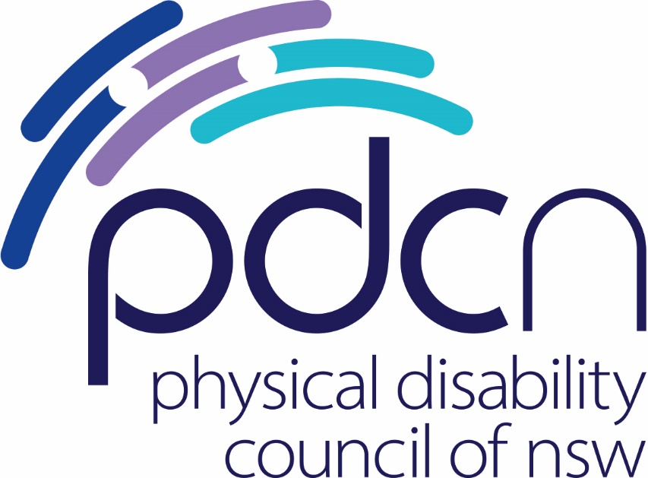

Submission to Transport Social Policy of Transport for NSW

Wheelchair Accessible Taxi Roundtable

November 2023

Physical Disability Council of NSW

3/184 Glebe Point Road, Glebe NSW 2037

02 9552 1606

www.pdcnsw.org.au

alice.batchelor@pdcnsw.org.au

Contents

Who is the Physical Disability Council of NSW? 3

Recommendations 4

Introduction 5

Issues 5

# Who is the Physical Disability Council of NSW?

The Physical Disability Council of NSW (PDCN) is the peak body representing people with physical disabilities across New South Wales. This includes people with a range of physical disability issues, from young children and their representatives to aged people, who are from a wide range of socio-economic circumstances and live in metropolitan, rural and regional areas of NSW.

Our core function is to influence and advocate for the achievement of systemic change to ensure the rights of all people with a physical disability are improved and upheld.

The objectives of PDCN are:

* To educate, inform and assist people with physical disabilities in NSW about the range of services, structure and programs available that enable their full participation, equality of opportunity and equality of citizenship.
* To develop the capacity of people with physical disability in NSW to identify their own goals, and the confidence to develop a pathway to achieving their goals (i.e. self-advocate).
* To educate and inform stakeholders (i.e.: about the needs of people with a physical disability) so that they are able to achieve and maintain full participation, equality of opportunity and equality of citizenship.

# Recommendations

Establish a Taskforce on taxis to address systemic issues

Establish a Taskforce with a commitment from all stakeholders to address systemic issues including; A Transport for NSW representative, a Point to Point Transport Commissioner Representative, a Representative from the Office of the Minister for Disability Services, 2 Representatives from the Disability Sector, The NSW Taxi Council CEO or nominated Delegate (when the CEO is unavailable).

Increase regulatory powers of the Point-to-Point Commissioner

Appropriate oversight, enforcement and penalties by the Point-to-Point Commission for non-compliance of the WAT license. This must also include operation of the vehicle, wheelchair restraints, and conduct of the driver.

Increase incentives for Wheelchair Accessible Taxis

A commitment from Transport for NSW to review incentives for WAT licenses and zero interest loans for WAT vehicles, and increase the $15 lift fee for drivers to a rate in agreement with industry standards effective immediately.

Enforce a single streamlined central booking system across the whole state.

Enforce a single centralised booking system for Wheelchair Accessible Taxis across NSW to minimise frustrations for both users and drivers. This will also ensure appropriate monitoring and compliance of WATs to carry out contractual obligations to prioritise wheelchair bookings.

Consult with industry on best practice design for booking systems for WATs.

Booking systems must be developed in consultation with industry to ensure ease of use for drivers and operators as well as users.

# Introduction

The Physical Disability Council of NSW appreciates the opportunity to further express our member concerns regarding the state of wheelchair accessible taxis (WATs) in NSW. In June, PDCN and Spinal Cord Injuries Australia (SCIA) met with Minister for Transport Jo Haylen, and attended a roundtable on these issues in November. This has been a welcome forum for feedback, however it is essential that reform is achieved in this area as this has been an ongoing issue for people with physical disabilities, with particular concerns for those living in regional and remote areas.

Issues relating to WATs in need of reform involve driver incentives, adequate regulatory oversight for the Point-to-Point Commissioner to monitor compliance, and a centralised booking system that functions across the whole of NSW. The implementation of these changes would benefit from the oversight of a taskforce, to ensure all factors are considered and issues are addressed relating to WATs broadly.

# Issues

Since 2020, the Physical Disability Council of NSW has received an ever-increasing number of reports of issues related to taxi services from people with disabilities, to the point where many people with disability no longer consider taxis to be reliable, despite their necessity as an essential mode of transport. This has been expressed from our membership and people with disability who rely on these services and documented by PDCN in our research report ‘Taxi Troubles’ published in February 2023.

“Taxis don't come when I book them. I'm never rude or antisocial, I just can't get them to accept the booking unless it is a really long journey. I haven't been to the hospital for any outpatient appointments for 3 years. I haven't physically been to the GP for over 2 years. I can't make a medical appointment anywhere because I usually have to cancel at the last minute because I can't get a taxi. I can/could use a service like WAT in Sydney, but they charge double what a taxi does, and I can't afford it. I don't go anywhere anymore I just stay at home- it's less stressful and less frustrating.”

PDCN member (excerpt from Taxi Troubles)

This lack of reliability is inhibiting the capacity of people with disability to use taxis as a means of connecting with their communities, since attempting to find a taxi to go out is often stressful and frustrating and therefore not worth the effort.

“It’s become truly bad. I'm wary of even booking now. I now limit outings to those I can wheel to/from. I missed several events that cost me a significant amount for tickets. I missed a relative's funeral service. I have no faith in the taxi system to meet my needs now.”

PDCN Member (excerpt from Taxi Troubles)

For many people with disability, taxis are an essential form of point-to-point transport to get to essential medical appointments, employment, and broader social occasions. While many people with disability can ride in standard taxi vehicles, some rely exclusively on wheelchair accessible taxis (WATs). Supply of taxis, including WATs is particularly important in rural and regional areas of NSW, where there is a reliance on these services since minimal alternative public transport is available.

**Recommendation:**

1. Establish a Taskforce with a commitment from all stakeholders to address systemic issues including; A Transport for NSW representative, a Point to Point Transport Commissioner Representative, a Representative from the Office of the Minister for Disability Services, 2 Representatives from the Disability Sector, The NSW Taxi Council CEO or nominated Delegate (when the CEO is unavailable).

WAT trips, particularly in outer Metropolitan and regional areas have been a long-standing problem with passengers facing significant delays to be picked up. Some regional areas are severely restricted by access to WATs, as less drivers see the benefit in attaining a WAT license or driving WAT vehicles. It has also been noted by members of PDCN that some drivers are refusing to pick up wheelchair users, this may be due to it being a more lucrative option to transport larger groups of people, especially from airports.

From our member experience, **36%** of surveyed WAT users in a 12-month period had **experienced booking a WAT that never turned up**, and **one quarter** of participants had **waited more than 2 hours** for a booked taxi to arrive.

There has been a reduction in the number of WAT drivers across all regions across NSW, from 941 registered WATS in October 2019 to 691 in October 2023[1]. From our member experience, there are only two operational WATs in the regional town of Orange, servicing a population of over 40,000 people[2]. It has also become an issue that during peak hours, these vehicles are used for school pick up and drop off, forcing people with disability to manage their time around these factors. This is partly because of the COVID-19 pandemic and drivers not returning, and partly because the current incentives available on licenses, vehicles and fares need to be reviewed.

A condition of having a WAT license requires holders to prioritise wheelchair passengers but there are minimal penalties applied when this does not occur. Further to this, the WAT driver is often not the license holder and so has no obligations to prioritise wheelchair passengers nor log into the Wheelchair Book & Ride app, despite this being the centralised booking system for WATs. Incentives for drivers and operators of WATs are also inadequate, with NSW having the lowest payment to drivers for each wheelchair passenger using the TTSS, known as the lift fee, nationally at $15.[3]

**Recommendation:**

1. Appropriate oversight, enforcement, and penalties by the Point-to-Point Commission for non-compliance of the WAT license. This must also include operation of the vehicle and wheelchair restraints and the conduct of the driver.
2. A commitment from Transport for NSW to review incentives for WAT licenses, to introduce zero interest loans for WAT vehicles and to increase the lift fee for drivers.

In addition to issues with WAT supply, is the problem in booking services. This is related to the confusion of platforms through which a WAT is to be booked. In March 2021 the new booking service, Wheelchair Book & Ride, was introduced to replace the established Zero200 as the centralised booking service for the Sydney area and operated by Spinal Cord Injuries Australia.

After the implementation of Wheelchair Book & Ride as the centralised booking service, the legacy Zero200 service maintained its booking platform serving its own fleet of WATs – in direct competition with the new official booking service. This has led to the existence of two competing booking systems which does not serve the interests of its users, essentially splitting coverage of the available WATs. This has seen frustration on both ends of the service, with people booking on both systems at the same time in hope of a shorter wait time, and drivers showing up to empty bookings.

The Wheelchair Book & Ride service relies on drivers to login to a secondary app but only a small number do, even though it is a condition of the WAT license. There appears to be a lack of information and/or reluctance to engage with the app booking service, further eroding coverage of WAT availability. This is due to a lack of enforcement of compliance for drivers to use this system, with minimal oversight from the Point-to-Point Commissioner or Transport for NSW to monitor compliance and use by drivers and operators.

Additionally, the Book and Ride service operates only within the Sydney Metropolitan area, and Zero200 continues to operate as a commercial service, leaving regional and rural areas without this same quality of service from the centralised booking service for WATs. This is in conjunction with low numbers of WATs in operation, especially in regional and rural areas.

**Recommendations:**

1. Enforce a single streamlined central booking system across the whole state.
2. Consult with industry on best practice design for booking systems for WATs.

It is important that Government and the taxi industry work together urgently to increase WAT fleets to meet demand, decrease wait times and cancellations of essential transport for people with disability, and implement driver training to a higher standard. This may be achieved through further incentives for drivers and operators of WATs, ongoing and renewed driver training programmes, and increased regulatory powers from the Point-to-Point Commissioner alongside a specific taskforce implemented to identify issues and solutions going forward.

1. Transport for NSW (2023), ‘Issues Paper: Roundtable 14 November 2023’, *Availability of wheelchair accessible services,* NSW government
2. Orange Taxis (2023), ‘Our Fleet’, *Orange Taxis,* accessed online 28th Nov 2023 <<https://www.orangetaxis.com.au/our-fleet/>>
3. Transport for NSW (2023), ‘Wheelchair accessible taxis’, *Point to point transport,* accessed online 28th Nov 2023 <<https://www.transport.nsw.gov.au/projects/programs/point-to-point-transport/wheelchair-accessible-taxis>>