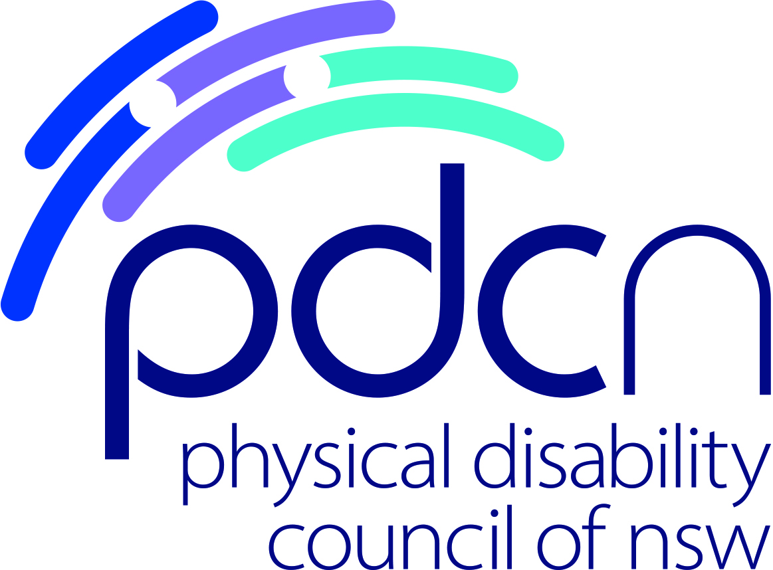

2022 – 2025 Strategic Plan

Our Vision
As people with physical disability we live in a society where our human rights are protected, our equality of opportunity is assured and our full participation is a reality

Our Purpose
To build empowered, inclusive communities through -
Information and education
Engagement and participation
Developing individual capacity and resilience

Our Values
As we implement our vision we will be guided by our values:
Integrity – we are trustworthy, open and honest in all our undertakings
Inclusion – we include people with physical disabilities in all we do
Independence – we value our independence to remain true to our values
Innovation – we are committed to finding new ways to better support people with physical disabilities and the work
we do
Collaboration – we work in partnership with our members, stakeholders and the broader community to achieve our purpose

Ordinary People, Ordinary Lives

Our Profile

The Physical Disability Council of NSW (PDCN) was conceived in 1994 by the late Kevin Byrne AM and a dedicated committee of management, and formalised as a Council in 1995. PDCN has, since its inception, worked towards advancing social justice for people with physical disability.

From its initial focus in 1996 on the provision of adequate attendant care, inefficiencies in the PDAP program (the supplier of aids and equipment) and the development of children’s leisure services, PDCN began community consultations in 1997, and have continued to build our reputation and broaden our reach throughout NSW ever since.

Today the Physical Disability Council is regarded as the peak systemic advocacy body for people with physical disability in NSW, and provides a range of free services to our members, or any others that request it - from information provision, to education and capacity building workshops and programs, preparing submissions and reports, to advocating on our members’ behalf to Government and local communities for full inclusion in NSW society.

PDCN is a not for profit organisation, and a registered charity. We hold Deductible Gift Recipient status, and are endorsed to receive tax concessions. Our organisation’s work is governed by an elected voluntary Board of Management, a majority of whom have physical disability, and regulated via the various State and Commonwealth laws, and our Constitution.

A large portion of our current funding comes from the NSW State Government. Currently, PDCN is faced with challenges in ensuring the sustainability of our organisation as the political and funding landscape changes. We are responding to this with an approach based on innovation, diversification of funding sources, and building outcomes focused programs, underpinned by rigorous data collection and analysis.

We will continue to listen to our members, and other stakeholders to ensure that what we do responds to the needs of community in which we work, and explore opportunities for new partnerships with like-minded organisations, and the wider corporate sector.

The development of the 2020 – 23 Strategic Plan is a step towards achieving this change and readying ourselves for our future opportunities and needs. It provides us with a concise, clear tool to guide our governance, programs and activities. The associated Operational Plan will ensure we have a set of actions and outputs that will drive us towards achieving our strategic goals and ensuring accountability for both the Board and staff of the organisation.

Nothing about us, without us

Key Focus Areas:

Champion
Advocate for the full and equitable inclusion of people with physical disability in all parts of NSW society

Educate & Inform
Deliver innovative, outcomes focused programs that make a difference to the lives of, and develop the capacity of, people with physical disability
Provide informed expert commentary on the issues that affect people living with physical disability

Connect & Grow
Develop and strengthen partnerships that enhance the work we do, and benefits people with physical disability
Build a sustainable organisation that remains true to our vision and values

1: Champion
Advocate for the full and equitable inclusion of people with physical disability in all parts of NSW society

Intended Outcomes |  | Strategies | Indicators of Success
 |  | By June 2025 we will have achieved the following:
Outcome 1.1  PDCN solidifies and strengthens our engagement with relevant NDIS personnel and policy mechanisms to ensure continued reforms align with the best interests of people with physical disability within and outside the scheme. | 1.1.1  1.1.2  1.1.3 | Build and strengthen relationships with key NDIS sections and bodies (Independent Advisory Committee, Quality and Safeguards Commission, Policy team  Generate broad NSW disability sector support for a collaborative approach to lobbying against changes that reduce participants choice and control  Engage with NSW Minister for Disability and other key NSW stakeholders to elicit support and pressure Federal government against changes that reduce participants choice and control | 1 Year  - Consistent contact established within the NDIS Independent Advisory Committee  - Ongoing relationship developed with the NDIA Policy team  - Direct relationship established with the NDIS Quality and Safeguards Commission  Throughout  - Reforms to the NDIS ACT are only enacted where it adds benefit to people with disability  - State/Territory oversight remains in its current form (or better!)

Intended Outcomes |  | Strategies | Indicators of Success
 |  | By June 2025 we will have achieved the following:
Outcome 1.2  NSW State Government commits to Silver Universal Design Standards within the National Construction Code, and proposes Gold Standard for certain types of builds | 1.2.1  1.2.2  1.2.3  1.2.4 | Partner with Building Better homes Campaign Members to deliver a strong campaign strategy in order to gain NSW ministerial support.  Develop a core of support within other relevant stakeholders, across building and broader sector  Garner NSW Government support for implementing Silver Universal Design standards in NSW home builds.  Ensure replication of National regulations at NSW level. | 1 Year  - Build broader support from relevant stakeholders for the outcome proposed, including key government stakeholders, building industry and ageing sector  - Ministerial support attained for Silver Universal Design standards  2 Year  - NSW building legislation reflects National Construction Code  - NSW building sector is willing to comply with a planned timeline for roll out of changes  3 Year  - NSW building sector enacting Silver Standard Universal Design in marketing and display homes, and in a percentage of new NSW builds

Intended Outcomes |  | Strategies |  |  |  | Indicators of Success
 |  | By June 2025 we will have achieved the following:
Outcome 1.3  All Ticketek online bookings allow for booking of accessible seating |  |  | 1.3.1  1.3.2  1.3.3 | Build a group case for complaint with the Australian Human Rights Commission (with assistance from PIAC)  Connect with Ticketek through complaint process  Continue to progress online booking of accessible seating through any online platform | 1 Year  - Finalise complainants and proceed with Human Rights Complaint  - Ticketek engages in accessible conversation  2 Year  - Collaboration on a process and timeline for online accessible seating with Ticketek  - 25% of all Ticketek events allow for online booking of accessible seats.  3 Year  - 100% direct Ticketek online bookings allow for booking of accessible seats.

Intended Outcomes |  | Strategies | Indicators of Success
 |  | By June 2025 we will have achieved the following:
Outcome 1.4  People with disability experience better disability related care during hospitalisation.  All NSW hospitals have a standarised disability care admission plan and staff responsible for its implementation. | 1.4.1  1.4.2  1.4.3  1.4.4 | Finalise targeted relationship with NSW health to endorse project.  Build concept ‘App’  Establish a trial project within NSW Health  Review trial, address changes and begin general roll out in NSW public hospitals. | 1Year  - NSW Health ‘buy in’ for integrated App version of Care Plan  - ‘App’ developed in conjunction with NSW Health (or Dept of Customer Service)  2 Year  - App testing in NSW hospital trial  - Appropriate ‘App’ data integrated within Dept Customer Online Health Project  3 Year  - General rollout across NSW public hospitals  - Endorsement across disability sector  - Patients report better disability related in- hospital care

Intended Outcomes |  | Strategies | Indicators of Success
 |  | By June 2025 we will have achieved the following:
Outcome 1.5  NSW Hand control licencing and rental vehicle hand control issues are reformed and exemptions finalised to allow for equitable access to independent driving for those who require them  Dept Customer Service addresses need for continued review of disability where disability is stable (in order to re-license, update mobility passes, hand controls etc) | 1.5.1  1.5.2  1.5.3 | Further engagement with Transport for NSW team to address hand control exemptions  Work with Customer Service teams to develop ‘one touch’ digital information customer file  Continue to provide feedback/submissions to consultations, consulting our members as required. | 1 - 2 Year  - Clear exemptions for hand controlled vehicles are applied universally, and do not further disadvantage drivers with a disability, or rental companies hiring vehicles with hand controls  3 Year  - Digital information system in place storing disability specific data that reduces need for continued medical assessment where disability does not change (for renewals of licence, mobility passes, hand control fittings etc)

2: Educate and Inform
Deliver innovative, outcomes focused programs that make a difference to the lives, and develop the capacity of, people with physical disability.
Provide informed expert commentary on the issues that affect people living with physical disability.

Intended Outcomes |  | Strategies | Indicators of Success
 |  | By June 2025 we will have achieved the following:
Outcome 2.1  People with disability are connected and have the information to make decisions & choices. | 2.1.1  2.1.2  2.1.3 | Deliver, and refine an outcomes focused program of peer groups, individual peer mentoring and workshops to provide opportunities to connect and share information  Regularly consult with pwd to ensure information provided is relevant and responds to diverse and changing needs  Provide information on partner organisations and networks PDCN work with to broaden pwd’s knowledge, networks and supports | Throughout  - People with disability have increased connections & community as a result of peer group attendance & workshop participation  - People with disability feel valued, well connected and an integral part of their community  - People with disability are provided with timely information enhancing decision making capabilities and opportunities to increase choice & control in their lives  - PDCN meet or exceed project targets with regard to peer group, mentoring and workshop numbers

Intended Outcomes |  | Strategies | Indicators of Success
 |  | By June 2025 we will have achieved the following:
Outcome 2.2  People with disability have the skills and confidence to participate, contribute and protect their rights | 2.2.1  2.2.2 | Develop and refine a suite of capacity building workshops that build capacity of people with disability to make effective use of information and develop skills to make positive and progressive changes in their lives  Deliver capacity building workshops to both metropolitan and regional/rural participants | Throughout  - People with disability confidently participate in peer groups, peer mentoring sessions & workshops  - People with disability have developed skills to confidently participate and contribute to community  - People with disability have developed skills to confidently advocate for their rights
Outcome 2.3  People with disability contribute to leading, shaping and influencing their community | 2.3.1  2.3.2  2.3.3 | Ensure our capacity building programs provide opportunities for people with disability to lead discussions, facilitate leadership opportunities, and build connections with local community  Through the Lived Experience Advisory Panel and other relevant mechanisms, people with physical disability lead the design and delivery of PDCN’s strategic focus areas, and are agents for positive change  Effective data analysis employed to continuously improve on the programs delivered, ensuring we are achieving our stated outcomes | Throughout  - People with disability lead and influence subject matters discussed in peer groups, peer mentoring sessions & workshops  - People with disability are provided regular opportunities to provide feedback and influence ongoing improvements of the project  - People with disability are core to the design and delivery of all programs at PDCN  - People with disability have an increased sense of agency, purpose and confidence to challenge social norms and influence a more inclusive society

Intended Outcomes |  |  | Strategies |  | Indicators of Success
 |  |  | By June 2025 we will have achieved the following:
Outcome 2.4  People with disability are provided with expert, accurate commentary on the issues that affect their lives | 2.4.1  2.4.2  2.4.3 |  | PDCN engage with people with disability and the sector via a broad range of media  PDCN develop communication tools and approaches that are up to date and meet the varying access needs of our members  PDCN provides timely, accurate information on the issues that affect people with disability to our members |  | Throughout  - Engagement rate across PDCN social media platforms (facebook and twitter) grows by 5% per year  - PDCN website traffic (page views) increases by 5% per year
Outcome 2.5  NSW Government and the broader community are provided with expert, accurate commentary on the inclusive needs of people with physical disability | 2.5.1  2.5.2  2.5.3 |  | PDCN consult with their membership on the issues that affect them (to inform and prioritise their representation activities)  PDCN seek opportunities to engage with government and the broader NSW community on the needs of people with physical disability.  PDCN provide written commentary to disability related reform |  | Throughout  - Member surveys indicate that PDCN members feel consulted on the priority work of the organisation  - PDCN is invited to represent people with physical disability on 20-23 advisory boards/committees  - PDCN complete 8-10 written submissions to disability related parliamentary/legislatory enquiries each year  - PDCN are recognised by government and the broader community as experts/leaders on the needs of people with a physical disability and are sought by both for our input.
3: Connect and Grow
Develop and strengthen partnerships that enhance the work we do, and benefits people with physical disability.
Build a sustainable organisation that remains true to our vision and values.

Intended Outcomes |  |  | Strategies | Indicators of Success
 |  |  | By June 2025 we will have achieved the following:
Outcome 3.1  PDCN has developed and strengthened partnerships throughout NSW that broaden and enhance the work we do and benefits people with disability |  | 3.1.1  3.1.2  3.1.3 | PDCN identify relevant organisations that align with our vision and values  PDCN develop partnerships and collaborations that enhance and add value to the work we do  PDCN increases collaborations with regional and rural communities | 1 Year  - PDCN develops relationships with 2 x potential partners to explore collaborations  2 Year  - PDCN establishes 2 x partnerships with likeminded organisations to deliver advocacy or funded project work  - PDCN further identifies and increases relationships with 3-4 rural and regional organisations  3 Year  - PDCN has developed up to 6 partnerships with both metro and regional/rural organisations that broadens our reach and enhances the work we do

Intended Outcomes |  | Strategies | Indicators of Success
 |  | By June 2025 we will have achieved the following:
Outcome 3.2  PDCN has built a sustainable organisation that remains true to our vision and values | 3.2.1  3.2.2  3.2.3  3.2.4 | Increase our reach and diversify our membership base throughout NSW  Develop a funding strategy that diversifies our income streams and considers our objectives, targets and capacity to resource  Regularly review grant websites for strategically aligned grant opportunities  Implement fee for service educational offerings | 2 Year  - Increase PDCN rural and regional membership by 10%  - Be successful in obtaining 1 targeted grant  - Develop E-learning platform and fee for service offering  3 Year  - Continue to increase PDCN membership across all member types – to a minimum of 10%  - Be successful in obtaining 1 targeted grant  - Have diversified our income streams  - Continue to develop further fee for service training offerings

