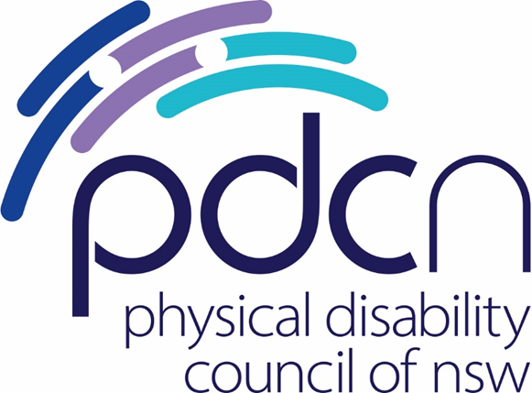

Physical Disability Council of NSW

‘Access Denied’
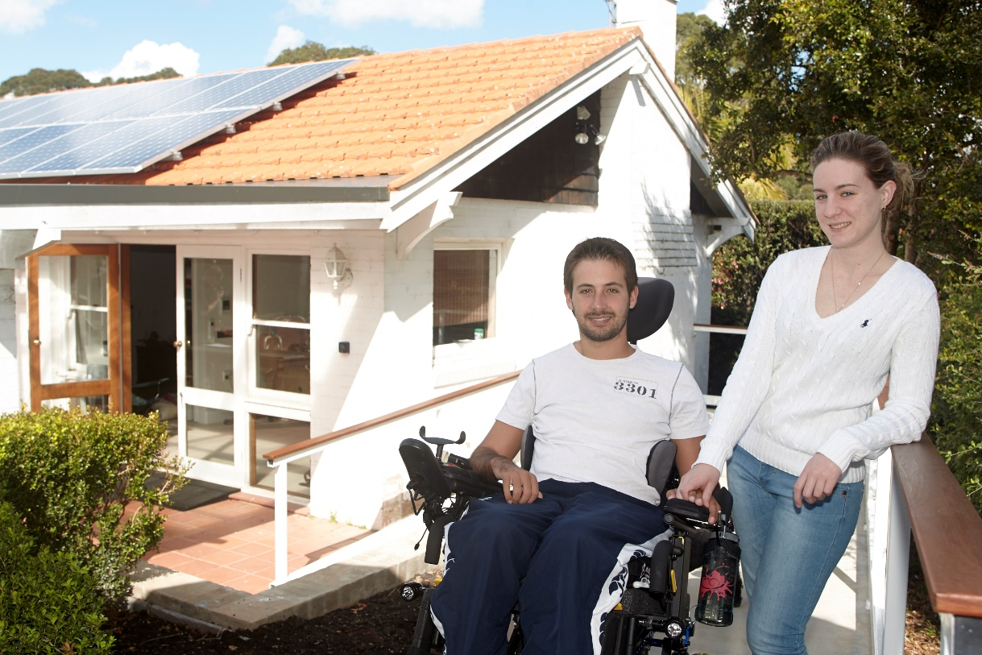

The experiences of people with physical disability across
the NSW housing sector

H. Stone, A.Batchelor & M.Mead
May 2022

Who is the Physical Disability Council of NSW?
The Physical Disability Council of NSW (PDCN) is the peak body representing people with physical disabilities across New South Wales. This includes people with a range of physical disability issues, from young children and their representatives to aged people, who are from a wide range of socio-economic circumstances and live-in metropolitan, rural and regional areas of NSW.
Our core function is to influence and advocate for the achievement of systemic change to ensure the rights of all people with a physical disability are improved and upheld.
The objectives of PDCN are:
· To educate, inform and assist people with physical disabilities in NSW about the range of services, structure, and programs available that enable their full participation, equality of opportunity and equality of citizenship.
· To develop the capacity of people with physical disability in NSW to identify their own goals, and the confidence to develop a pathway to achieving their goals (i.e., self-advocate).
· To educate and inform stakeholders (i.e.: about the needs of people with a physical disability) so that they can achieve and maintain full participation, equality of opportunity and equality of citizenship.

Introduction by the President
The basic right to live in a house, in comfort, and be able to socialise with friends and family is something most Australians take for granted.

For people with disability, like myself, the path to realising this is not easy. For many in NSW it’s impossible. In 2022, the fact that people with disabilities can’t find a safe home to live in, for years, is a disgrace – and I call on the State Government to do something about it.

When we talk about designing homes that work for families we aren’t just talking about bricks and mortar. Social inclusion starts with the home. You are giving people the right base to work, go to school, to be involved as citizens and members of the community.

The irony of the situation is that we know the answer for people with physical disability is the best answer for everyone. Building homes with universal design features works for parents of young children, those who are injured, and older people. It means that you can comfortably have people come to socialise and stay and it means that your home will work for you, now, and into the future – and it’s good to remember none of us have a crystal ball on these things.

This is a sobering read, but it’s an important one. Last year, for the first time, minimum accessibility requirements were incorporated into the National Construction Code, the effective blueprint for all Australian builds. As I write this, five of the seven states and territories have committed to incorporating these new design standards into their jurisdictions. Only NSW and WA have refused to apply them.

Now we aren’t talking massive changes here – literally seven key design features – many of them cost neutral, that would change the way all of us live in our homes for the better. We need the NSW Government to sign on to the NCC mandate, so that all people in NSW can have safe, comfortable and accessible homes to live in and visit.

Chris Sparks

President
Physical Disability Council of NSW

Acknowledgements
The authors would like to thank the many people with physical disability across NSW who shared their experiences with us across our research for this report.

We also thank Ms Joza Cabral, who contributed to the research of this report while on student placement at PDCN from Western Sydney University.

Contents
Who is the Physical Disability Council of NSW? 2
Introduction by the President 3
Acknowledgements 4
Contents 5
Summary 6
Prevalence of physical disability in NSW 9
General obligations to ensure suitable housing 9
Research Methods 10
1. Accessibility/adaptability 13
Common accessibility deficiencies across homes 13
Relationship between housing accessibility and physical safety 14
Experiences of homeowners 15
Limits to modifications 15
Lack of universal design options in the mainstream housing market 16
Experiences of private renters 17
Rental insecurity as an impediment to modifications 18
Social housing tenants 19
Retrofitting costs as an impediment to modifications across all property types 22
2. Choice 24
Lack of transparency across property listings 25
Perceptions of prejudice across the real estate industry 25
Affordability as a significant issue 26
Low rates of income support as a barrier to accessible housing for people with physical disability 27
Moving to find a more accessible home 27
Is Specialist disability Accommodation (SDA) a viable alternative option? 28
Retirement Villages and Residential Aged Care 29
3. Inclusion 30
Visiting the homes of others 31
Where to from here? 32
Final comments 35
Index of Tables 36

Summary
Living in a comfortable and safe home is something many people in Australia simply take for granted.
The home is the centre of our domestic lives, a place to do all the essentials of life, to relax and spend quality time with loved ones, including family and friends.
Unfortunately, for many people with physical disability in NSW, securing a comfortable home in which to realise these modest goals can be a major challenge.
Whether looking to buy, rent, or modify their existing homes, people with physical disability are constantly constrained by the existing limitations of Australian housing design. They are often forced to make compromises around where they live, how much they pay for housing and how they live in their homes.
People with physical disabilities, including older people, want to be a part of the community. A fundamental aspect of being part of a community is living in it, and being able to engage with neighbours, friends and family on equal terms to everybody else.
While our members have a diverse range of physical capacities and life situations, there are three key commonalities in the types of housing people with physical disability aspire to live in, including:
Accessibility/adaptability – people with physical disabilities want housing that is either built to purpose or can be adapted to be accessible. If modifications are required, people with physical disabilities want to be able to make these modifications both cheaply and easily, with a minimum of regulatory ‘red tape’
Choice – people with physical disabilities want to be able to choose from homes across a variety of locations, sizes, designs and price ranges. They want to have affordable housing options close to community facilities, their places of employment, school, family and friends
Inclusion – people want housing that facilitates their inclusion within the broader community. People with disabilities want to be able to visit the homes of friends and family as well as use their own homes as a place for entertaining others.
These goals are integral to the realisation of Australia’s international and domestic commitments to the rights of people with physical disability.
Over the past six months, PDCN has conducted extensive research into the experiences of people with physical disability across all elements of the NSW housing market. We have connected with just under a hundred people with lived experience of a broad range of physical disabilities and ages living in different types of housing across various parts of NSW.
We have defined accessible housing broadly. An accessible home is a home where someone with physical disability can comfortably enter and exit, access all rooms, and can do the usual activities expected within a home – sleep, eat, toilet and entertain – both safely and with dignity, noting that the physical requirements of a home will vary with the specific accessibility needs of an individual.
We looked at the experiences of people with physical disabilities, who rent, those who buy existing properties as well as those who have built properties specific to their accessibility specifications.
We also briefly examined whether the introduction of the National Disability Insurance Scheme (the NDIS) has enhanced the capacity for people to be able to modify their homes or move into purpose-built properties.
There are several key takeaways from our research:

- Most people with physical disability in NSW live in the mainstream housing market;

- There is a serious shortage of accessible housing options for people with physical disabilities across the NSW housing market regardless of whether it is property to rent or own;

- Specialised housing options such as social housing, Specialist Disability Accommodation, retirement villages and residential aged care are neither preferable nor viable options for many in the physical disability community;

- Home modifications are not a satisfactory response to the shortage of accessible homes, and cannot be universally realised for all who require them across the physical disability community;

- There is a lack of clear guidance for those looking to build their own homes on how to build these homes accessibly, in line with universal design best practice;

- Renters in the private market have the least options in terms of realising modifications to their homes, which is exacerbated by weak tenancy laws around evictions, modifications and rent increases; and

- The lack of housing accessibility is felt not only in the homes that people with disability live in, but also in the homes of their friends and family that they struggle to visit.
We note that as we write this report, we are at an important crossroads.
Australia’s population is ageing due to increasing life expectancy and declining fertility rates. Both the number of people at the older ages is growing and older people are representing an increasing share of the total population. People aged 65 years and older currently make up approximately 16% of the Australian population - amounting to 4.2 million older Australians - and this percentage is expected to climb to 23% of the overall population by 2066.
In 2021, minimum accessibility standards for new home builds were incorporated into the National Construction Code (NCC), Australia’s primary set of technical design and construction provisions for buildings in a majority decision by state and territory building ministers. Since then, five out of seven Australian states and territories have committed to incorporating these standards within their jurisdictions.

We believe that this report identifies the extent to which the public and private sectors are failing to address the housing needs of our growing membership in NSW and shines the spotlight on how challenging it can be for people with physical disability to find a safe and comfortable place to call home in our current housing market. The prevalence of physical disability is often underestimated by decision-makers, and the experiences of people with disability outside the scope of their direct interactions with government services are seldom the subject of examination.
The NSW Government has the capacity to greatly improve the housing experiences of people with physical disability, through targeted reform and leadership. We recommend that the NSW Government takes the following actions to better realise its international and domestic housing commitments to the physical disability community:
- Implement the minimum accessibility standards in the National Construction Code at a state level across all new home builds;

- Build more social housing to at least Silver Level+, with at least 25% to Gold Level Livable Design; increase existing supports for community housing providers to encourage expansion of the community housing sector;

- Reform existing tenancy laws to provide tenants with disability with the prima facie right to modify their rental property to meet their accessibility requirements;

- Reform existing tenancy laws to remove no ground evictions;

- Reform existing tenancy laws to prevent unsubstantiated rent increases;

- Modify NSW strata laws to prevent body corporates from refusing disability-related accessibility modifications.

Prevalence of physical disability in NSW
It is difficult to identify the extent to which people in NSW live with physical disability and previous estimates have varied significantly, due to differences across operational definitions, measurement instruments, and survey methodology.

For the purposes of our research, we have estimated the prevalence of physical disability within NSW in line with the methodology used by the Australian Bureau of Statistics (the ABS). Using this methodology, most recent figures indicate that people with disability make up approximately 18.1% of the overall NSW population, and 77% of those, or 1,036,574 individuals have a physical disability as their main disability.

General obligations to ensure suitable housing
The NSW Government and Local Government Authorities (LGAs) are bound by international, federal, and jurisdictional commitments to ensuring that people with disability are provided with equitable housing opportunities.
At a federal level, Australia is obligated to provide suitable housing for people with disability under the United Nations Convention on the Rights of Persons with Disabilities (the UNCRPD), which states:
‘States Parties to the present Convention recognize the equal right of all persons with disabilities to live in the community, with choices equal to others, and shall take effective and appropriate measures to facilitate full enjoyment by persons with disabilities of this right and their full inclusion and participation in the community, including by ensuring that:
a) Persons with disabilities have the opportunity to choose their place of residence and where and with whom they live on an equal basis with others and are not obliged to live in a particular living arrangement’
This obligation is applied in a domestic context through Australia’s Disability Strategy 2021-2031, which includes a specific outcome area, Inclusive Homes, and Communities, which emphasises the intersectionality between accessible housing and other key aspects of social inclusion, particularly for older Australians.
‘Accessible and well-designed housing supports independence and social and economic participation. Increasing the availability of accessible housing provides choices on where to live, who to live with, and enables people with disability to visit, socialise and connect with neighbours, family, and friends…. improved take-up of universal design principles will support people regardless of age or disability to live in their home through all stages of their lives.'
Despite this, the Strategy’s Roadmap fails to provide a strategic federal action plan on housing for people with disabilities, nor commit to addressing the housing needs of people with disabilities under its proposed schedule of works.
At a state level, the NSW Government legislates its commitments to meeting the diverse housing needs across the community through its State Environmental Planning Policy (Housing for Seniors and People with a Disability) 2004.
The Seniors Living SEPP aims to encourage the provision of housing (including residential care facilities) across NSW that will increase ‘the supply and diversity of residences that meet the needs of seniors or people with a disability, make efficient use of existing infrastructure and services, and be of good design’.
At a more localised level, various councils across the state have adopted local housing strategies which support the delivery of new homes for seniors and people with disability, through their local strategic planning statements.
Building and construction companies are required to build in compliance with state and local planning policies across the development of housing projects but have not historically been held accountable to incorporate inclusive design across builds outside this context, although the NSW Government encourages accessible design provisions in its Apartment Design Guide, Low Rise Medium Density Design Guide, and State Environmental Planning Policy (Housing for Seniors and People with a Disability) 2004.

Research Methods
This report is based on data collected by the PDCN policy team through consultation with members and relevant secondary research.
Data for this report was collected through a mixed method approach consisting of a general online survey for people with lived experience of disability, one-on-one consultation calls to individual PDCN members, an online consultation involving people with lived experience of disability, and a survey specific to the housing experiences of people living with disability in social housing. This survey was distributed across PDCN’s membership and through the channels of other organisations working in the ageing and physical disability sectors within NSW.
In total we had participation of 97 people with lived experience of physical disability.
In our survey, people self-identified as having a broad range of physical disabilities including cerebral palsy, muscular dystrophy, spinal cord injury, multiple sclerosis, arthritis, spina bifida, osteogenesis imperfecta, polio/post-polio, small stature, amputation, and reduced physical mobility/functionality due to stroke.
The most highly reported physical disability was arthritis (33%) followed by spinal cord injury (14%), paraplegia (10%) and multiple sclerosis (10%).
We also received significant engagement from the vision impaired/blindness (12.7%) community which was both unexpected and warrants further investigation.

27% of participants were aged between 50-59, the 60-69 age range came up at 19% while participants aged 70-79 were at 17%. People aged under 50 years collectively represented 23% of total participants.

Q4 Nature of Disability of Respondents
Figure 1: Nature of Disability (PDCN Housing Experience Survey, 2022)
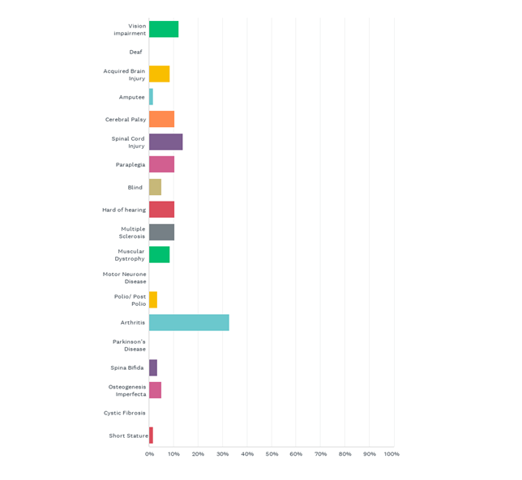
Access this data in table format.

The breakdown of housing types was not unexpected and accords generally with what we know from ABS data on the nationwide housing trends of people with disability.
It is noted that since disability is known to increase with age, a significant proportion of people with disability may have had the capacity to purchase homes prior to the onset of disability, increasing the overall figures of home ownership, but that this experience may not be the case for those who are born with disability, or acquire disability early in their working life.

Q5 What is your current living situation?
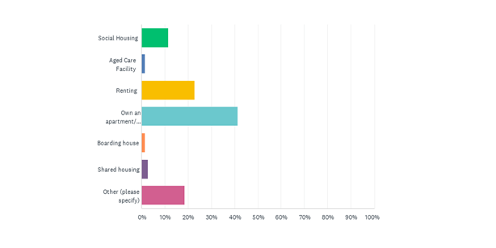
Figure 2: Current Living Situation of People with Disability (PDCN Housing Experience Survey, 2022)
Access this data in table format.
Surveying involved the collection of open and closed answer responses to housing accessibility questions, collecting both qualitative and quantitative results. Methodology data for both the surveys and consultation are included as annexures to this report.
Secondary research included a literature review of associated research within this area, including current practices in housing policy and their linkages to housing for people with disability. Through our research we determined three overarching themes of concern facing people with disability within the housing sector. These themes relate to accessibility/adaptability, choice and inclusion.

Accessibility/adaptability
Most housing in NSW has been constructed with a very narrow view as to who might visit or live there:
‘Most existing Australian housing was designed with an ‘average user’ (a healthy, young, adult male) in mind’ (Burns, 2004; Heylighen, 2008; Imrie, 2003)
For the physical disability community, this has resulted in a lack of homes in which they can comfortably and safely live or visit.
A large proportion of housing stock, including both new and older properties, have been unintentionally built with barriers such as inaccessible bathrooms, steps, and inadequate manoeuvring space for mobility devices such as wheelchairs. Many of these same properties often have constraints in how they can be retrofitted for accessibility, and may be impacted by external factors, for instance, strata bylaws or heritage provisions.
Most people surveyed reported a lack of overall satisfaction in the accessibility of their own home. On a scale of 0-50 where 0 equates to completely satisfied with the accessibility of the home and 50 equates to entirely dissatisfied, the average score across survey participants was 44.
Homeowners were more likely to be satisfied with the accessibility of their home, particularly if they had built the home themselves. Both private and social housing renters were less satisfied with the overall accessibility of their homes.
Many survey participants reported that they were dissatisfied with the overall accessibility of their home despite having modified the property in some way to increase its usability. This indicates potential shortfalls in the current mechanisms utilised to increase housing accessibility on a case-by-case basis.

Common accessibility deficiencies across homes
One of the major deficiencies across homes identified by those we surveyed and interviewed was a lack of level access or ramps. This not only impacts an individual’s capacity to access a property in the first instance but can also affect their capacity to move between sections of the home.
“The most common feature I’ve come across in many brand-new apartments is a small lip/change in level through doorways. What might seem inconvenient, simply makes it impossible to move or transfer equipment and wheelchairs comfortably through doorways. Ramps need to be made [by us] every time we move… eating into funding if available.”
Stairs were consistently reported as a significant challenge. Participants described having to crawl or slide down staircases or be carried by relatives. Another issue presented by stairs is that they can prevent people from bringing assistive technology, like mobility scooters, indoors.

“In 2016 I was moved to a property with 26 stairs and stayed for three years. I just had to stay up there (in the home) or go down the stairs on my backside.“
When I first came home from hospital my son had to carry me upstairs at the front of the house. I wish I could have a ramp for my mobility scooter. Steps mean I can’t get it inside.”

Another major deficit was the lack of accessibility across bathrooms, which impacted the capacity for individuals to toilet and/or shower. Small bathrooms that cannot accommodate assistive technology or more than one person at a time, combined bath/shower arrangements, and showers with hobs were all described as presenting major challenges.

In some cases, this resulted in people having limited options to wash, which was a significant cause of distress and discomfort:
“When I was first diagnosed, I was homeless for the first four years and living on people’s couches… the property was not accessible, and I could not even use the shower, so I only showered once every three months when it became absolutely necessary.”
Lack of space to manoeuvre a wheelchair or other assistive technology throughout the home was also a major issue. This could be due to the narrowness of halls and doorframes, the size of rooms, and the overall design layout. It was not uncommon for people to identify one or more of these specific issues in a single property:
“There are three of us living in a 2-bedroom flat and I live in the loungeroom, so it is very small. My wheelchair only goes into the kitchen. There is a dog-leg corner into the bathroom so showering equipment is limited (a shower trolley would be better, but we can't fit it in) and there is no hoist from the bathroom to the lounge room. I am dressed on a mattress on the floor where I sleep as there is no room for a bed or change table.”
Other design features described as problematic included: driveway widths, positioning of cupboards and light switches, sloping backyards, lack of ceiling hoists, the positioning of door handles and power-points, lower kitchen benches and taps, handles and door locks that are difficult to manipulate.

We note that the most reported problems across all participants were structural in nature, providing little practical capacity to alter the accessibility of these properties without some form of retrofitting, although ramps (including portable ramps) were sometimes seen as an option in the case of smaller flights of stairs.

Relationship between housing accessibility and physical safety
The impact of accessibility on the overall safety of a home was also a theme which came out across our research. Research from Monash University in 2008 indicates that the family home accounts for 62 percent of all falls and slip-based injuries and costs the Australian population $1.8 billion in public health costs.
Many modifications, such as handrails and hob-less showers are sought by people with physical disability to prevent slips and falls, however it became clear that accessible design was also critical to individuals’ capacity and confidence in evacuating premises in the case of emergencies.
This was particularly highlighted in comments by an individual who could ordinarily live independently but was forced to move home due to delayed maintenance of the lift in his apartment block:
“My lift has been broken for two weeks now. I had to evacuate out by crawling down the flight of stairs.”
A lack of level access, both into and within the home, was also identified as a serious safety risk by several participants:
“I previously lived in public housing with only stairs and there was [sic] 47 stairs making it difficult to access my unit. Then I had a fall and housing offered my current accommodation. I took the unit because I wanted to get out of hospital, but it is not fully accessible.”
“[I’ve had] numerous falls due to stairs and steps, sloping walkways and paths, passageways too narrow for walkers etc.”

Experiences of homeowners
Homeowners can be divided into two groups – those who bought an existing home and those who build their own home. People with physical disability who had bought an existing home were more likely to identify deficiencies in their homes, and rate their homes as ‘partially accessible’, as opposed to fully accessible. Homeowners as an overall group however, rated higher satisfaction levels with their homes than those who rented, either privately, or within social housing.

Limits to modifications
Homeowners who bought homes were most likely to have modified their home in some way to increase its accessibility, although the capacity to do this could be limited by a variety of factors. For example: cost of modifications, strata bylaws in apartment blocks, and the structural limitations of the property itself.

Case study:
Andrew owns an apartment in a strata scheme. He has a degenerative condition, and his physical mobility has decreased to the point where he now requires a wheelchair full time. Andrew wants to install a stair lift at his expense in the common foyer, but the strata committee will not permit this. Andrew has pursued this matter through the Administrative Appeals Tribunal and was not successful in getting a resolution. He has determined his only solution is to move elsewhere.

Lack of universal design options in the mainstream housing market
We know that there are several universal design guidelines available across the public market. Despite this, most people who built their own homes with a view to accessibility were not aware of the existence of these guidelines.

Q16 If you have built your own home, were you aware of any existing accessible housing designs that you could use? (These are sometimes referred to as Universal Design, or Livable Housing Design)
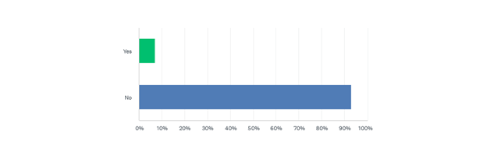
Figure 3: Awareness of accessible housing design (PDCN Housing Experience Survey, 2022)

Access this data in table format.

There may be a lost opportunity here in that at least some people who built their homes ‘bespoke’ reported that, while their homes might have originally been suited to their needs these needs had either changed since the time of building, or had not been anticipated across the original build, requiring further works.

“The process [of building a home] was long but in the end the accommodation was suitable. The problems arose when I had to shift to an electric wheelchair. We quickly realised that the extra dimensions versus a manual [wheelchair] meant passageways in particular were too narrow. Holes and scrapes along the passageway walls are the result. It was also interesting the sharp corners of walls when turning in and out of passageways also caused issues which could be reduced by rounding these types of corners.”
“I have a lot of experience in accessible facilities & included many of these in my home. I regret not having wider doorways.”
“House was designed for a manual wheelchair. I am now in an electric wheelchair and despite the 920cm passageways the holes, scrapes dents and chips in wall plasterwork and doorway timbers testify to the extra width access needed for an electric wheelchair.”
“If I had my current knowledge of the relative sizes of manual verses electric wheelchair, I would have increased the entry, passageways and doors when designing the house. Now it is too late.”

Case study:

April* and Darren* built a home to accommodate their 18-month-old daughter Rosa’s* physical disability needs. They were not aware of any accessible housing designs on the market. They have since found out more information about the extent of Rosa’s condition and her mobility needs and have realised that additional works that were not anticipated will be needed in the future.

Many who had built their own homes rated this process as difficult to somewhat difficult. When asked why this was the case, key themes which arose were a lack of information on how to build accessibly and cost ‘blowouts’ by tradespersons.

We note that universal design is usually built with anticipation of future adaptations, for instance, pre-emptive reinforcement of walls to accommodate future grab rails or staircases that will accommodate a future chair lift if required.

Experiences of private renters
Private tenants were far less likely to have modified their homes, with a number stating that they had tried to negotiate unsuccessfully with their landlord and had been refused. This is in line with current rental laws in NSW which permit landlords to reject substantial modification requests from tenants without grounds for the rejection.
“Landlords of private rentals do not want their home modified to accommodate disability. This means the only options for people needing modified housing is to either buy or try to get social housing. Not good enough.”
Several renters had made temporary (non-fixed) modifications to properties themselves (at their own expense) to try to increase the property’s accessibility:
“I installed [portable] ramps to entry and rear of the home and balconies. As a renter, ramps are basically my only option for modifications.”
Others didn’t consider it worth even asking landlords, and simply accepted that they would live with reduced accessibility across their renting life:
“If I’m renting, I can’t make changes.”

Where reasons were provided by landlords for rejecting modification requests, tenants reported being told that the modifications would ‘damage the premises’ or be ‘visually unattractive’. This was, in many cases irrespective of whether the tenant offered to pay for these modifications themselves or return the premises to its original state at the end of the tenancy.

Rental insecurity as an impediment to modifications

Our research indicates that rental insecurity is a strong disincentive for tenants with physical disability to seek approval for modifications to improve the accessibility of their homes.

This fear is not unreasonable, given the culture of short-term leases in NSW and the capacity for landlords to issue no grounds evictions.

A proportion of renters advised that they would not ask for modifications, as they were concerned that the landlord would evict them.
“In terms of [modifications], I personally would not [ask for them] because you usually don't know your landlord and have no idea how they might respond, but it depends. I bought a shower chair a while ago, so that I can sit down in the bathroom and lean on it if needed to step over the shower frame. It also fits in the shower space if needed. So, the chair has given me the extra help I've needed for the past few months, without asking for mods.”
Although recent changes to the Residential Tenancies Act 2010 (NSW) encouraging longer lease terms might provide greater security for renters, research by Choice, the National Association of Tenants’ Organisations (NATO) and National Shelter in 2017 indicates that the cultural trend towards short term leases within Australia as a whole, is firmly entrenched – with 51% of tenants surveyed having leases of 12 months, with only 6% of renters having leases for even just two years.

The security of tenants is greatly undermined by the existence of so called no grounds eviction clauses under NSW tenancy legislation. No grounds evictions are mostly unknown across other OECD countries and permit landlords to potentially evict tenants with as little as 30 days notice without the need to specify a particular ground or demonstrate breach of the agreement.

Where alternative housing options are limited, the physical process of moving has additional complications and proximity to support services is vital, the fear of termination appears very palpable in the minds of the renters with physical disability who participated in our survey.

“As there is no such thing as a permanent rental, moving means having to pack up every few years and move and negotiate stairs. This is impossible to do if you’re older and carrying disabilities particularly arthritis.”

Case study:
Jan* rents a townhouse and uses a wheelchair full time. She had to search extensively to find the townhouse – it was the most accessible property she could find in her regional town, even so, half of the property is inaccessible to her. Jan now needs a ceiling hoist since she can no longer transfer herself (i.e.: from bed to wheelchair). She has been approved for NDIS funding for the hoist but needs approval from the landlord and body corporate as well.
Jan is reluctant to raise the issue because she knows that the landlord will most likely refuse to grant permission for the hoist. Jan is also aware that the landlord can refuse to renew her lease.
Threat of rent increases as an impediment to modifications
Rent increases are also seen as a disincentive to request modifications, particularly if the modifications require some outlay by the landlord.

Even if landlords were not looking to financially recoup their own outlays, there was at least one example of a landlord using accessibility modifications in a common area as an opportunity to ‘rebrand’ an apartment complex as ‘accessible’ and subsequently increase the rent for all tenants.

We were concerned by what we observed as landlords ‘cherry picking’ modifications (paid for by the tenant) that they considered added value to the property while rejecting those they considered would negatively affect marketability.
“We asked the landlord to let us install a ramp to access the flats from the street and a ceiling hoist between rooms inside the unit [at our expense] … [the landlord] rejected the hoist but let us build the ramp. Then [the landlord] started advertising the block as accessible – no benefit to us as they put up the rent per week.”
Housing affordability is a significant issue for many people with lived experience of disability, with 38% of households consisting of at least one person with disability, identifying as low-income verses 18% of households without a person with disability.

Our research demonstrates that people with physical disability will make decisions around what level of inaccessibility they can tolerate to be able to maintain a tenancy at an affordable rate.

The reluctance to request modifications and a propensity to ‘making do’ to avoid a negative response from the landlord, indicates that the rates of inaccessibly of rental properties as reported to landlords, or otherwise documented, is likely to be significantly underreported.

Social housing tenants
For people with physical disability on low incomes, social housing is often viewed as an attractive housing option, since rents are capped as a proportion of household income, and tenure is generally secure.
An additional advantage, while not specifically expressed, is that social housing providers, in general build to universal design standards and accept responsibility - to an extent - for improving the accessibility of properties, if necessary, eliminating the cost burden of modifications for tenants.
NSW Land and Housing Corporation (LAHC), for instance, is required to modify properties to accommodate the needs of tenants with disability to a certain cost, and if this is not possible within the context of a certain property, relocate the tenant to a more suitable home.
Despite policies expressly obligating social housing providers to provide properties that meet a tenants’ disability related needs, social housing providers do not represent their housing as being specific to those with disability – LAHC expressly states in its modification policy that it is not a disability housing provider.
Our research indicates that this distinction may not be clear in the minds of those with physical disability, or that a lack of affordable, accessible housing options for low-income people with physical disability has resulted in tenants otherwise considering social housing to be the best (i.e., affordable, and accessible) housing option for them.
“As private rentals do not want to have their home modified to accommodate disability, the only options for people needing modified housing are to either buy or try to get social housing. Not good enough.”
Social housing provides a more appropriate option for many people with lived experience of physical disability because newer social housing is more likely to be built to universal design specifications. Currently 41% of households in social housing contain at least one family member with disability.

LAHC, as an example, has for some time, committed to building new properties to Silver Level Livable Housing Design standards, which incorporates design features that benefit many people with physical mobility limitations.

Wait times to access social housing though, particularly in high demand areas, with good public infrastructure are significant – ten years plus in some instances. There are currently 44,127 applicants waiting for social housing on the NSW Housing General Register, and a further 5801 applicants on the Priority Housing Register.

“Very limited housing options. If you are newly injured or have a disability and are looking for housing, the only options you really have are social and community housing, however waitlists are a huge issue.”

The NSW Government’s 2021-22 Intergenerational Report has predicted that an additional 68,000 NSW families will need social housing by 2061, meaning without significant investment, waiting lists will more than double. Despite this, to date, the NSW government has only committed to 9,386 new social housing dwellings by 2026.

People with physical disability are not always specifically prioritised for social housing, and will often need to live in areas that are serviced by public transport and are near hospitals and other services – those areas where wait times are often highest.
“I spent six years on the high priority waitlist and did not get one offer.”
“I was on the high priority social housing list for 10 years in a major regional location & never offered any accommodation.”
Several survey participants able to secure a social housing property indicated that they were satisfied with the overall level of amenity of their home:
“[My home is] on the first floor (not higher) and there is a lift which is maintained properly. There are bus stops close by. Accessible stations are a 20min ride. There is a closer station which will be upgraded but hasn't yet. Inside, it's bigger than our previous studio. The bathroom and kitchen are manageable.”
Despite this, most survey participants who were social housing tenants still identified as living in a property that was poorly suited to their needs, with 23% rating their property as partially suitable and 46% of respondents rating their property as being not at all suitable.

Our data suggests that this was primarily due to extended delays in realising requested modifications and extended wait-times to be relocated when this was determined to be the most viable option by the Corporation.
“I have resided in social housing since 2007. During this time, I have been relocated from a villa to stand alone house and now to an over 55's complex with Minister’s approval due to my changing physical disability and housing needs along with limited housing options available. The relocations are as a direct result of my changing family requirements and physical condition. My two children are now adults and left home and my medical condition and changing physical needs has deteriorated and the housing provided has become unsafe and unsuitable for my needs in a wheelchair.”
The process of formally requesting modifications for premises and evidentiary requirements such as occupational therapist reports were all viewed as impediments to realising home modifications and the process was generally viewed as difficult.
“I have been waiting for two years to have my front home to be modified with ramps so I can regain my independence.”

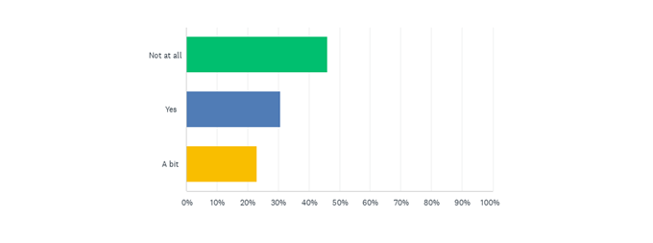
Q8 If you currently live in social housing, does your property meet your accessibility needs?
Figure 4: Social Housing Survey (PDCN, 2021)
Access this data in table format.

For example, for minor modifications such as doorbell installations and toilet seat replacement, the NSW Land and Housing Authority requires a letter of recommendation from a relevant health professional to be written and submitted and for major modifications such as grab rail installation and alterations of door frames, an Occupational Therapist (OT) report and OT summary report is required. The OT must be assigned by LAHC who will only do so after receiving a GP referral.

In the case where a decision was made to transfer a tenant, as opposed to modifying the property, one tenant detailed their experience of having to wait years for an appropriate property to become available.

Case study:
Alice* suffers with inflammatory arthritis and finds getting around to be difficult and painful. A few years ago, Alice was moved into a property with 26 stairs, where she had to stay for three years due to a lack of other options. For most of the three years Alice felt stuck and isolated upstairs. If necessary, she would have to shuffle up and down the stairs on her backside.
Our research indicates that people with disability in social housing properties that are not suitable, often lack the option to exit social housing.

While one respondent advised that they had left social housing and bought a home, many others indicated that while they had considered other housing options, including Specialist Disability Accommodation, they either faced extended waitlists to move out of social housing, were not eligible for these alternative forms of accommodation, or otherwise lacked the resources (e.g. finances or family support) to live elsewhere.

Retrofitting costs as an impediment to modifications across all property types
Where modifications were able to be realised to improve the accessibility of a home, the costs associated with retrofitting was often a barrier to realising them, and the amount of people achieving modifications through NDIS or Aged Care funding was significantly lower than expected.

Research indicates that retrofitting is considerably more expensive than building with accessibility in mind in the first instance, with estimated costs being up to 22% times more efficient at the time of build.

Several people who had renovated their properties spoke to the high costs associated, with examples where people had modified parts of their homes but had been unable to afford other modifications or had modified parts of their homes to meet their needs at a set point in time, but then had to modify further as their accessibility needs increased.
Impediments to realising home modifications via the NDIS
While NDIS participants may be eligible for home modification funding through their plans, this only accounts for a small proportion of the overall physical disability community. As an indicator, there are currently approximately 534,655 NDIS participants nationwide, inclusive of all types of disability, compared to approximately or 1,056,440 individuals with physical disability in NSW alone.
Similarly, accessing capital funds for home modifications is predicated on being able to establish a need for the specific modification (including the provision of expert medical documentation), and meeting criteria set by the NDIA including amongst, other matters, that the home modification being considered represents value for money in that the costs of the support are reasonable relative to both the benefits achieved and the cost of alternative support.
Home modifications are a large part of the NDIS’s services and unfortunately have come to be known as a complex, frustrating and lengthy process. The NDIS will only permit ‘NDIS approved’ occupational therapists, of which there are very few, to assess an individual’s modification request. This complication makes the process extremely drawn-out, confusing, and unpredictable.
“I had to wait three months for a NDIS approved Occupational Therapist to complete their assessment before I could even begin the modification paperwork. It’s not a fast thing.”
Realising home modifications via Commonwealth Home Support Packages
People who receive Commonwealth Home Support Packages (Aged Care Packages) are similarly restricted. Packages are capped, and even if an individual has capacity within their budget to accommodate home modifications, achieving them can be difficult. Again, the problem appears to be that process is labour intensive and requires extensive documentary evidence.
It was found through our survey that of the 65% of people who had modified their properties 49% of respondents used their own savings to make modifications to their homes, despite 71% of respondents having either a NDIS plan or an Aged Care Package. Whilst not the specific focus of our research, we received evidence to suggest that long approval times and ‘red tape’ were a disincentive to relying on available NDIS funds to realise modifications:
“Everything that is for disability is extremely expensive. If NDIS is helping with costs, it takes a long time to a get approval, even longer for quotes to be approved and then the work to commence.”
Where people did modify their homes, the most common retrofits included modifying bathrooms (54%), adding grab rails (57%) and the installation of ramps (38%). Less common modifications included the installation of electronic opening doors, the widening of doorways, modifying of bedrooms, widening of hallways and the installation of ceiling hoists.

Modifications on an as needed basis, like building a home without accessibility guidelines, may cause issues later when an individual’s accessibility needs change over time, and may not be cost-effective overall. We note that government funded schemes for home modifications focus on ‘point-in-time’ assessments of a person’s functional capacity, whereas a more considered approach could be to modify to universal design standards in the first instance, and where possible, to be able to pre-emptively plan for a decline in an individual’s functional capacity.

Q12 If you have made accessibility modifications to a property, what modifications did you make? (Choose ALL that may apply)
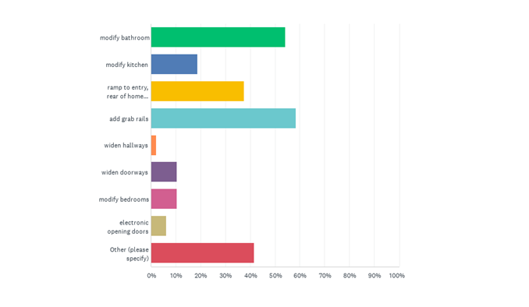
Figure 5: Accessibility modifications made to homes (PDCN Housing Experience Survey, 2022)
Access this data in table format.
Modifications allow for improved safety within the home and increases the ability for an individual to remain independent without having to relocate. It was clear from our research that people with disability were keen to live as independently as possible within their homes, and where they were able to, had invested significant time, effort, and personal resources into trying to realise this. The consequences of a lack of choices and options will be explored in more detail below.

Choice

Prior research has indicated that there is a lack of affordable choices in homes for people with physical disability in the Australian housing market, and our data further supports this conclusion.
“Finding a home that is accessible or able to be made accessible is like looking for a needle in a haystack.”
“I have been disabled for approximately seven years now and during this whole time it has been near impossible to find and maintain secure, safe, affordable, and accessible properties in the private rental market.”
“Landlords of private rentals do not want their home modified to accommodate disability. This means the only options for people needing modified housing is to either buy or try to get social housing. Not good enough”
Regardless of whether they rent or buy, people with disability can spend months looking for a property that suits their accessibility and affordability requirements and are often forced to ultimately compromise on elements of comfort, utility, proximity and/or safety.

Lack of transparency across property listings
For the 42% of people with disability in Australia who live in a private rental property, a significant issue is how the real estate industry markets rental properties. Currently, most property listings lack transparency around accessibility features and make it impossible for a potential applicant with physical disability to know if they will even be able to access the property.
People with disability described travelling long distances for an open house viewing, only to realise they could not access the listed property. A number stated that they wished that there were specific listings for accessible properties, or that online property sites had search options for accessible design features, like step-free entry ways and ground floor bedrooms.
“I should be able to go into a real estate agency and look at their list of available accessible homes.”
“When real estates [sic] list rental homes on websites there needs to be a way for people to easily check if it is accessible, or if the property at least has minimum accessibility standards.”

Perceptions of prejudice across the real estate industry
A few individuals living with physical disability described feeling like they will be overlooked as potential applicants when applying for properties due to real estate agency assumption that they will be ‘difficult clients’ with complex modification requests.
“Modification needs are associated with physical disability — putting us in the ‘too hard’ basket.”
“Finding a rental anywhere is too difficult. As soon as you mentioned the additional access you need like handrails, people do not even want to look at you.”
Individuals were reluctant to disclose disabilities, or to call property agents to find out about the accessibility of specific properties for fear that this would somehow limit their chances of securing a desired property. It is outside the scope of this report to examine the credibility of these views, but we can imagine that such beliefs would compound the anxieties people with physical disability already experience about potentially being evicted from rental properties and having to find alternative accommodation.

Affordability as a significant issue
It comes as no surprise that one of the biggest barriers to accessible housing is affordability. While many people know their access needs and are capable of independence, the cost of modifications of homes or finding a home that is suitable for their needs is a process that many are unable to afford.
Adults under the age of 65 with disability are less likely to work, with 48% employed compared to 80% of those without disability and are more likely to be dependent on income support as their primary source of income at 56% compared to 13% for those without disability. The flow on effect is that people with disability as a cohort are less likely to be homeowners (55% of people with disability under 65 owning their own home verses 61% of people without disability) and more likely to have financial constraints when trying to find suitable rental options within the private rental market, which limits already reduced options:
“In several weeks of searching [for a rental property] …. not one of the properties we saw was suitable for someone with a power chair and no walking ability at all, in that we didn't see any [properties] that were ground floor with flat access. In the price range we looked at, first floor with a lift and good stairs was the best we found. Only one listing mentioned disability access - to say there was none.”

Compromising on independence for affordability and in-home support
For many, the compromise on affordability and accessibility was living independently. People with disability and their families reported having settle for living in group homes or with family for the foreseeable future despite a keen desire to live independently:
“What he was offered was a three person share house, which [because] he's always lived by himself with [...] significant supports, [...] he was saying that he doesn't feel safe living with other people. It's not his choice.” - PDCN member, parent of adult son with physical disability.
“I found it hard finding a place to rent [in Sydney] and difficult getting around on public transportation. I didn’t last long in Sydney, only six months. I had to go back to my parents’ accessible home in regional Australia and study online.”
This was a particular issue for younger people with physical disability, who saw a lack of housing options as a major barrier to establishing independent adult lives. At its most extreme, a lack of accessible housing options was observed to give younger people with disability no choice but to live in aged care facilities:
“I lived in aged care for 10 years (all my 40s) before I found a wheelchair accessible SDA property 6 years ago”’
We note that at the time of drafting this report, there were 130 people under 45 years of age living in residential aged care nation-wide. Of the states and territories, NSW has the highest percentage of younger people living in aged care, at 34% (44 people).
Many people we surveyed who bought existing homes or rented had compromised on the accessibility of their homes in one way or another, settling on properties, in the short term, that only partially met their accessibility requirements to avoid homelessness or a loss of independence. Cost constraints were often also a significant factor in settling for a particular property, as was proximity to services and supports.

Low rates of income support as a barrier to accessible housing for people with physical disability
Constrained incomes significantly impact people with physical disability, limiting both the range of properties they can choose from and the extent to which they can modify properties if they don’t already suit their needs.
“Not enough access to social housing/ affordable housing for me [and other] people with disabilities. I rent but only with the assistance of family financial support.”
This is particularly the case for people with disability who rely on income support (either Disability Support Pension or JobSeeker) as their primary source of income.
Currently, the maximum basic rate for the DSP for a single independent over the age of 21 years is $987.60 per fortnight and the rate for JobSeeker Payment is $642.70 per fortnight. The mean price of residential homes in NSW in 2022 is $1,207,200, while the median weekly rent is $516.
Both payments effectively lock people out of the rapidly rising housing market as buyers, while at the same time greatly restrain their options in the rental market.
This is confirmed in Anglicare’s Rental Affordability Snapshot conducted in April 2022, which indicates that a single person on the Disability Support Pension could afford just 51, or 0.1 percent, of the 45,992 properties reviewed nationally, and only eight properties were affordable for a single person on Job Seeker - all rooms in share houses.
It was noted that the Snapshot does not measure accessibility or modifications, and that options may in fact be less for those with specific accessibility requirements.

Moving to find a more accessible home
It became apparent that renters would continue to look for more appropriate housing, moving to places that better met their existing requirements as they found them, or as their accessibility needs changed.
In the case of social housing tenants, several tenants spoke of being “on the wait list’ for transfer to a more accessible property or Specialist Disability Accommodation (SDA). 47% of our survey respondents reported having to move home at least once due to accessibility issues, 22% had moved between two and five times, just under 10% had moved six to ten times and 5% stated they had moved more than ten times on account of accessibility issues.

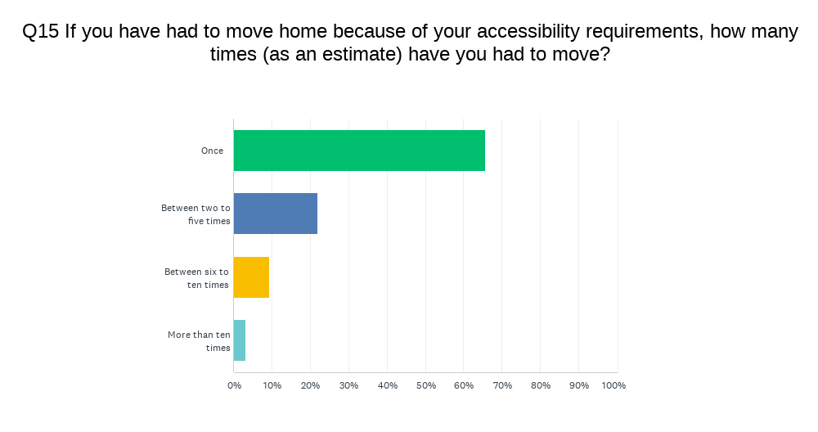
Q15 If you have had to move home because of your accessibility requirements, how many times (as an estimate) have you had to move?
Figure 6: Moving home for access purposes (PDCN Housing Experience Survey, 2022)
Access this data in table format.

Is Specialist Disability Accommodation (SDA) a viable alternative option?
Specialist Disability Accommodation (SDA) is designed to provide accommodation for people with disability with high and complex disability support needs.
As of November 2020, there were 440 SDA places estimated to be in development in NSW, with 31.2% of developments being delivered by the community housing sector. At the same time, there was an undersupply, based on estimated existing supply and SDA supply in development of close to 2000 properties.
Although Specialist Disability Accommodation addresses a gap in society, it is a costly support that is only provided to a small number of NDIS participants. Because of this, the rules NDIS use to determine a participant’s eligibility are rigorously applied - and very few meet the criteria.
“I was told that I wasn't eligible for SDA because despite being a complete quadriplegic, I am too independent. I do my own personal care, I go to work, but I need significant access and that's not enough to be eligible for SDA. SDA’s are purpose built for people with high needs but it is not for everyone with a disability. It is only for a category of people with disabilities who do need it.”
“The NDIA has Specialist Disability Accommodation, but you still have to wait for one that suits your access needs and often the building may suit but the location may not.”

Retirement Villages and Residential Aged Care

Retirement villages have long been promoted as a downsizing housing option for people as they age. Retirement villages are a niche form of housing requiring residents to be over a certain age (usually 55 years). There are usually different options for care in retirement villages, including:
- self-contained accommodation, for people who can live independently
- serviced (or assisted living), which includes meals, cleaning, and other services
- a mix of self-contained and serviced, allowing people to change if they need to.

While retirement villages are an option for some, it should be acknowledged that for many there can be significant disadvantages to living in these types of segregated accommodation settings.

The process of getting into a retirement village can be complex and there are often fees and charges for common facilities as well as village rules. The same housing options, such as extra bedrooms for family to stay, multiple car spaces and private garden space, may not be offered.

People may have already invested significant amounts in their own homes to increase accessibility and may be reluctant to move from their immediate neighbourhoods and lose the freedom and independence that comes from living in their own homes within the broader community. It is interesting to note that despite close to 70% of our survey participants being over the age of 50, only 2% of total participants reported living in a retirement village, which accords with a study of community attitudes for the Royal Commission into Aged Care, Quality and Safety which found that an overwhelming number expressed a desire across all generations to age in place and live in their own homes independently for as long as possible.
“If I could stay in my own home, I would, because it would be safe there. It’d be scary moving out after 30 years.”
“Probably when I was in my sixties, I thought about the stairs here, I’ve lived here for 47 years … and I haven’t got a walk-in shower, and I’ve tried to get that put in, but they won’t do it … the only thing they’ll do is a different location and I think that’ll kill me.”
Moving into residential aged care, for those we surveyed was viewed as a last case scenario associated with a loss of independence and control. This is again in line with findings of the Royal Commission into Aged Care Quality and Safety:
“People do not usually enter residential aged care willingly. They often do so with great trepidation. They fear loss of autonomy, of individuality, of control over their own lives. They fear ceasing to be a person with distinct needs and preferences, with an emotional and intellectual life and freedom to do what they want, when they want to do it.”
Only 1% of our survey participants identified as living in residential aged care. In addition to the reduction in independence, it is noted that the costs associated with residential aged care may also be viewed as a deterrent. Residents can face basic daily fees of up to $54.69 per day, or $19,961.85 a year and these costs may be further increased by additional paid care and services that might be offered for residents. For those who own their own homes, the transition into residential aged care often results in the sale of the family home.

While we support retirement villages and residential aged care as housing options, we believe they fall short as a primary solution to addressing housing accessibility, in that they do not accord with Article 19 of the UNCRPD. While these forms of housing are arguably in the community, strictures imposed under these for instance, age restrictions and an inability to accommodate intergenerational households, do not afford people with disabilities true choice and control of where or with whom they live in line with the full scope of Article 19 of the UNCRPD:
Both independent living and being included in the community [specific to Article 19] refer to life settings outside residential institutions of all kinds. It is not “just” about living in a particular building or setting; it is, first and foremost, about not losing personal choice and autonomy as a result of the imposition of certain life and living arrangements.
Neither large-scale institutions with more than a hundred residents nor smaller group homes with five to eight individuals, nor even individual homes can be called independent living arrangements if they have other defining elements of institutions or institutionalization.
Although institutionalized settings can differ in size, name and set-up, there are certain defining elements, such as obligatory sharing of assistants with others and no or limited influence over whom one has to accept assistance from; isolation and segregation from independent life within the community; lack of control over day-to-day decisions; lack of choice over whom to live with; rigidity of routine irrespective of personal will and preferences; identical activities in the same place for a group of persons under a certain authority; a paternalistic approach in service provision; supervision of living arrangements; and usually also a disproportion in the number of persons with disabilities living in the same environment.

It would be more appropriate that these forms of accommodation form two of a range of housing options across the NSW housing market, catering to the diverse needs and preferences of people with physical disability and their families.

Inclusion

People with physical disabilities want homes that support their involvement in the community. Many people who participated in our research were distressed at the direct impact of housing accessibility on their capacity to live active and involved lives as members of their communities. At the worst extremes, peoples’ homes effectively kept them isolated and dependent on others, with palpable negative flow on effects across their health and wellbeing.
“I have been unable to shower for 7 years, no access to community, bed bound because house won’t accommodate wheelchair.”
“In 2016 I was moved to a property with 26 stairs and stayed for three years. I just had to stay up there (in the home) or go down the stairs on my backside.“
Where housing was accessible, it was clear that people with physical disability had much greater levels of independence, and enjoyed their homes significantly more:
“The installation of ramps into and within my house was a great boon. This allowed me to go outside for the first time in a long time.”
“I am extremely glad that I moved from a two-storey house to a retirement village when I was 75.”
It was also apparent that the benefits of accessibility improvements could be realised by different household members at different times:
“The changes to my house were made for my deceased husband, now I am benefitting from it.”

Visiting the homes of others

An estimated 90% of homes will be visited by a person with a disability or injury yet many homes remain at a standard of accessibility that will not allow for the equitable comfort of these visitors. A significant number of people we surveyed and interviewed described the challenges they regularly experienced when trying to visit others and the effects that this had on their social lives:
‘’I lead a very social life, we have barbeques and such, but we [my wife and I] never get invited anywhere because our friend’s houses aren’t accessible for me. It’s not just affecting me, it affects [my wife’s] socialising too.”
“I can’t visit my grandfather because of a steep driveway and stairs. I visit my aunty but generally stay in the backyard as the house is relatively inaccessible.”
“Family & friends do not have accessible homes. There is a lack of understanding from family regarding installing a simple rail in the bathroom to allow a disabled persons to use the bathroom”

When people with disability do visit the homes of others that are not accessible this is often an undignified experience:
“Some of my friends are quite strong, they can lift my chair up a bit and drag me in the house” - PDCN member, full time wheelchair user
“Occasionally when I do go out, I have to be carried up the stairs”
The challenges that participants experience in going to others’ homes were a stated reason as to why a number choose to not attend social gatherings or go out often:
“I don’t really go out that much. I can usually get into a toilet, but I can’t close the door behind me, so I just have to leave the door open”
This is supported by data from the Australian Bureau of Statistics (2018) which found the most avoided situation for people with disability because of their disability was visiting family and friends, at 39.2%.
Multiple studies have found that loneliness has been linked to poor physical and mental health and an overall dissatisfaction with life. The information we have received across our research indicates a direct correlation between housing accessibility and loneliness and the potential for poorer physical and mental health outcomes for people who are impacted by limited accessible housing options warrants further investigation.
What is clear is that housing accessibility is more than just an issue faced by people with disability, it also affects friends and families – when most homes are unsuitable and inaccessible, everyone suffers the consequences.

Where to from here?
“I have suffered terribly since becoming disabled and every system has failed me”
We believe that this report is the tip of the proverbial iceberg, and more research can be done to understand the full extent to which the NSW housing market does not meet the needs of people with physical disability and their families.

Notwithstanding this, the report provides evidence of significant gaps in existing state and federal government strategies to address the housing needs of the physical disability community, which warrants urgent intervention if NSW is to meet its domestic and international human rights commitments.

There are several key takeaways from our research:

- There is a serious shortage of accessible housing options for people with physical disabilities across the NSW housing market regardless of whether it is properties to rent or own;
- Specialised housing options such as social housing, SDA, retirement villages and residential aged care are neither preferable nor viable options for many in the physical disability community;
- Home modifications are not a satisfactory response to the shortage of accessible homes, and cannot be universally realised for all who require them across the physical disability community;
- There is a lack of clear guidance for those looking to build their own homes on how to build these homes accessibly, in line with universal design best practice;
- Renters in the private market have the least options in terms of realising modifications to their homes, which is exacerbated by weak tenancy laws around evictions, modifications and rent increases; and
- The lack of housing accessibility is felt not only in the homes that people with disability live in, but also in the homes that their friends and family that they struggle to visit.
Our research suggests that there are a number of steps the NSW Government could take in the short term to improve housing options for people with physical disability and their families.
Implement the minimum accessibility standards in the National Construction Code at a state level across all new home builds.
The newest version of the National Construction Code, set to take effect from 1st May 2023, includes mandated minimum accessibility provisions in line with Silver Level Livable Housing Design. Five out of seven states and territories have committed to applying the NCC accessibility provisions at state level over the next few years.
Silver Level Livable Design includes seven core design elements:
  - A safe continuous and step free path of travel from the street entrance and / or parking area to a dwelling entrance that is level;
  - At least one, level (step-free) entrance into the dwelling;
  - Internal doors and corridors that facilitate comfortable and unimpeded movement between spaces;
  - A toilet on the ground (or entry) level that provides easy access;
  - A bathroom that contains a hob-less shower recess;
  - Reinforced walls around the toilet, shower, and bath to support the safe installation of grab rails at a later date;
  - Stairways are designed to reduce the likelihood of injury and also enable future adaptation.
Incorporating these design features into new homes would address many of the accessibility concerns expressed across our research and increases the number of accessible homes to both rent and buy. Our research indicates that for many people with physical disability, silver level accessibility would be sufficient to address their accessibility needs. For those with additional accessibility requirements, silver level accessibility would facilitate easier and more cost-effective upgrades.
Build more social housing to at least Silver Level+, with at least 25% to Gold Level Livable Design; increase existing supports for community housing providers to encourage expansion of the community housing sector

Our research shows that rental affordability is felt particularly hard across the physical disability community, who are significantly more likely to depend on income support as a primary form of income. Over past years, there have been consistent calls for the NSW Government to commit to building 5000 new social housing properties for the next ten years to meet current and future supply shortages. We understand that current investment levels are approximately 700 homes a year. Such a commitment would substantially benefit people with physical disability who cannot afford rents in the private rental market.
Building social housing to Silver Level+ is the most cost-efficient way to construct these properties, incorporating a base level of accessibility plus a ground floor bedroom, which is difficult to otherwise achieve via retrofit. While Silver Level would facilitate quicker and cheaper upgrades, having a proportion of social housing stock already built to the next level of Livable Design Accessibility – Gold Level – would ensure that people with more significant accessibility needs could either be allocated these homes in the first instance, or be transferred to this stock as a potential alternative to retrofitting their property.
Gold Level Accessibility incorporates a further five design features:
- Kitchen space is designed to support ease of movement between fixed benches and to support easy adaption;
- The laundry space is designed to support ease of movement between fixed benches and to support easy adaption;
- There is a space on the ground (or entry) level that can be used as a bedroom;
- Light switches and powerpoints are located at heights that are easy to reach for all occupants;
- Home occupants are able to easily and independently open and close doors and safely use tap hardware.
Our suggestion of 25% of homes is based on data that indicates that 1 in 4 families in social housing in NSW currently have at least one family member with disability.
At the same time, the community housing sector could play a key role in bridging the gap for
Reform existing tenancy laws to provide tenants with disability with the prima facie right to modify their rental property to meet their accessibility requirements
Tenants with physical disabilities should be able to request accessibility modifications to their properties that enhance the accessibility of the property and be guaranteed that a landlord cannot unreasonably refuse their request. Reasonable grounds for refusing a request could include that there are existing planning laws that prohibit the type of modification being requested, or that that tenant has not provided sufficient assurance that they will be utilising suitably qualified tradespersons. Tenants could be required to return properties to the state that they were prior to the modification on vacating the premises.

Reform existing tenancy laws to remove no ground evictions
Our research shows that many tenants with physical disabilities don’t request modifications to their rental properties for fear that they might receive a no-grounds eviction. To be able to realise home modifications (including home modifications via the NDIS and Commonwealth Home Support Packages) tenants need to feel that they are not putting their tenancy at risk in asking for them.
Reform existing tenancy laws to prevent unsubstantiated rent increases
Rent increases are another impediment to seeking accessibility modifications to rental properties, particularly for renters with physical disability living on modest incomes. The Residential Tenancies Act 2010 should be amended to provide tighter stipulations on when a landlord can increase the rent, and by how much. Rent increases across any one year should not exceed CPI.
Modify NSW strata laws to prevent body corporates from refusing disability-related accessibility modifications
Our research suggests there is a legal gap which allows body corporates to refuse accessibility related modifications in strata properties including common areas. Body corporates should be prohibited from refusing accessibility modifications to properties that enhance the accessibility of a specific lot or shared common areas, unless the body corporate can demonstrate reasonable grounds for denying the request, again for example, if the request is in contravention of planning laws.

Final comments
Our research indicates that people with physical disability want the choice to live in their local communities and to age in place with their friends and families, and most will never meet the criteria to be eligible for specialist disability accommodation.
The NSW Government has a significant part to play in meeting Australia’s housing commitments to people with physical disability under the UNCRPD. Current mechanisms for addressing the housing needs of those with physical disability in NSW are not meeting the needs of our membership.
Regulating minimum accessibility standards across all NSW home builds would facilitate an increase in housing that could meet many of our members’ immediate housing needs, as well as being readily modifiable for those with additional accessibility requirements.
At the same time, giving people with disability greater rights and protections to realise accessibility modifications across existing housing stock, in particular rental properties and homes within strata schemes, would greatly enhance the capacity for people with disability to live safely and independently as part of the broader community.

Index of Tables

Table 1: Nature of disability (PDCN Housing Experience Survey, 2022)
Question: Nature of Disability (Tick all that may apply)

Answer Choices | Responses
Vision impairment | 12.07%
Deaf | 0.00%
Acquired Brain Injury | 8.62%
Amputee | 1.72%
Cerebral Palsy | 10.34%
Spinal Cord Injury | 13.79%
Paraplegia | 10.34%
Blind | 5.17%
Hard of hearing | 10.34%
Multiple Sclerosis | 10.34%
Muscular Dystrophy | 8.62%
Motor Neurone Disease | 0.00%
Polio/ Post Polio | 3.45%
Arthritis | 32.76%
Parkinson's Disease | 0.00%
Spina Bifida | 3.45%
Osteogenesis Imperfecta | 5.17%
Cystic Fibrosis | 0.00%
Short Stature | 1.72%
Other (please specify) | 44.8%

Return to graph on page 11.

Table 2: Current living situation of people with disability (PDCN Housing Experience Survey, 2022)
Question: What is your current living situation?

Answer Choices | Responses
Social Housing | 11.43%
Aged Care Facility | 1.43%
Renting | 22.86%
Own an apartment/ house | 41.43%
Boarding house | 1.43%
Shared housing | 2.86%
Other (please specify) | 18.57%

Return to graph on page 12.

Table 3: Awareness of accessible housing design (PDCN Housing Experience Survey, 2022)

Question: If you have built your own home, were you aware of any existing
accessible housing design that you could use?

Answer Choices | Responses
Yes | 7.14%
No | 92.86%

Return to graph on page 16.

Table 4: Social housing survey (PDCN, 2021)
Question: If you currently live in social housing, does your property meet
your accessibility needs?

Answer Choices | Responses
Not at all | 46.15%
Yes | 30.77%
A bit | 23.08%

Return to graph on page 22.

Table 5: Accessibility modifications made to homes (PDCN Housing Experience Survey, 2022)
Question: If you have made any modifications to a property, what modifications did you make? (Choose all that apply)

Answer Choices | Responses
modify bathroom | 54.17%
modify kitchen | 18.75%
ramp to entry, rear of home or balconies | 37.50%
add grab rails | 58.33%
widen hallways | 2.08%
widen doorways | 10.42%
modify bedrooms | 10.42%
electronic opening doors | 6.25%
Other (please specify) | 41.67%

Return to graph on page 24.

Table 6: Moving for accessibility reasons (PDCN Housing Experience Survey, 2022)
Question: If you have had to move home because of your accessibility requirements, how many times (as an estimate) have you had to move?

Answer Choices | Responses
Once | 65.63%
Between two to five times | 21.88%
Between six to ten times | 9.38%
More than ten times | 3.13%

Return to graph on page 28.

Australian Institute of Health and Welfare, Older Australians, web report, last updated 30 November 2021 < Older Australians, Demographic profile - Australian Institute of Health and Welfare (aihw.gov.au)> accessed 5 July 2022.
Ibid.
Australian Building and Construction Board, National Construction Code <National Construction Code | NCC (abcb.gov.au)> accessed 16 August 2022
Australian Institute of Health and Wellbeing (AIHW), The definition and prevalence of physical disability in Australia, 16 July 1999 <The definition and prevalence of physical disability in Australia, Summary - Australian Institute of Health and Welfare (aihw.gov.au)> accessed 2 September 2022
Australian Bureau of Statistics, New South Wales, Census 2021 Quick Stats <2021 New South Wales, Census All persons QuickStats | Australian Bureau of Statistics (abs.gov.au)> accessed 26 August 2022
United Nations, Convention on the Rights of People with Disability < Convention on the Rights of Persons with Disabilities (CRPD) | United Nations Enable> Art. 19, accessed 16 August 2022
Australian Government, Disability Gateway, Roadmap - Australia’s Disability Strategy 2021-2033, updated 3 February 2022 <Roadmap – Australia’s Disability Strategy 2021–2031 | Disability Gateway> accessed 6 July 2022.
NSW Government, State Environmental Planning Policy (Seniors Living) 2004 (NSW), Ch 1, s. 2.
NSW Government, NSW Planning Portal, Local Housing Strategies Tracker <Local Housing Strategies Tracker | Planning Portal - Department of Planning and Environment (nsw.gov.au) accessed 7 July 2022.
Carmenella and Bridge
Monash (2008)
From LHA guidelines - Monash University Accident Research Centre. (2008) The relationship between slips, trips and falls and the design and construction of buildings. (Funded by the Australian Building Codes Board). 3 New Zealand Ministry of Social Development. (2009) Economic effects of uti
We note that the Standard Form Residential Tenancy Agreement now allows for the selection of a lease term up to 5 years and a further fillable option for longer term leases as agreed - https://www.fairtrading.nsw.gov.au/__data/assets/pdf_file/0007/608380/Standard-Residential-Tenancy-Agreement.pdf.
APO (2017), Unsettled: Life in Australia’s private rental market, p.8 <https://apo.org.au/sites/default/files/resource-files/2017-02/apo-nid73768.pdf>
Kollmorgen. A (2014), ‘Rental Rights’, Choice, 22 August 2014, accessed 1 September 2022 <https://www.choice.com.au/money/property/renting/articles/rental-rights>
Australian Institute of Health and Welfare (2022), ‘Income and finance’, People with disability in Australia 2022, Australian Government <https://www.aihw.gov.au/reports/disability/people-with-disability-in-australia/contents/income-and-finance/income>
Expected waiting times | Family & Community Services (nsw.gov.au)
‘We Can’t Wait’: new campaign to end housing limbo for 50,000 families, n.d. https://communityhousing.org.au/media-releases/we-cant-wait-new-campaign-to-end-housing-limbo-for-50000-families/
Barnes, E., Writer, T., Hartley, C. (2021). Social housing in New South Wales: Contemporary analysis (Report No. 1). Centre for Social Impact. https://www.csi.edu.au/media/uploads/social_housing_in_nsw_contemporary_analysis.pdf
Eligibility for Social Housing Policy | Family & Community Services (nsw.gov.au)
Communities and Justice. (2018, May) Modifications not requiring an occupational therapist report https://www.facs.nsw.gov.au/download?file=593985
This is based on building to Silver Level Livable Housing design at the time of build verses when an unplanned need arises. Livable Housing Design Australia, Livable Housing Design Guidelines, 2017 < Downloads (livablehousingaustralia.org.au)> accessed 25 August 2022.
https://data.ndis.gov.au/explore-data#:~:text=Description,Groups%20and%20All%20Age%20Bands.&text=The%20average%20budget%20by%20support,to%20the%20relevant%20support%20class.
Snapshot of Australia, 2021 | Australian Bureau of Statistics (abs.gov.au)
(section 34 (1) (c))
Carmonella and Bridge
Australian Institute of Health and Welfare. (2020, October 02) People with disability in Australia: Living arrangements https://www.aihw.gov.au/reports/disability/people-with-disability-in-australia/contents/housing/living-arrangements
Australian Institute of Health and Welfare (2022), ‘Income and finance’, People with disability in Australia 2022, Australian Government <https://www.aihw.gov.au/getmedia/5f322ec4-ef63-4c43-a854-64f7a2f55a04/aihw-dis-72-people-with-disability-in-australia-2022.pdf.aspx?inline=true>
Gusheh. M, Murphy. C, Valenta. L, Bertram. N & Maxwell. D (2021), Adaptable housing for people with disability in Australia: a scoping study, Monash Urban Lab, Australian Human Rights Commission <https://humanrights.gov.au/sites/default/files/document/publication/monash_-_adaptable_housing_2021_-_digital.pdf>
ibid
Services Australia (2022), ‘Payment Rates’, Health and Disability, Australian Government, 2nd June 2022 <https://www.servicesaustralia.gov.au/payment-rates-for-disability-support-pension?context=22276>
How much JobSeeker Payment you can get - JobSeeker Payment - Services Australia
Residential Property Price Indexes: Eight Capital Cities, December 2021 | Australian Bureau of Statistics (abs.gov.au)
Rent Tracker Postcode Tool | Tenants' Union
Rental-Affordability-Snapshot-National-report.pdf (anglicare.asn.au)
Summer Foundation (2021), ‘State and Territory Overview’, Specialist Disability Accommodation: Supply in Australia, January 2021 <https://www.summerfoundation.org.au/wp-content/uploads/2021/02/2021_Housing-Hub-and-Summer-Foundation_SDA-Supply-Survey-January-2021.pdf>
Summer Foundation (2021) SDA eligibility criteria https://www.summerfoundation.org.au/resources/sda-eligibility-criteria/
https://agedcare.royalcommission.gov.au/sites/default/files/2020-07/they_look_after_you_you_look_after_them.pdf
ibid
Commonwealth Government, Royal Commission into Aged Care Quality and Safety, Interim Report: Neglect, Vol 1, 2019 accessed 1 September 2022, p.4
https://www.myagedcare.gov.au/aged-care-home-costs-and-fees
Emeritus Professor Ron McCallum AO, The United Nations Convention on the Rights of Persons with Disabilities - An Assessment of Australia’s Level of Compliance, Research Report to the Royal Commission into Violence, Abuse, Neglect and Exploitation of People with Disability, 8 October 2020 < https://disability.royalcommission.gov.au/publications/united-nations-convention-rights-persons-disabilities-assessment-australias-level-compliance-research-report> Accessed 8 March 2022.
Australian Network for Universal Housing Design, Submission by Australian Network for Universal Housing Design to the Royal Commission into Violence, Abuse, Neglect and Exploitation of People with Disability (2019), https://aduhdblog.files.wordpress.com/2019/12/anuhdsubmission-to-the-disability-royal-commission.finalnen.pdf
Gusheh. M, Murphy. C, Valenta. L, Bertram. N & Maxwell. D (2021), Adaptable housing for people with disability in Australia: a scoping study, Monash Urban Lab, Australian Human Rights Commission <https://humanrights.gov.au/sites/default/files/document/publication/monash_-_adaptable_housing_2021_-_digital.pdf>
Australian Bureau of Statistics (2021), Snapshot of Australia, 28 June 2022 <Snapshot of Australia, 2021 | Australian Bureau of Statistics (abs.gov.au)>
(AIHW, 2021).
https://abcb.gov.au/news/2022/weve-released-ncc-2022
Trina Jones from Homelessness NSW told the commission that at current investment levels of approximately 700 houses a year, it would take 70 years to meet the current waiting list. Disabled person pushed to brink of homelessness after eviction from house needing repairs, inquiry told (msn.com)
LHA Gold (livablehousingaustralia.org.au)

