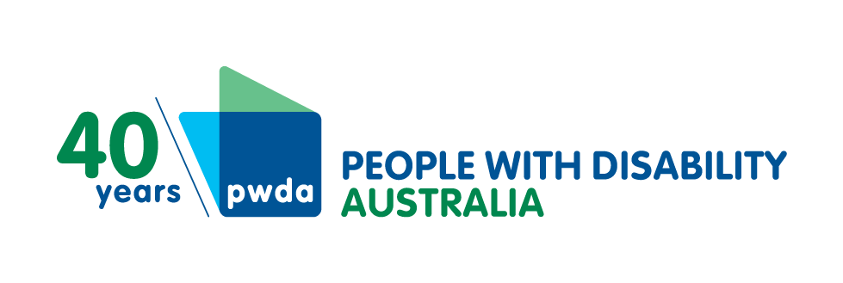
PO Box 666
Strawberry Hills
NSW 2012
+61 2 9370 3100
pwd@pwd.org.au
www.pwd.org.au

NSW Budget misses the mark for
disability community
People with Disability Australia (PWDA) and the Physical Disability Council of New South Wales (PDCN) have called the NSW Budget a disappointment for nine in 10 people with disability in the state, advising that there was nothing new of significance in the budget for people with disability.
About 1.35 million people of NSW’s population of 8.17 million people live with disability, or one in four people.
Sydney-based PDCN Chief Executive Officer Serena Ovens stated she was extremely disappointed with Tuesday’s budget announcement.
Ms Ovens said: “People with disability have once again been forgotten in the 2023 budget. It seems that the NSW Government’s vision of ‘transformational reform, and a better, brighter future’ does not include us.
“Although there is much in the budget to be welcomed, including the focus on women, First Nations peoples and those experiencing domestic and family violence, a truly transformational budget would have addressed the lack of accessible and affordable housing options for people with disabilities and ensured the disability community was better supported across national emergencies such as pandemics, fire, and floods, at the very least.”
While it was hoped that some of the targeted funding for women and First Nations peoples would be channelled towards supporting people with disabilities, the budget had missed out key groups experiencing disability, including men, LGBTIQA+ people, older persons, culturally and linguistically diverse people, and migrants and refugees with disability.
One priority of the disability community that the state government did commit to was a dedicated $3.4 billion in cash support and $400,000 of in-kind backing for the National Disability Insurance Scheme (NDIS).
PWDA President Ms Samantha Connor said: “While it’s great New South Wales is still meeting its commitment to funding the federal National Disability Insurance Scheme, this only helps people with disability who can access the scheme.
“Given 9 in 10 people cannot access the National Disability Insurance Scheme, the latest NSW Budget is disappointing for hundreds of thousands of people with disability.
“It’s vital that New South Wales meets the needs of the 1.2 million people with disability in the state who can’t access the NDIS, by loosening its purse strings so disabled people can access mainstream and local disability support services in our community.”
PDCN and PWDA were pleased the budget had committed $26.6 million to repairs and upgrades across its social housing portfolio, but saw no commitment towards increasing housing accessibility across the broader housing market.
The organisations described the government’s social housing vision in the latest budget as lacklustre, noting its commitment to a further 610 community homes and Aboriginal Housing Authority properties in this year’s budget fell far short of meeting the social sector and NSW Council of Social Service’s (NCOSS) established target of 5000 new social housing properties each year for the next 10 years.
PWDA’s Ms Connor said: “As more people with disability take up their human right to choose where they live by transitioning away from group housing to social housing and private homes, it is important that the state keeps up the supply of accessible homes that we can move into.
“It’s vital to respecting our choices of where to live, and keeping us safe from risks of COVID-19 in certain settings, that the government keeps up the supply of properly accessible social housing and private homes for people with disability to rent or own.”
PDCN’s Ms Ovens said: “The need for social housing is dire, especially during the pandemic, so it’s time the NSW Government got serious about this and other essential services for people with disability.”
The CEO said she was also disappointed in the NSW Government’s timetable for accessible transport improvements.
Ms Ovens said: “As PDCN tipped last year, the NSW Government’s failure to properly support transport accessibility upgrades means the government will miss its own target of making all train stations suitable for people with disability by next year.
“Older, inaccessible train stations make it harder for people with disability to be easily part of our community, and to participate in work, education and leisure.”
In this year’s budget the government has extended a Transport Access Program target of making all NSW train stations accessible by 2023 to a four-year delivery window.
PDCN and PWDA welcomed continued support for the Together Home housing services program for people experiencing homelessness, which received funding of $120 million this year.

Media contacts
Physical Disability Council of New South Wales Chief Executive Officer Serena Ovens
serena.ovens@pdcnsw.org.au
+61 411 327 877 | +61 2 9552 1606
People with Disability Australia Communications Coordinator Lindsey Woollard
media@pwd.org.au
+61 408 682 867 | +61 2 9370 3100

