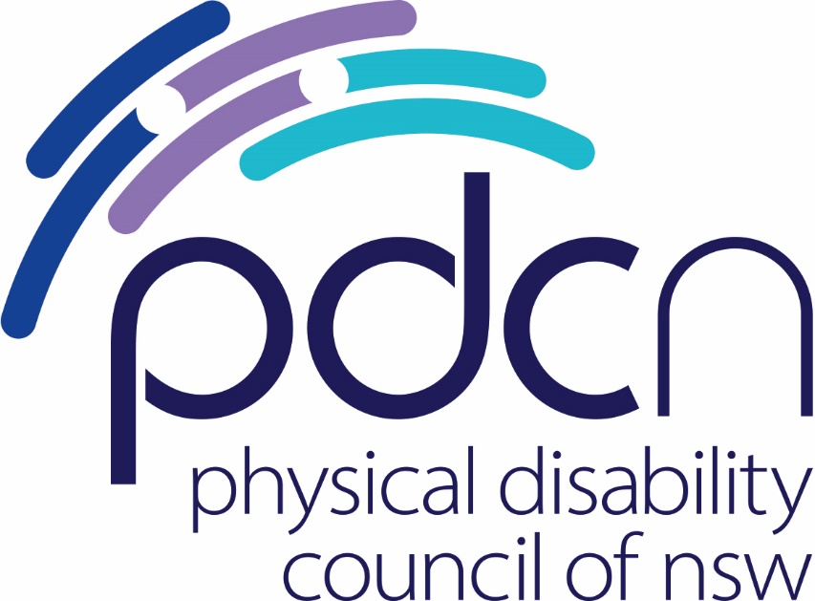

Submission to the NSW Parliamentary Inquiry

Waste Avoidance and Resource Recovery Amendment

(Plastics Reduction) Bill 2021

3 May 2021

Physical Disability Council of NSW
3/184 Glebe Point Road, Glebe NSW 2037

02 9552 1606
www.pdcnsw.org.au

hayley.stone@pdcnsw.org.au
serena.ovens@pdcnsw.org.au

Recommendations:
Recommendation 1:
That the Bill be amended to include specific requirements for plastic straws as a specific category of plastics, and regulate that businesses should only offer plastic straws to patrons if there is reason to believe that they have a legitimate need to use one as described in s.48G (1)(a) & (b)

Recommendation 2:
That s.48G (2) reference the need for the Commission to liaise with people with disabilities and their representatives to develop strategies to develop affordable and effective non-plastic alternatives to single use plastic items required for the purposes of s 48G (1).

Recommendation 3:
That all levels of Government commit to broad community education on the conscious consumption of single use plastics, including plastic straws.

Recommendation 4:
That the Government encourage increased innovation and technology across the waste recycling industry to increase the capacity for plastic straws to be recycled.

Who is the Physical Disability Council of NSW?
The Physical Disability Council of NSW (PDCN) is the peak body representing the estimated 1,079,200 people with physical disabilities across New South Wales. This includes people with a range of physical disability issues, from young children and their representatives to aged people, who are from a wide range of socio-economic circumstances and live in metropolitan, rural and regional areas of NSW.

The objectives of PDCN are:

- To educate, inform and assist people with physical disabilities in NSW about the range of services, structure and programs available that enable their full participation, equality of opportunity and equality of citizenship.
- To develop the capacity of people with physical disability in NSW to identify their own goals, and the confidence to develop a pathway to achieving their goals (i.e., self-advocate).
- To educate and inform stakeholders (i.e.: about the needs of people with a physical disability) so that people with physical disabilities can achieve and maintain full participation, equality of opportunity and equality of citizenship.

Comments
The value of plastic straws to the physical disability community

PDCN acknowledges that plastic waste is a critical threat to the environment and appreciates the opportunity to comment on the Waste Avoidance and Resource Recovery Amendment (Plastics Reduction) Bill 2021. Our comments will focus on the phrasing out of plastic waste – in particular, plastic straws.

Plastic straws are used in the daily lives of our members to assist them to eat and drink. Plastic straws are commonly used by people with cerebral palsy, spinal muscular atrophy as well as those with spinal cord injuries.

The advantages of plastic straws are:

- They are inexpensive.
- Plastic straws can bend, flex and be easily manipulated by an individual into their mouth,
- They are heat resistant to higher temperatures than most biodegradable alternatives,
- Plastic straws do not collapse when sucked on,
- Plastic straws do not weaken or fall apart with use, meaning they pose less of a choking risk than weaker alternatives,
- They are more hygienic than reusable straws which require cleaning,
- They are soft enough to avoid risk of physical damage or injury during use.

To date, there is no market equivalent which can match these features. We are concerned that the phasing out of plastic straws across Australia may result in unanticipated hardship for people with physical disabilities who rely on plastic straws on a daily basis.

We understand that the elimination target date for plastic straws would be 6 months after the date that s.48D commences.

The intention of s.48 G is not clear.

We appreciate that the Act acknowledges that there may be a legitimate use for plastic straws for those who medically need them, reflected in the fact that any elimination targets may be subject to ‘any legitimate reason for manufacturing, selling or distributing the use of single use plastics that meet the access needs of people who need them to be able to eat or drink safely or independently.’

However, we are unsure how to interpret this provision and whether it will allow for cafes, restaurants and other distributors to offer plastic straws to those who legitimately need them (which is our preferred solution), or whether plastic straws will be repurposed as medical items and subsequently sold in smaller numbers through specialist suppliers like chemists.

If the latter is the case, we have grave concerns that this will increase the cost of plastic straws and make them less readily available for people who need them on a daily basis. Plastic straws are currently able to be accessed across all places where beverages are offered, at all times of day or night. If accessibility is restricted, this would significantly impact on the accessibility of cafes, restaurants, bars and clubs for people with physical disability.

Reduce prevalence, but don’t remove the option for those with legitimate need.

It is important that the intention of s.48G(1) is made clear – what we would hope to see is that plastic straws could be distributed across the same venues but provided on an “as needs” basis. We note that the net consumption of plastic straws under such an approach would not change – either people with physical disabilities would supply their own plastic straw or receive one from a venue on request, but it would mean that people with physical disabilities were not disadvantaged by the changes and that they could access a straw if they needed it.

The importance of co-design across viable alternatives

At the same time, while we welcome the creation of a Plastics Reduction Commission, we note that there is no express obligation for the Plastics Reduction Commission to consult with people with physical disability on research and innovation across this space under s. 48(g)(2). As major stakeholders in this space, the Act should emphasise the importance of co-design with people with physical disability on effective non plastic alternatives to allow them to be able to eat or drink safely, independently and in comfort.

The recycling industry should be required to look to expanding the range of recyclable plastics to include plastic straws

We also note that plastic straws are normally considered able to be recycled via standard plastics recycling processes in Australia despite the fact that they are generally made from polypropylene plastic, which is, itself recyclable.

Given that plastic straws form a significant component of plastics pollution, we would like to see greater accountability across the recycling industry towards recycling single use polypropylene products such as plastic straws as part of the strategy to reduce environmental pollution and note that some industry providers already do this.

The role of community education

In 2020, PDCN participated in a roundtable discussion with Government on the issue of reducing plastic straws. During this discussion we advocated for greater community education on making more conscious decisions around the use of disposable plastics, including increased education around recycling.

We argued for broader campaigning and education as an alternative to regulation on the production and distribution of plastic straws which would be to the detriment of our members and noted that some businesses were already phrasing out plastic straws without regulation. At that time, we recommended a non-regulatory approach building on grassroots acknowledgment that single use plastics were a significant environmental hazard.

Concluding remarks

In summary, while we support the objectives of the Bill and acknowledge the environmental impacts of single use plastics, we believe that plastic straws should operate under a separate subcategory to other single use plastics, given their essential role in the daily lives of people with disability.

We appreciate that plastic straws are overused across the community and that they form a significant component of plastic pollution, but equally, people with physical disability need to eat and drink independently in a manner that is safe and comfortable.

We believe that the appropriate compromise would be for the Bill to include specific requirements for plastic straws – in particular, that businesses should only offer plastic straws to patrons on an ‘as needs basis’. This would result in an overall reduction in use of straws but would not place a disproportionate regulatory burden on people with physical disability who require plastic straws to eat or drink.

Such an approach, coupled with community education and increased accountability across the recycling industry to manage smaller polypropylene products, would offer the most equitable solution to balancing the accessibility needs of people with disability with environmental protection, until viable alternatives to plastic straws are available for our membership.

References

Australian Bureau of Statistics (ABS), Disability, Ageing and Carers, Australia: New South Wales, 2018 < https://www.abs.gov.au/AUSSTATS/abs@.nsf/DetailsPage/4430.02018?OpenDocument> accessed 15/12/2020. This figure was determined by assessing the number of persons across NSW identifying as having a disability who identified any level of core functioning limitation. It is likely to represent an underestimate of the percentage of persons.
Waste Avoidance and Resource Recovery Amendment (Plastics Reduction) Bill 2021 (NSW) s. 48G (1)(a) & (b).
Quinte Waste Solutions, ‘The Struggle with Straws’ https://quinterecycling.org/the-struggle-with-straws/ accessed 3 May 2021.
Tayao, Ian, ‘How to Recycle Plastic Drinking Straws: An Effort to Save the Earth’ Nov 9, 2019 < https://waster.com.au/how-to-recycle-plastic-drinking-straws/> accessed 3 May 2021.

