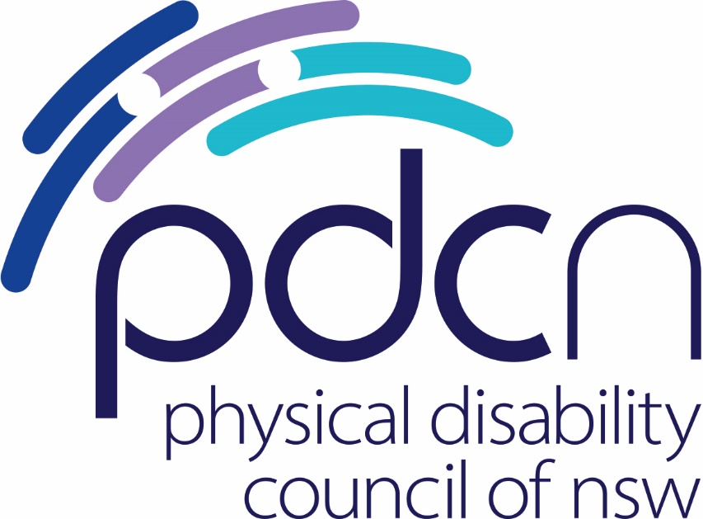

Submission to the Social Services Legislation Amendment (Strengthening Income Support) Bill 2021

5 March 2021

Physical Disability Council of NSW

3/184 Glebe Point Road, Glebe NSW 2037

02 9552 1606

www.pdcnsw.org.au

hayley.stone@pdcnsw.org.au

Contents

Who is the Physical Disability Council of NSW? 3

Recommendations 4

Introduction 5

References 7

# Who is the Physical Disability Council of NSW?

The Physical Disability Council of NSW (PDCN) is the peak body representing people with physical disabilities across New South Wales. This includes people with a range of physical disability issues, from young children and their representatives to aged people, who are from a wide range of socio-economic circumstances and live in metropolitan, rural and regional areas of NSW.

Our core function is to influence and advocate for the achievement of systemic change to ensure the rights of all people with a physical disability are improved and upheld.

The objectives of PDCN are:

* To educate, inform and assist people with physical disabilities in NSW about the range of services, structure and programs available that enable their full participation, equality of opportunity and equality of citizenship.
* To develop the capacity of people with physical disability in NSW to identify their own goals, and the confidence to develop a pathway to achieving their goals (i.e. self-advocate).
* To educate and inform stakeholders (i.e.: about the needs of people with a physical disability) so that they are able to achieve and maintain full participation, equality of opportunity and equality of citizenship.

# Recommendations

Recommendation 1

Permanently increase social security income support working age payment rates in line with the proposal of ACOSS **and retain** supplementary payments that reflect specific costs experienced by cohorts, such as the Mobility Allowance for people with physical disability.

Recommendation 2:

Extend the broadened qualifications criteria for Jobseeker and youth allowance, under Part 2 of Schedule 1 indefinitely in recognition of ongoing effects of the Covid19 pandemic.

Recommendation 3

Indefinitely extend the portability period for certain age pensioners and recipients of the disability support pension unable to return to, or depart from, Australia within 26 weeks due to the impact of COVID-19.

Recommendation 4

Ensure continuity of income support for all persons who receive income supports with travel restrictions, who are genuinely unable to return home, on an indefinite basis.

# Introduction

As the peak representative organisation for people with physical disability within NSW, including people who rely on various forms of government income support, the Physical Disability Council of NSW appreciates the opportunity to respond to proposed changes under the *Social Services Legislation Amendment (Strengthening Income Support) Bill 2021*.

Our submission is framed in terms of Australia’s international obligations under both articles 9 and 11 of the International Covenant on Economic, Social and Cultural Rights which provides all persons with the right to social security and an adequate standard of living, and continuous improvement across living standards, in addition to the specific rights accorded to people with disability under the UN Convention on the Rights of Persons with Disabilities (the UNCRPD).

## This includes the right to an adequate standard of living and social protection, including Government assistance for people with disability experiencing poverty to meet disability related costs, under Article 28 of the UNCRPD.

We will address each of the parts below.

## Part 1: Increasing working age payments

We do not support the current proposal to increase working age payments by $50 a fortnight.

43% of people with disability nationally rely on government income support as their primary source of income, including Jobseeker and Youth Allowance.[1]

While there is no official poverty measure in Australia[2], it is clear that many people on the ordinary rate of Jobseeker and Youth Allowance, live hand to mouth and are consistently unable to meet essential costs, including housing, utilities, transport, food and medications, notwithstanding supplementary payments including the mobility allowance, rent assistance etc. An increase of $50 per fortnight is insufficient to address this problem.

The results of recent polls and growing support for campaigns such as Raise the Rate[3] indicate that there is widespread support across the community to increase JobSeeker and Youth Allowance Payments to ensure that people studying or looking for work can meet their basic living costs.

PDCN is in support of increasing the current rate of working age payments in line with the recommendation of ACOSS – that is, to increase the base rate of JobSeeker Payment by at least $25 a day and ensure everyone on income support receives at least $65 a day, with ongoing indexation of payments in line with wage movements at least twice per year.[4]

**Most critically any increases to working age payments should not be at the expense of supplementary payments or schemes that would ordinarily be received by certain classes of individuals, on top of their base payment, such as the Mobility Allowance, the Continence Aids Payment Scheme, or access to the Low-Income Health Card.**

Part 2: Qualification for youth allowance or Jobseeker Payment - Coronavirus

We appreciate that the Minister for Families and Social Services plans to extend the current provisions which allow for someone who is self-isolating or in quarantine, or caring for someone who is, to still be eligible for the Jobseeker or Youth Allowance payments; but would prefer to see this provision extended indefinitely in line with Government information regarding Covid19 transmission.

We understand from our engagement with NSW Health that there are still a number of unknowns relating to the effectiveness of the vaccine rollouts, across all three vaccines, and that there is a likelihood that vaccination will reduce the severity of the virus for a vaccinated individual; but may not prevent that person from contracting Covid19 or transmitting the virus to others.[5]

We also know that, in light of this, NSW Health will continue to promote social distancing and the use of PPE amongst the vaccinated community to try to mitigate the ongoing risk to vulnerable populations.

We do not have sufficient information to know how effective vaccination will realistically be for people who are at serious risk from contracting the virus or for how long they will need to continue self-isolation.

We also note that there may be some highly vulnerable persons for whom the risks of contracting the virus at any level may pose extreme risk, regardless of immunisation status, and that there may be people who cannot be immunised who will have no choice but to continue to self-isolate during outbreak situations.

We do not want people to lose access to income support when they have a legitimate reason to self-isolate or quarantine or are supporting someone else to do so. We also consider that the removal of income support is against the greater public interest as it may encourage people to act against public health orders, as was observed across the casual workforce until mechanisms were put in place to ensure adequate financial support for these employees.

We support the logic of Economic Justice Australia in their submission regarding the practical impact of extending the current eligibility provisions:

There will be natural attrition of applications of the measure as COVID-19 community transmissions further decline across Australia, and the provisions will be rarely if ever applied once vaccination is rolled out and herd immunity is achieved. As such the cost implications of removing the end-date will be negligible. However, in the event that there are clusters of new infections, legislation enabling people in isolation or caring for someone due to COVID-19 will already be in place.

and ask that the broadened qualifications criteria for Jobseeker and Youth Allowance under Part 2 of Schedule 1 be extended indefinitely in recognition of the ongoing effects of the pandemic and the uncertainties around vaccine effectiveness in transmission prevention.

## Part 3: Ordinary waiting periods

We endorse the proposal to continue the waiver on ordinary waiting periods to access parenting payment, jobseeker payment and youth allowance.

## Part 4: Income Free Areas and Taper Rates

We tentatively welcome the introduction of a higher rate of ordinary income-free area for jobseeker payments, youth allowance (other), parenting payment partnered and related payments to $150 per fortnight and appreciate that this may help elevate some of the economic hardship experienced by those on income support who supplement their payment with limited part-time or casual employment.

We see this as separate and distinct from any increases to working age payments as we note that the option to utilise the increased income free area will not necessarily translate to people on jobseeker payments, youth allowance (other) parenting payment partnered and related payments being able to realise the $150 per fortnight as a means of supplementing the cost of their basic living expenses.

## Part 5 – Portability

We are aware that there are many Australians currently overseas with limited opportunity to return home. We note the most recent information on the DFAT and DHA websites advises those seeking to return home to expect delays:

Australia has strict border measures in place to protect the health of the Australian community. Very limited flights are currently available to and from Australia and you may not be able to travel at this time.[6]

We support the portability period for certain age pensioners and recipients of the disability support pension (for severely disabled persons) unable to return to or depart from Australia within 26 weeks due to Covid19.

We note that there are several other income support payments that are affected by overseas travel, including Youth Allowance for job seekers, Youth Allowance for students and apprentices and the Jobseeker Payment.[7]

It would be equitable for all income support recipients on payments affected by travel who are genuinely unable to return home to be provided with ongoing access to their income support payments – indeed, such access may be critical in preventing these people from experiencing extreme financial hardship in countries where they have limited to no support and in facilitating faster repatriation back to Australia.

We also note that the amendments only extend the temporary discretionary power until 30 June 2021.We consider that it is extremely unrealistic that flights to and from Australia will resume with any certainty at that time and would accordingly argue that the discretionary power be extended indefinitely.

References

1. ABS, *Selected Living Cost Indexes*, Australia, Sept 2020 < [Selected Living Cost Indexes, Australia, December 2020 | Australian Bureau of Statistics (abs.gov.au)](https://www.abs.gov.au/statistics/economy/price-indexes-and-inflation/selected-living-cost-indexes-australia/latest-release)> accessed 4 March 2021.
2. Australian Government, Department of Foreign Affairs and Trade, Indicator 1.2.1 <[Tracking Australia's Progress on the Sustainable Development Goals (sdgdata.gov.au)](https://www.sdgdata.gov.au/sites/default/files/2030_agenda_for_sustainable_development.pdf)> accessed 4 March 2021.
3. Raise the Rate Campaign < [Home - Raise The Rate](https://raisetherate.org.au/)> accessed 4 March 2021.
4. Raise the Rate Campaign < [About the campaign - Raise The Rate](https://raisetherate.org.au/about/)> accessed 4 March 2021
5. PDCN attends monthly meetings with NSW Health as a member organization of both the Non Government Organisation Community of Practice Group (NGOCOP) and the Disability Community of Practice Group (Disability COP). The COPs are a Covid19 initiative of NSW Health.
6. Australian Government, Department of Homeland Affairs < [Australian citizens, permanent resident or New Zealand citizens usually resident in Australia | COVID-19 and the border (homeaffairs.gov.au)](https://covid19.homeaffairs.gov.au/australian-citizen-or-permanent-resident)> accessed 4 March 2021.
7. Australian Government, Services Australia, *Payments while outside Australia <* [Youth Allowance for students and Australian Apprentices - Payments while outside Australia - Services Australia](https://www.servicesaustralia.gov.au/individuals/services/centrelink/youth-allowance-students-and-australian-apprentices/how-report-and-manage-your-payment/travel-outside-australia/payments-while-outside-australia#affected)> accessed 4 March 2021.