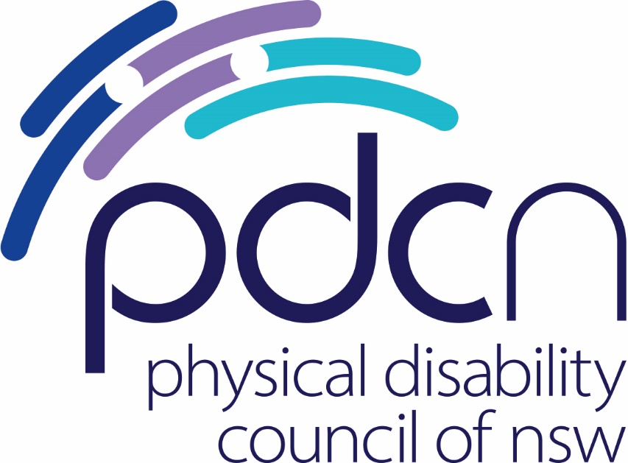

NSW State Budget Submission 2021 - 2022

12 February 2021

Physical Disability Council of NSW
3/184 Glebe Point Road, Glebe NSW 2037

02 9552 1606
www.pdcnsw.org.au

hayley.stone@pdcnsw.org.au

Who is the Physical Disability Council of NSW?
The Physical Disability Council of NSW (PDCN) is the peak body representing the estimated 1,079,200 people with physical disabilities across New South Wales. This includes people with a range of physical disability issues, from young children and their representatives to aged people, who are from a wide range of socio-economic circumstances and live in metropolitan, rural and regional areas of NSW.

Our core function is to influence and advocate for the achievement of systemic change to ensure the rights of all people with a physical disability are improved and upheld.

Continuing to meet the State’s commitment to people with physical disability, both now and in the future.
Covid19 has severely impacted our economy and we appreciate that tough decisions have to be made to bolster our financial recovery.
Having said this, it is critical that the State Government remains committed to its efforts towards promoting, protecting and securing the rights of people with disability, and continues its work towards ensuring that people with disability across NSW have equal access to all supports and services, both at this critical time, and into the future – social investment must come first.
PDCN considers that social investment can involve large scale economic stimulation and create jobs – a win all round. We call on the NSW Government to focus its spending on projects that achieve these dual benefits as the most responsible choice in current circumstances.

In the 2021-22 State Budget we ask the NSW Government to commit to the following:

Build more social housing and build it right!
Fast track the rollout of accessibility upgrades under the NSW Transport Access Program

Help local councils create more livable communities
Increase funding for the Ageing and Disability Commission to track progress under the Disability Inclusion Act

Build more social housing and build it right!
Access to safe, secure and affordable housing is vital to the health and wellbeing of everyone.For people with disability, access to appropriate, sustainable housing is key to inclusion, facilitating both independence and participation across the social, economic and political aspects of everyday life.
As of 30th June 2020, there were 46,087 applicants on the general waitlist for social housing and 5308 people on the priority waitlist. People with physical disability are a large cohort of those needing to utilise social housing, as can be seen in the fact that in 2018, 4 in every 10 social housing households contained at least one family member with a disability.
A report from the Australian Institute of Health and Welfare (2016) indicated that 59% households were homeless prior to their public housing tenancy starting – when considering that these households may wait up to 10 years to be allocated a property, this represents a massive investment of resources which could be substantially lessened through greater stock and faster allocation rates.
We welcomed the State Government’s injection of $812 million for new and upgraded social housing - but the reality is, this will only result in an estimated 1,280 new properties - literally the tip of the iceberg and not enough to cover those in urgent need of homes. We need to see significantly more investment both in building social and community housing and in building it right.
Recommendation 1:
The state government commits to building 5000 homes per year for the next 10 years (20,000 homes over the next 4 years) to meet current and projected demand.

Accessible design as best practice
Housing accessibility is a mainstream issue across our society, especially given increasing rates of people aged 65 years and older as a proportion of our overall population.
It is estimated that 60% of houses in the private market will be occupied by a person with physical disability at some point over its life. Given that an estimated 4 out of every 10 families in social housing are reported to have at least one family member with a disability, we anticipate that the rate of occupation by those with physical disability across the lifespan of a social housing property to be much higher, making housing accessibility a major consideration across social housing stock.
Incorporating universal design features into new social housing builds would greatly improve accessibility across the portfolio. Government owned social housing should be built to Gold Level design standards as defined under the Livable Housing Guidelines, as a minimum^{vii} since these design standards have been recognised as reflecting best practice in terms of accessible housing design across Australia.
Given broader economic costs associated with long term homelessness and the administrative costs associated with inappropriate housing allocations, including the management of transfer requests, modifications to current homes and temporary rehousing, it makes sense to build properties that can meet the access needs of the broadest demographic of tenants possible.
We also need to see the Government encourage private investment across the community housing sector with an emphasis again, on accessible design.
Such actions would show a commitment to meeting the NSW Government's disability inclusion commitments, reduce taxpayer costs associated with homelessness and stimulate jobs across the building and construction industry – a win for the economy, taxpayers and for people with physical disabilities and their families who need accessible social housing.
Recommendation 2:
That funds be committed to a dedicated "Social Housing Accessibility Redevelopment Fund" to retrofit state owned properties social housing to a minimum of Gold level Livable Housing Design; and that the Government provide a new funding pool for private social housing providers to apply for grants towards the retrofitting of privately owned community housing stock to Gold level.

Fast track the rollout of accessibility upgrades under the NSW Transport Access Program
Accessible transport is vital to building inclusive communities – enabling people with disabilities to access work, school and socialise outside the home.
Considerable work has already been done to increase accessibility across the State's railway stations and other means of transport via the Transport Access Program and this work has significantly improved the lives of those with accessibility requirements.
PDCN recommends that the State Government fast track all state rail projects geared towards increasing passenger accessibility as a priority in this budget with a goal towards finalising all projects flagged under the Transport Access Project 3 (TAP3) over the next 4 years.
Such work would greatly improve transport options for people with disability and would stimulate increased rates of construction across the State – a win for rural communities in terms of jobs and accessibility.
Recommendation 3:
Prioritise scheduled works under TAP3 as a matter of priority with a view to finalising all projects across the next 4 years.

Help local councils create more livable communities
The accessibility of your community shouldn't be a matter of your postcode, but unfortunately this is situation for many people with disability across the State.
The reality is that many LGAs struggle to meet their obligations under the Disability Inclusion Plan to provide accessible public spaces, and in those communities, people with disability are being left behind.
In line with the last budget's commitment towards additional funding for LGAs towards the construction and maintenance of roads, cycleways and footpaths, PDCN asks that the Government commit additional funds for LGAs specific to projects geared towards enhancing accessibility across public spaces. We want to see more accessible playgrounds, more pedestrian ramps & and more lift and change facilities, to name but a few much-needed additions to public spaces, across the State.
Such investment would greatly enhance the capacity for LGAs to develop achievable projects across their Disability Inclusion Action Plans (DIAPs) for the next four years. It would result in an injection of funding at local level for communities and small businesses doing it tough as well as creating infrastructure to enhance community accessibility long term.
Recommendation 4:
That the Government create a specific funding pool for Local Governments to access for projects specifically geared towards increasing disability accessibility (both physical and non-physical) within communities.

Increase funding for the Ageing and Disability Commission to track progress under the Disability Inclusion Act
The Disability Inclusion Plan represents the NSW Government’s commitment ''to identifying and breaking down the barriers which prevent those with disability from enjoying the same opportunities and choices as everyone else.'' The Plan is the primary mechanism under which NSW aims to meet its domestic and international obligations towards disability inclusion.
To date, there has been no independent authority to monitor and track progress towards meeting outcomes as prescribed under the Plan. Whilst departments and agencies are required to report annually on progress, there is variation across the quality and consistency of reporting, and reporting does not reliably focus on improvements in the lives of people with disability as the primary indicator of progress. We also understand that there is inconsistency in terms of reporting across the four focus areas. A strong governance, reporting and evaluation mechanism is critical moving forwards, to ensure that Plan’s objectives can be met.
We welcome news that the Ageing and Disability Commission will be actively tracking and monitoring compliance across Government as of this year. It is important that the Commission receives sufficient funding to take on what we anticipate will be a complex and significant undertaking, given the above issues.
PDCN calls on the Government to provide additional funding to the Ageing and Disability Commission to fund a full-time Senior Project Officer to track and report on compliance across all relevant agencies and departments and conduct qualitative and quantitative research on the practical impacts of Government projects and initiatives on the lives of people with disability. We understand that this would amount to a sum of 150K a year, or 600K over the next four years.
Providing funding for a full-time employee in this role would provide the Commission with sufficient resourcing to ensure that robust mechanisms for reporting and evaluation can be developed – leading to more comprehensive data and better reporting capabilities.
Recommendation 5:
That the Government provide an additional 600K to the Ageing and Disability Commission to resource its new responsibilities in reporting on and evaluating the DIP.

For more information, please contact Hayley Stone, Senior Policy Officer, at hayley.stone@pdcnsw.org.au or phone, 0422 855 681.

References

Australian Bureau of Statistics (ABS), Disability, Ageing and Carers, Australia: New South Wales, 2018 < https://www.abs.gov.au/AUSSTATS/abs@.nsf/DetailsPage/4430.02018?OpenDocument> accessed 15/12/2020. This figure was determined by assessing the number of persons across NSW identifying as having a disability who identified any level of core functioning limitation. It is likely to represent an underestimate of the percentage of persons.
Shaw, M., Housing and public health, Annual Review of Public Health, 25, 2004, pp. 397-418 referenced in Australian Institute of Family Studies, Robinson, E. and Adams, R., Housing stress and the mental health and wellbeing of families, AFRC Briefing No. 12 — June 2008 <Housing stress and the mental health and wellbeing of families | Child Family Community Australia (aifs.gov.au)> accessed 18 January 2021.
NSW Government, Department of Communities and Justice, Expected Waiting Times < Expected waiting times | Family & Community Services (nsw.gov.au) > accessed 12 February 2020.
NSW Government, Department of Communities and Justice, op cit.
Australian Institute of Health and Welfare, Housing assistance in Australia 2020, web report, 5 August 2020 < Housing assistance in Australia 2020, Occupants and households - Australian Institute of Health and Welfare (aihw.gov.au)> accessed 12 February 2020.
NSW Government, Department of Communities and Justice, op.cit.
Ibid.
Livable Housing Australia, Livable Housing Design Guidelines, 2017 < SLLHA_GuidelinesJuly2017FINAL4.pdf (livablehousingaustralia.org.au)> accessed 12 February 2020
NSW Government, Transport For NSW, TAP 3 < TAP 3 | Transport for NSW> accessed 12 February 2020.
NSW Government, Department of Communities and Justice, Disability Inclusion Plan < Disability Inclusion Plan | Family & Community Services (nsw.gov.au)> accessed 12 February 2020.

