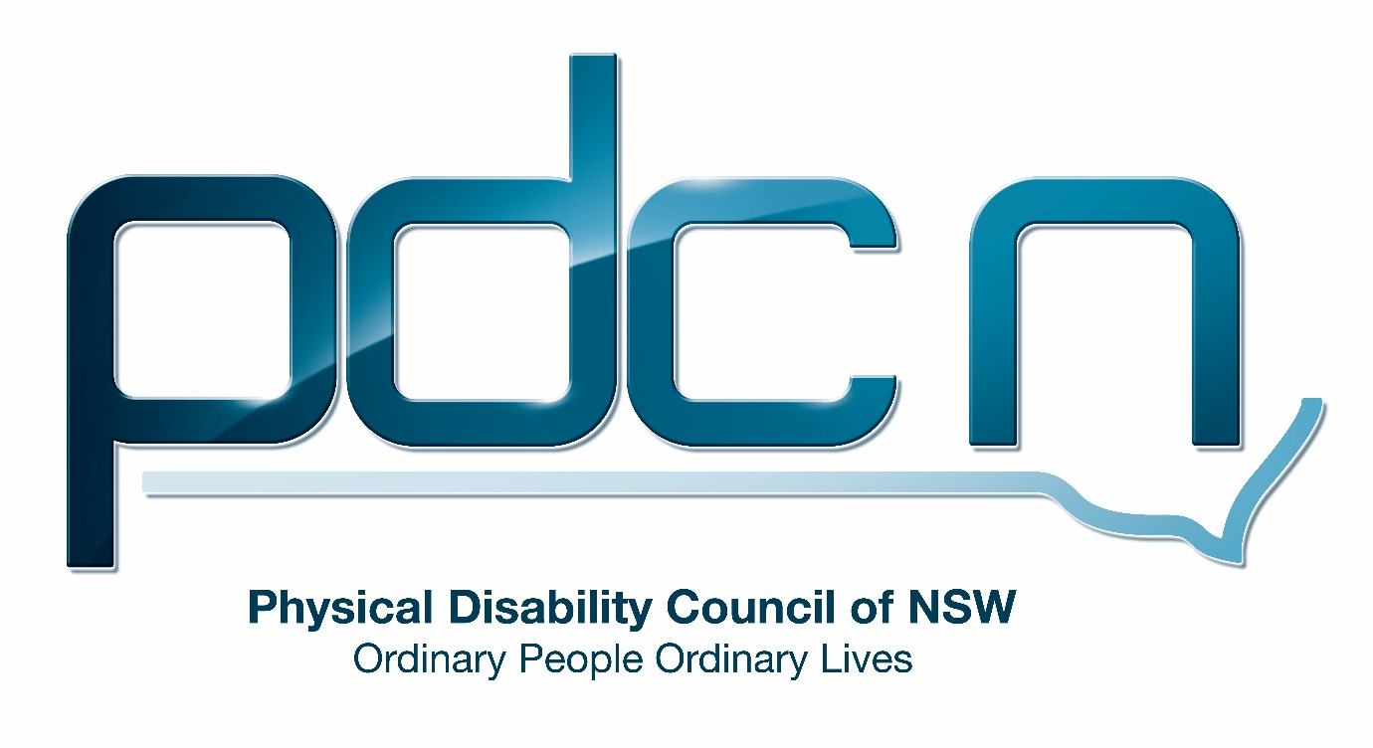

Submission for Department of Social Services

Supported School Transport and transition to the National Disability Insurance Scheme

19th July 2017

Ellen Small

Physical Disability Council of NSW

3/184 Glebe Point Road, Glebe NSW 2037

02 9552 1606

www.pdcnsw.org.au

ellen.small@pdcnsw.org.au

Who is the Physical Disability Council of NSW?

The Physical Disability Council of NSW (PDCN) is the peak body representing people with physical disabilities across New South Wales. This includes people with a range of physical disability issues, from young children and their representatives to aged people, who are from a wide range of socio-economic circumstances and live in metropolitan, rural and regional areas of NSW.

Our core function to is influence and advocate for the achievement of systemic change to ensure the rights of all people with a physical disability are improved and upheld.

The objectives of PDCN are:

* To educate, inform and assist people with physical disabilities in NSW about the range of services, structure and programs available that enable their full participation, equality of opportunity and equality of citizenship.
* To develop the capacity of people with physical disability in NSW to identify their own goals, and the confidence to develop a pathway to achieving their goals (i.e: self-advocate).
* To educate and inform stakeholders (i.e: about the needs of people with a physical disability) so they are able to achieve and maintain full participation, equality of opportunity and equality of citizenship.

Introduction:

The Physical Disability Council of NSW (PDCN) appreciates the opportunity to provide feedback to the Department of Social Services on Supported School Transport and the transition to the National Disability Insurance Scheme (NDIS). As Supported School Transport is not a direct area of concern for a majority of our members PDCN only receives limited feedback in this area and will provide responses to the questions in the consultation paper where we feel we can add value to the discussion.

**Discussion**

The provision of supported school transport, known as assisted school transport in NSW is essential to ensure children and young people with disability can access the education system on an equal basis to their peers who do not have a disability. PDCN would like to emphasise that the barriers young people with disability experience when accessing education lead to lower involvement in tertiary education, employment and training as individuals enter adulthood.

Furthermore, access and inclusion are key foundations of the National Disability Strategy (NDS). NDS action area 5 policy direction 2 seeks to reduce the disparity in educational outcomes for people with disability to improve their social wellbeing and economic security[1].

In addition, the right to equal and active participation in the community, including accessing education is clearly mandated in the Convention on the Rights of Persons with Disabilities(CRPD), which was ratified by Australia in July 2008. Article 24 of the UN Convention on the Rights of People with Disabilities guarantees the right to education without discrimination, on the basis of equal opportunity[2].

Currently the public transport system in NSW is not fully accessible. NDS policy direction four states ‘a public, private and community transport system that is accessible for the whole community’ is vital for people with disabilities to have mobility in the community and ‘underpins all aspects of life for people with a disability’[3]. This is accurate for young people with disabilities accessing both supported and mainstream education with access to transport key to facilitating inclusion.

PDCN supports the key objectives of the National Disability Insurance Scheme (NDIS), which is offering participants greater choice and control over the supports they receive, including the ability to exercise choice by directly engaging the service providers from whom they receive transport services.

**1.What works well with the current supported school transport service?**

PDCN has received positive feedback regarding the current enrolment process. Although enrolment for assisted school transport is time consuming and slightly cumbersome, with families and the school both required to complete the application form once registered in the first year of the child’s attendance at the school, special school or support class, the transport continues for the subsequent years that the child remains enrolled at the same school or supported education program.

PDCN recommends if supported school transport is to be transferred to the NDIS system, the NDIA must ensure that the process for requesting funding for supported school transport during each plan review is straightforward and set pricing to guarantee individuals have enough funding to meet their transport needs for the succeeding year. PDCN has observed that underfunding of participant transport needs in NDIS plans has been a significant issue for individuals accessing the scheme.

**3.Should current arrangements remain?**

PDCN believes under the right conditions, with sufficient support for both families and service providers to transition to the scheme, and the introduction of the transport broker role, supported school transport could be delivered successfully under the NDIS and would be effective in providing families greater choice and control of this essential service. PDCN is optimistic that the NDIS will enable greater participation of children with disabilities in mainstream education, improving their employment and participation in the community as adults.

**7. What level of flexibility would families be looking for in their supported school transport arrangements?**

PDCN is supportive of a new model for supported school transport as families have reported desiring greater flexibility than that which is currently provided. The current model sees transport providers contracted by the Department of Education without any consultation with families. PDCN believes families would significantly benefit from supported school transport being provided using the individualised funding arrangements consistent with the provision of other services under the NDIS.

A more individualised approach to service provision would see participants being able to choose the transport service provider that best meets their individual needs. For some students and families this benefit would mean greater control over the journey to and from school and being able to avoid being made to be part of a “run” that involves multiple pickups resulting in a very long travel time for some students.

PDCN has observed that long trip times are consistently a concern for parents and students. Currently if a trip does not exceed one hour, this is considered a reasonable travel time and the Department of Education will not reconsider the route to which a student has been assigned. However, this change may only be of significant benefit for individuals living in metropolitan areas as in rural or regional NSW there is a limited number of transport service providers and this may limit participant choice.

In addition, the autonomy provided to participants by individualised funding would allow for families and students to have input regarding the staff assisting them or their child, including both drivers and disability support workers on transport services. Families would have the option to only engage transport service providers who have specific training to meet their child’s explicit needs or are willing to train staff. A PDCN stakeholder expressed concerns that the transport aide assisting her child was not trained in epilepsy management and able to administer medication if required. The parent raised this concern with the Department of Education who took six months to address this issue. Under the proposed model this parent would have the ability to remedy this situation more efficiently and could employ a transport aide/ disability support worker with this training.

Furthermore, one mother whose child receives transport assistance raised with PDCN that confirming her daughter’s supported school transport was difficult over the school holiday period and it was near impossible to make changes to the route without several weeks’ notice - for example, a different drop off point such as respite rather than the child’s home. PDCN believes parents require the flexibility that directly contracting a transport service provider would allow e.g. one service provider for school drop off and another for the afternoon pickup or the ability to have their child dropped directly from school to respite or a community program instead of the family home.

PDCN believes the assessment criteria utilised under the NDIS will enable more person-centred evaluation of each student’s eligibility for supported school transport. Assessments will be made based on what is deemed a reasonable and necessary support and can better consider the individual child’s situation and functional requirements.

As an example, PDCN observed a situation where a child with Autism spectrum disorder was automatically approved for school transport when he was attending a ‘satellite’ (supported classroom) within a local catholic primary school, but since transitioning to a mainstream classroom within the same school, he is no longer eligible for supported school transport.

(This is due to the school not being the closest school to his home.)

However, PDCN feel it would be deemed ‘reasonable and necessary’ under the NDIS for this child to be eligible for supported school transport to continue to attend his current school where he is familiar with the teachers, fellow students and environment, and is likely to have less behavioural and educational issues, and more likely to have success in the transfer to a mainstream classroom.

**14. What responsibilities should transport brokers and transport providers have to keep children safe? What should be the responsibilities of parents and schools?**

**15. What other mechanisms are needed to keep children safe?**

To keep children safe, it is essential that there are mechanisms in place to screen workers to ensure they do not pose an unacceptable risk to students using supported school transport. If supported school transport is delivered under the NDIS, transport providers would be required to register with the NDIS Quality and Safeguarding Commission. The registered provider status ensures that providers have met minimum training standards for employees including basic legal obligations for workers relating to safeguarding. In addition, employees must have a current Working with Children Check and police check. The NDIS Quality and Safeguarding Framework will see a strengthening of protections for people with disabilities, with the introduction of a nationally consistent worker screening system that also considers a range of factors including allegations of workplace misconduct and professional disciplinary proceedings. Transport service providers would also need to train their employees in correct loading and manual handling procedures.

**18. What are the benefits of families managing provider payments themselves? What support would be helpful in managing this?**

PDCN sees the essential benefit of families managing provider payments is the flexibility to engage several different service providers for example one transport provider to drop off their child at school and one for the pickup. Furthermore, families would have the ability to change service provider if they are unhappy with the service offered. This was raised by many as a concern if they were unhappy with a driver or transport supports (once again exercising this level of choice and control over transport services many not be possible in rural and regional NSW).

PDCN believes participants would require the support of a plan manager to help with payment and a transport broker to provide initial support if the family will be self-managing the participant’s plan.

**21.How does the potential model improve on the current arrangements for supported school transport?**

PDCN is supportive of a new model for supported school transport as we believe it would provide families and students a greater level of choice, control and flexibility in their transport services that is currently not available with providers was being contracted directly by the Department of Education.

1. Commonwealth of Australia, National Disability Strategy (NDS) 2010- 2020, page 55
2. United Nations, Convention on the Rights of People with Disabilities (CRDP), page 16
3. Commonwealth of Australia, National Disability Strategy (NDS) 2010- 2020, page 32