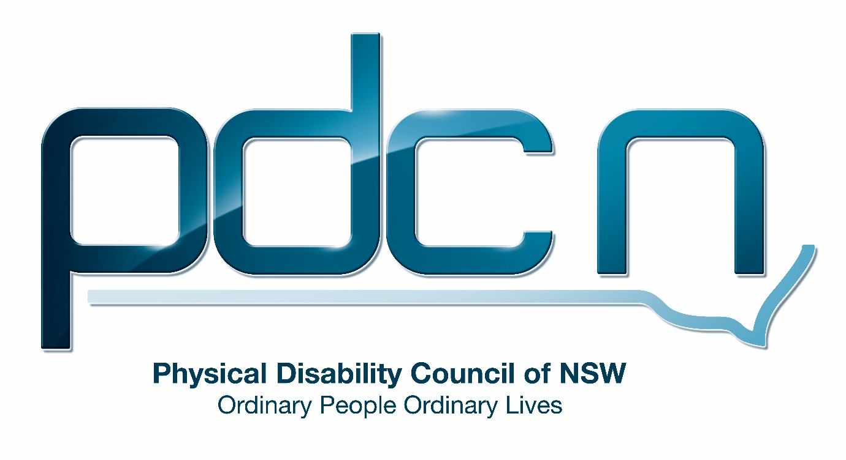

Submission for The City of Sydney

Social Sustainability Policy and Action Plan - A City for All

25th May 2018

Ellen Small

Physical Disability Council of NSW
3/184 Glebe Point Road, Glebe NSW 2037

02 9552 1606
www.pdcnsw.org.au
ellen.small@pdcnsw.org.au

Who is the Physical Disability Council of NSW?
The Physical Disability Council of NSW (PDCN) is the peak body representing people with physical disabilities across New South Wales. This includes people with a range of physical disability issues, from young children and their representatives to aged people, who are from a wide range of socio-economic circumstances and live in metropolitan, rural and regional areas of NSW.

Our core function to is influence and advocate for the achievement of systemic change to ensure the rights of all people with a physical disability are improved and upheld.

The objectives of PDCN are:
- To educate, inform and assist people with physical disabilities in NSW about the range of services, structure and programs available that enable their full participation, equality of opportunity and equality of citizenship.
- To develop the capacity of people with physical disability in NSW to identify their own goals, and the confidence to develop a pathway to achieving their goals (i.e: self-advocate).
- To educate and inform stakeholders (i.e: about the needs of people with a physical disability) so they are able to achieve and maintain full participation, equality of opportunity and equality of citizenship.

Introduction:
The Physical Disability Council of NSW (PDCN) appreciates the opportunity to provide feedback to the City of Sydney on the Social Sustainability Policy and Action Plan - A City for All.

PDCN is committed to creating a more inclusive society that enables the full economic, social and political participation of people with disability in the Sydney community. PDCN will provide feedback, where appropriate, on what we believe are key priorities and objectives for the City of Sydney to consider in the implementation of the Social Sustainability Policy and Action plan. With our main office based in Glebe, PDCN works across the City of Sydney and is enthusiastic about working collaboratively with council to guarantee the city achieves its goal of being a diverse and inclusive community.

Our response will be organised using the four policy directions:
Direction 1- Inclusive city: social justice and opportunity
Direction 2- Connected city: diverse, cohesive communities
Direction 3- Livable city: quality places and spaces
Direction 4- Engaged city: good governance and active participation

An inclusive city: social justice and opportunity
Diverse housing tenures and types 1.7, 1.8, 1.9
PDCN supports this objective, as a socially just and inclusive community must have affordable housing choices for individuals on a range of incomes. Affordable housing is essential for people with disability as there is a strong correlation between disability and the incidence of poverty due to the limited earnings of people in receipt of government benefits and people on part-time wages; and the additional expenses often associated with having a disability. In addition, people with disability may be further socio- economically disadvantaged by barriers to accessing employment, education and community services. Data has identified that people living in the most disadvantaged quintile of Sydney were 2.6 times as likely to have severe disability (2.9%) as people living in the most advantaged quintile (1.1%), when local areas were ranked according to their residents’ average access to economic resources. Currently the labour force participation rates of people with disabilities are significantly lower than the general population; 53.4% of the 2.1 million Australians with disability of working age were in the workplace or actively seeking work, compared to 83.2% for people with no disability.
Additionally, we support the aim of increasing the supply of ‘housing universally designed for people of all ages and abilities’ as the inadequate provision of accessible public housing and accessible rental properties is consistently observed as an issue for people with disabilities. Unfortunately, it is known that a high proportion of public housing tenants have a disability. PDCN members and stakeholders frequently report being unable to find a suitable rental property, living in subsidised housing that does not meet their access needs or being unable to afford to live independently of family despite receiving individualised supports through the National Disability Insurance Scheme.
PDCN believes the City of Sydney can increase the availability of functional and well-designed housing through planning and property levies for new developments and incentives for developers and designers to include features such as zero step entrances and wider doors in the initial design and construction of dwellings. Accessible design also future proofs housing for residents who may have declining mobility or experience disability as they age. To ensure greater accessibility across all building types, PDCN suggests the City of Sydney mandate gold standard housing under Australian Livable Housing Design Guidelines to improve access to all homes across the board.
Due to the economic factors previously mentioned, people with disability are less likely to own their own home. Therefore, PDCN believes the objective of improving housing choice for renters, particularly long-term rental tenancy options is essential for ensuring the City of Sydney continues to have a diverse mix of residents. People with disabilities may require home modifications to their rental property and for both economic and practical reasons securing a long-term rental is extremely desirable.
PDCN believes the initiatives proposed by City of Sydney to increase housing affordability and to provide greater security to renters are an important step to guaranteeing a diverse range of people are able to live within the city of Sydney and that individuals experiencing social and economic disadvantage are not relegated to fringe areas of the city where they have less access to essential services, employment and transport.
Affordable services, programs and facilities 1.10, 1.11
Disability can impact a person’s access to services and participation in social and community activities. The ABS general social survey reported that people with disability were less likely to have participated in sport or recreational activities or to have attended a sporting event as a spectator. They were also less likely to have attended a cultural venue or event in the last 12 months than their able bodied counterparts. As previously raised in this submission, people with disabilities experience higher rates of economic disadvantage. PDCN fully supports the actions in the social sustainability plan to make access to city community services and facilities more affordable to residents on lower incomes. Alongside ensuring that all events and facilities are physically accessible, we believe this will increase social connectedness and make the city more inclusive.
PDCN suggests the City of Sydney tailor information about subsidised tickets, free cultural programs and discounts on access to community facilities to ensure it reaches individuals in the community who will most benefit. This information should be provided in a range of accessible formats and specifically targeted to people with disabilities through engagement with advocacy organisations and disability service providers to reach persons who are not currently utilising services in the community or may be socially isolated.
Strong empowered communities 1.17
In this action area, ‘increase digital literacy and inclusion’ PDCN believes that initiatives, such as education and training to address digital exclusion, should also be targeted to individuals with disabilities. The Australian Digital Inclusion Index 2017 reports that although digital inclusion is improving in this cohort, Australians with disability have significantly lower levels of digital inclusion compared to the general population. Digital inclusion is linked to other socio-economic outcomes and access to resources and these digital initiatives have the potential to improve health and well-being and employment outcomes for people with disabilities. PDCN suggests City of Sydney ensure that people with disabilities are engaged in these programs through targeted advertising and promotion.
Resilience and adaptive capacity 1.18, 1.19
PDCN suggests the objectives of ‘support communities to adapt to the impacts of climate change’ and ‘strengthen communities resilience in the face of shocks and emergencies’ have a greater focus on people with disabilities. Individuals with disabilities may be particularly vulnerable to heat stress and adversely affected by situations such as heatwave, storms or flooding which may leave the city without electricity. This may be due to a variety of reasons including difficulty evacuating in an emergency, inability to regulate their body temperature, difficulty identifying or communicating their discomfort, thirst, or other health needs and reliance on electrical equipment such as ventilators, hoists and power wheelchairs.
As the City of Sydney and emergency services are not likely to be able to provide direct assistance to residents identified as vulnerable in the event of a shock or emergency, support for vulnerable individuals such as people with disabilities should be proactive and focus on individual capacity building. Education initiatives on personal emergency planning and preparing individuals to examine their own vulnerabilities during incidents such as heatwaves, dust storms, storms and flooding will ensure the best outcomes in the event of an emergency. An example of this type of capacity building community initiative is our PDCN website; I’m Okay: Emergency Readiness for People with Disabilities. The I’m Okay website provides a step by step guide for people with disabilities to assess their own risk in a range of emergency situations and create a personal emergency plan. We also provide tools and resources to assist with planning in a variety of natural or personal disasters. In reaching these members of the community, partnerships with disability representative organisations and disability service providers will be essential to locate those individuals most socially isolated.
PDCN supports the objective of providing access to community facilities for respite in extreme weather events however we would like to reiterate that facilities must be accessible, with accessible bathroom facilities, accessible parking and within proximity to accessible transport. Furthermore, information about the use of these facilities in the event of an emergency should be provided in a variety of accessible formats and through several mediums for example letterbox flyers, online, television and both commercial and community radio.

Connected city: diverse, cohesive communities
Diverse thriving communities 2.11
PDCN supports City of Sydney’s commitment to increase the active participation in the cultural and creative life of the city of sectors of the community who may face barriers to their inclusion.
PDCN would like to repeat the importance of events being accessible to people with disability with all associated information being easy to understand, written in plain English and available in hard copy upon request. Furthermore, to ensure accessibility, information should be presented in a variety of formats including AUSLAN, large print, easy English, audio, braille, rich text format and captioning available on all video materials. In addition, the design and content on the City of Sydney website must be easy to navigate to ensure individuals, regardless of computer literacy level, are able to successfully access information, including information concerning accessibility of events.
As mentioned previously, due to the lower rates of digital access amongst people with disability, events should be advertised through a variety of channels including print media, with the ability to easily call and book event tickets via phone systems.

A liveable city: quality spaces and places.
Accessible places and spaces 3.7, 3.8, 3.9
PDCN supports all actions that will improve the accessibility of the public domain, local businesses and increase transport options for people with disabilities. PDCN congratulates the City of Sydney for their use of technology to facilitate easy access around the city for people with disability. The online accessibility map is a comprehensive resource we ourselves have recommended to our members and have utilised as an organisation for accessibility information when organising events or requiring information on the location of mobility parking places.
The continued delivery and improvement of accessible public spaces is essential, as people with disabilities experience physical barriers across the community that prevent their safe access to businesses and services - for example the quality of curb transitions, inadequate footpaths and unsafe design of street crossings limiting visibility to motor vehicles and other pedestrians. Access is further hindered by inadequate provision and upkeep of accessible bathrooms in parks and public spaces. PDCN feels City of Sydney must guarantee the provision of accessible toilets to the same abundance as other public toilet facilities, and to take this one step further and commit to “Lift and Change” facilities in all new public places, such as shopping centres, sporting facilities, major transport hubs etc. (allowing for people with severe physical disability whom require adult change facilities.)
PDCN members who access the community using power and manual wheelchairs or motorised scooters, have reported feeling unsafe due to pedestrian behaviors and a lack of awareness from the public around sharing footpath space. Public awareness programs should focus on safe shared road and footpath use to reduce hazardous interactions between mobility device users, pedestrians and motorists. PDCN suggests City of Sydney invest in public awareness campaign and education programs around shared use of public space to foster a more inclusive community. In addition, the provision of accessible infrastructure and public spaces is vital to ensure the practical accessibility of public transport services; for example, well designed bus stops to ensure wheelchairs users, or those with vision impairment can enter and exit an accessible bus safely at any point along the route or service.
PDCN supports greater collaboration with local businesses to improve their accessibility to people of all ages and abilities. PDCN believes City of Sydney needs to educate business on the social and economic benefits of catering to customers with disabilities through accessible premises and staff having disability awareness training. PDCN suggests City of Sydney consider releasing a guide in the style of ‘missed business’ a guide for businesses produced by the previous Marrickville Council, now part of Inner West Council.
PDCN would like to highlight the importance of the provision of community transport, to ensure there is equal access to social programs and services run by the City of Sydney. Transport options for people with disabilities may be limited due to inaccessible public transport and the prohibitive costs of frequent taxi travel or modified private vehicles.
The introduction of the National Disability Insurance Scheme (NDIS) has changed the disability service provider landscape and has created transport issues, particularly for those who do not receive individualised support and transport funding through the scheme. The transition to individualised funding within NDIS plans and the removal of subsidisations for community transport, previously through Government funded programs (such as the Community Transport Program and Community Care Support Program through Transport for NSW) has increased Community transport organisation trip prices considerably (to market price). In conjunction with the introduction of new forms of transport charged at market rates, PDCN is concerned that funding for transport in NDIS plans at the current set levels will be insufficient to cover these increases and this will severely limit the ability of NDIS participants to participate in the community and access essential services. Any significant increase in the pricing of community transport services has the potential to restrict access for disadvantaged groups such as people with disability.
Therefore, it is essential that the future provision of community transport services considers the new NDIS funding landscape when assessing community transport requirements for residents in the City of Sydney.
PDCN recommends ongoing collaboration between City of Sydney and community transport providers to ensure these systems run efficiently and people with disabilities or reduced mobility are not left without essential services.
Healthy active living 3.12
PDCN supports the objective of delivering more inclusive sport, recreation, health and wellbeing programs through community facilities. Grassroots level sporting clubs are one of the most affordable forms of social activity in the community. Increasing access to organised sport would provide significant benefit to groups in the community experiencing economic disadvantage.
PDCN suggests the City of Sydney focus on ensuring greater inclusion in current sporting programs and organisations, rather than creating separate programs for people with disabilities. Initiatives to increase sporting clubs’ understanding of the needs of people with disabilities and how to make existing sporting programs more accessible are vital in facilitating access to people with disability. PDCN recommends City of Sydney invest in disability awareness training for staff and management of community sporting organisations.
An engaged city: good governance and active participation
Transparent, accountable governance 4.2
PDCN strongly supports council information being delivered in a range of accessible formats to ensure all members of the community can participate in and influence council decisions. PDCN believes this commitment to ensure local government is accessible should extend to City of Sydney supporting the introduction of iVote at local government elections.
Balanced and inclusive local decision making 4.3, 4.4
PDCN is encouraged to see City of Sydney proactively seeking feedback and using deliberate and participatory engagement models to ensure under-represented sectors of the community such as people with disabilities are involved in decision making. This is crucial to achieve the true inclusion of people with disabilities in the community. Events such as Vivid, held within the City of Sydney annually have been successful in translating input from community consultations into achievements in practical accessibility. PDCN is supportive of working with the City of Sydney to ensure when the council holds consultations people with disabilities are actively involved and can provide recommendations, particularly regarding accessibility.

Conclusion
PDCN would like to congratulate City of Sydney on the extensive level of consultation undertaken in creating the Social Sustainability and Action Plan. Overall PDCN is pleased that the City of Sydney Social Sustainability and Action Plan is seeking to address the main areas of concern for our organisation and the cohort we represent i.e physical accessibility of the public domain and facilitating greater access to housing, services and programs for people with disabilities.
PDCN recommends that alongside the community wellbeing indicators the City of Sydney implements set identified targets to measure the tangible impact of the objectives and actions outlined in the plan. PDCN also suggests the plan include set timeframes for achieving the improvements in access and social inclusion.
Whilst we have provided recommendations throughout this submission, PDCN would highlight the following:
Recommendation 1 – PDCN recommends ensuring the accessibility of information for all services, programs and events by the City of Sydney. Information must be easy to understand, written in plain English and available in hard copy upon request. To ensure accessibility, information should be presented in a variety of formats including AUSLAN, large print, easy English, audio, braille, rich text format and captioning available on all video materials.
Recommendation 2- Ensure all City of Sydney services, programs and events utilise consultation with people with disabilities to guarantee their accessibly requirements are considered in both design and implementation.
Recommendation 3 – Ensure all wellbeing indicators have identified, measurable targets and clearly defined timeframes for completion (or achieving set targets)

Australian Institute of Health and Welfare (2009) The geography of disability and economic disadvantage in Australian capital cities.
Australian Bureau of Statistics (ABS), Survey of Disability, Ageing and Carers, 2015
Australian Institute of Health and Welfare (2009) The geography of disability and economic disadvantage in Australian capital cities. Page v
ABS general social survey, 2004, Table 11.
Thomas, J, Barraket, J, Wilson, C, Ewing, S, MacDonald, T, Tucker, J & Rennie, E, 2017, Measuring Australia’s Digital Divide: The Australian Digital Inclusion Index 2017, RMIT University, Melbourne, for Telstra
NSW Government, Department of Family and Community Services, Lift and change facilities, www.facs.nsw.gov.au/about/inclusion/disability/lift-and-change-facilities
Marrickville Council (NSW) and Human Rights and Equal Opportunity Commission, https://www.marrickville.nsw.gov.au/en/community/community-services/accessibility/missed-business/

