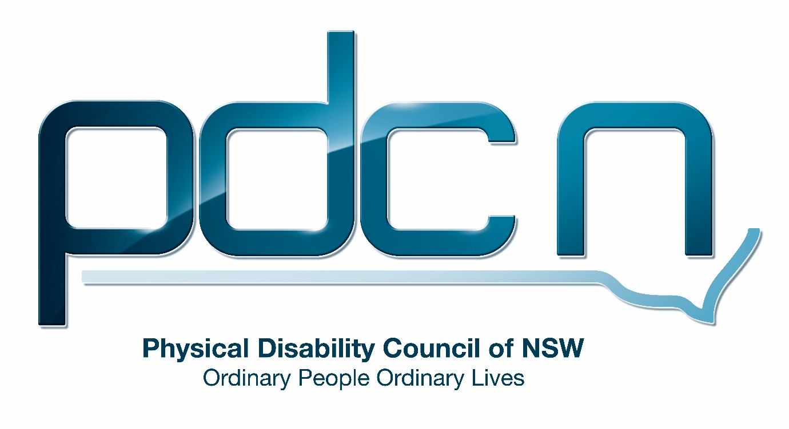

Submission to the UNSW Social Policy Research Centre

National Disability Strategy Review

19th July 2018

Ellen Small

Physical Disability Council of NSW
3/184 Glebe Point Road, Glebe NSW 2037

02 9552 1606
www.pdcnsw.org.au
ellen.small@pdcnsw.org.au

Who is the Physical Disability Council of NSW?
The Physical Disability Council of NSW (PDCN) is the peak body representing people with physical disabilities across New South Wales. This includes people with a range of physical disability issues, from young children and their representatives to aged people, who are from a wide range of socio-economic circumstances and live in metropolitan, rural and regional areas of NSW.

Our core function to is influence and advocate for the achievement of systemic change to ensure the rights of all people with a physical disability are improved and upheld.

The objectives of PDCN are:
- To educate, inform and assist people with physical disabilities in NSW about the range of services, structure and programs available that enable their full participation, equality of opportunity and equality of citizenship.
- To develop the capacity of people with physical disability in NSW to identify their own goals, and the confidence to develop a pathway to achieving their goals (i.e: self-advocate).
- To educate and inform stakeholders (i.e: about the needs of people with a physical disability) so they are able to achieve and maintain full participation, equality of opportunity and equality of citizenship.

Introduction:
The Physical Disability Council of NSW (PDCN) appreciates the opportunity to provide feedback to this review on the implementation of the National Disability Strategy.

PDCN believes the National Disability strategy (NDS), despite being essential for all Australians with disability has been sidelined by the roll out of the National Disability Insurance Scheme (NDIS). The NDS with its focus on inclusion and improving the lives of people with disability, their families and carers must be prioritised as it extends beyond the provision of disability support services and seeks to ensure people with disability have access to mainstream services and opportunities on an equal basis to other members of the community.

PDCN is concerned about the current confusion between federal and state governments regarding roles and responsibilities for implementing the strategy following the roll out of the NDIS and the transfer of funding for disability to the NDIA as per the bilateral agreement. In NSW this has presented many issues where the state government has not met their responsibilities to people with disability, particularly in terms of access to health and education.

The Strategy’s vision is for ‘an inclusive Australian society that enables people to fulfil their potential as equal citizens’. What are examples of how the Strategy has achieved this vision in one or more of its six policy areas?

PDCN has observed that one of the strategy’s most successful areas to date has been inclusive and accessible communities. The creation of disability inclusion action plans (DIAPS) by all government departments and local government has fostered achievements under the strategy. Many local councils have been very proactive in creating accessible facilities within their communities for example Northern Beaches council has two inclusive playgrounds and Bankstown Council alongside building an inclusive playground at Bankstown City Gardens has also built an accessible changing place. The changing place comprises of a large accessible bathroom that features a toilet with grab rails, adult size change table, a hoist and a shower facility.

In addition, Transport for NSW has made important inroads in creating a more inclusive community with significant improvements in transport infrastructure including train stations, ferry wharfs, and the allocation of more accessible bus services. These improvements have been predominantly in the metropolitan transport system and insufficient accessible public transport in rural and regional NSW remains a barrier to inclusion for people with disabilities living outside of Sydney. Whilst Transport for NSW have been proactive in executing the Transport Access Program further capital investment is still required to ensure NSW’s public transport system is fully accessible.

3. What policy areas do you think should be more of a priority in the strategy?
What are the key gaps in implementation of the strategy?
What would you like to see done to most effectively achieve an inclusive society for people with disability in these areas.

PDCN believes one the key gaps in the implementation of the NDS is a lack of enforceable requirements for federal, state and local governments to reach set targets and outcomes for the greater inclusion of people with disabilities. PDCN believes there has not been notable improvement in all six policy areas of the NDS 2010-2020 despite only two years remaining in the current strategy.

Although the policy area of economic security with its emphasis on access to employment opportunities for people with disabilities is already a priority, as outlined in the second implementation plan of the NDS, PDCN believes this must continue as a priority with employment figures for people with disability remaining low in comparison to the general population.

Currently the labour force participation rates of people with disabilities are significantly lower than the general population; 53.4% of the 2.1 million Australians with disability of working age were in the workplace or actively seeking work, compared to 83.2% for people with no disability. In addition, people with disabilities, including those participating in the workforce, experience higher levels of economic disadvantage and are frequently employed in precarious or casual employment.

PDCN has observed that there is still significant discrimination and prejudice against people with disability seeking employment. PDCN recommends disability awareness training and education initiatives to increase opportunities for people with disability in open employment. PDCN also recommends the NSW state government set mandates for increasing the percentage of people with disabilities employed by government agencies.

Another policy area PDCN believes should be a priority is Learning and Skills specifically, ensuring people with disability achieve levels of educational attainment akin to their peers. PDCN feels it is essential people with disabilities receive support to be fully included in the mainstream education system and have the support required to proceed to tertiary or further education if desired. PDCN would like to highlight that inclusive education has better outcomes for people with disabilities, assisting individuals to secure employment and greater financial security. Supporting the development of a more inclusive culture in our education system also has a positive impact on all students and helps to reduce stigma and discrimination experienced by people with disabilities.

In addition, PDCN would like to emphasise that continued improvement around Inclusive and Accessible Communities should be prioritised, as the physical accessibility of the built environment and an accessible transport system are essential to support free movement of people with disability in the community. The strategy speaks to the importance of whole of journey accessibility to guarantee people with disability can access employment, education and leisure opportunities.

As stated in the NDS, policy direction 4 without access to transport true inclusion in the community cannot be achieved. Policy direction four states ‘a public, private and community transport system that is accessible for the whole community’ is vital for people with disabilities to have mobility in the community and ‘underpins all aspects of life for people with a disability.
As stated earlier, PDCN recommends government increase investment in transport infrastructure to achieve earlier compliance with the Disability Standards for Accessible Public Transport and guarantee whole of journey accessibility across the transport network.

In this policy area PDCN has observed that an inadequate supply of accessible and affordable housing in well serviced locations is a continual issue for people with disabilities. In addition, the Australian housing market is characterised by an absence of long term rental stability creating difficulties for individuals whom require significant and expensive housing modifications to make their living situation accessible.

4. How has the NDIS affected the implementation of other areas of the strategy?
How has the NDIS affected other disability policy, given the changing role of state and territory governments?
How has the strategy brought about improvements for all people with disability, including those who are not NDIS participants?

The scale of the NDIS makes it the most significant action undertaken in the NDS. The transformation of the disability sector and changes in the structure of services and supports under the NDIS has impacted on the implementation of other action areas covered by the strategy. As many individuals with disability in NSW will not be eligible for individualised funding through the NDIS the strategy is essential to improve access to mainstream support services for all people with disability and ensure that barriers to education, employment and participation in the community are addressed and removed.

The National Disability Insurance Scheme has encountered many issues in its implementation and the removal of state-based disability services has left significant gaps in supports for people with disabilities.

In the case of transport, the transition to individualised funding within NDIS plans and the removal of subsidisations for community transport, previously through Government funded programs (such as the Community Transport Program and Community Care Support Program through Transport for NSW) has increased Community transport organisation trip prices considerably (to market price).

In conjunction with the introduction of new forms of transport charged at market rates, PDCN is concerned that funding for transport in NDIS plans at the current set levels will be insufficient to cover these increases and this will severely limit the ability of NDIS to participate in the community and access essential services. In addition, individuals with disability who are not eligible for the NDIS but have previously utilised community transport will find price increases may make this service unaffordable.

PDCN believes service gaps created by the removal of state funded disability services are also evident in the health sector where there is considerable disagreement and inconsistency between NSW Ministry of Health and the National Disability Insurance Agency (NDIA) around who is responsible for funding specific services for individuals with disability. For example, a PDCN member was receiving community nursing services for wound management and upon moving onto this NDIS was told this would no longer be provided by NSW Health. However, this was deemed a health issue by the NDIA and was not funded in her individual plan.

In addition, individuals previously receiving low level disability supports in the community funded through the Department of Ageing Disability and Home Care (ADHC) under the Community Care and Support Program (CCSP) are likely to be ineligible for the NDIS and will lose their current services. Rather than encouraging greater inclusion, policy decisions such as these will see individuals face challenges in daily living and may lead to increased hospitalisations and increased social isolation.

Furthermore, PDCN is concerned about a loss of state funding for independent advocacy organisations. Systemic advocacy is not funded under the NDIS and is vital to ensure the NDS policy framework is implemented and concrete changes are made in each action area to improve the lives of people with disability. PDCN recommends the state government guarantee funding for advocacy organisations beyond the transition period to the NDIS. Systemic advocacy undertaken by peak bodies such as PDCN, ensures the inclusion and full participation of people with disabilities in society by identifying and addressing issues on a larger scale than is possible with individual advocacy, or at times by an individual alone. Additionally, substantial expertise, community knowledge and collaborative relationships will be lost should these organisations no longer be funded.

5. What resources - such as funding, people, organisations- would help the strategy achieve its goals, and how would they help?

PDCN believes continued funding for advocacy organisations will play a key role in ensuring the strategy achieves its objectives. The non-profit sector, including both independent individual and systemic advocacy organisations should play an important role in providing advice and direct feedback from people with disabilities on where systemic changes should be made and the impact policies under the strategy have on the lives of people with disabilities. In addition, as stated in the NDS second implementation plan, advocacy organisations are well placed to contribute to the ongoing monitoring and evaluation of the strategy.

6. What are examples of how the strategy has helped governments work together to improve the lives of people with disability? How can cooperation between levels of government and across the disability sector be encouraged in the future?

PDCN is not positioned to comment broadly on the collaboration taking place between government agencies. However, in our role as a member of the NSW Electoral Commission’s Equal Access to Democracy Disability reference group PDCN has witnessed cooperation between levels of government to ensure more efficient consultation processes with disability representative organisations. From PDCN’s perspective the NSWEC and Australian Electoral Commission (AEC) have taken steps to ensure engagement with Disability representative organisations (such as PDCN, PWD and Vision Australia) is a collaborative approach through the AEC’s presence at the NSWEC reference group meetings. Many organisations have limited resources and ability to engage with government agencies and their commitment to ensure this process is simple and avoids duplication as much as possible is commendable.

8. How do you think the public sees the strategy?

PDCN has observed that public knowledge of the strategy is non-existent, with a significant lack of awareness of the strategy amongst our members and the broader community. There is also a lack of awareness within government agencies and this is consistently demonstrated in government policies that do not align with the objectives of the strategy policy areas and actions steps outlined in the NDS.

PDCN recommends greater publicity for the strategy including engagement with disability representative organisations to help promote the strategy within the disability community. Furthermore, as part of the second implementation plan for the strategy useful training resources to support individuals, organisations and communities to support the aims of the strategy were to be made available on the strategy’s website. PDCN would like to comment that we have found the available resources to be inadequate, and not to the level described in the implementation plan.

ABS, Survey of Disability, Ageing and Carers, 2015
Commonwealth of Australia, National Disability Strategy (NDS) 2010- 2020, page 32
Commonwealth of Australia, National Disability Strategy 2010- 2020 Second Implementation Plan, Driving Action 2015-1018, p17

