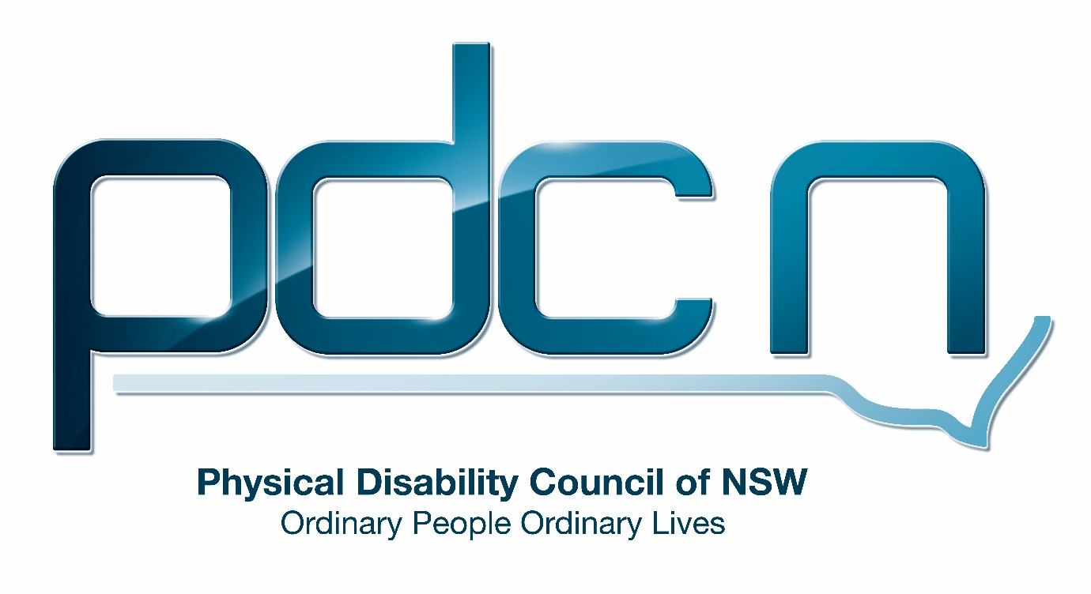

Submission regarding application for an exemption under the Disability Discrimination Act 1992 (Cth): Birchgrove Ferry

Australian Human Rights Commission

5th February 2017

Ellen Small

Physical Disability Council of NSW
3/184 Glebe Point Road, Glebe NSW 2037

02 9552 1606
www.pdcnsw.org.au
ellen.small@pdcnsw.org.au

Who is the Physical Disability Council of NSW?
The Physical Disability Council of NSW (PDCN) is the peak body representing people with physical disabilities across New South Wales. This includes people with a range of physical disability issues, from young children and their representatives to aged people, who are from a wide range of socio-economic circumstances and live in metropolitan, rural and regional areas of NSW.

Our core function to is influence and advocate for the achievement of systemic change to ensure the rights of all people with a physical disability are improved and upheld.

The objectives of PDCN are:
- To educate, inform and assist people with physical disabilities in NSW about the range of services, structure and programs available that enable their full participation, equality of opportunity and equality of citizenship.
- To develop the capacity of people with physical disability in NSW to identify their own goals, and the confidence to develop a pathway to achieving their goals (i.e: self-advocate).
- To educate and inform stakeholders (ie: about the needs of people with a physical disability) so they are able to achieve and maintain full participation, equality of opportunity and equality of citizenship.

Introduction:
The Physical Disability Council of NSW (PDCN) appreciates the opportunity to provide feedback to the Australian Human Rights Commission regarding Transport for NSW’s application for temporary exemption to the Disability Standards for Accessible Public Transport 2002 (DSAPT) in relation to the Birchgrove ferry wharf in Sydney.

PDCN is happy to support the application made by Transport for NSW concerning the temporary exemption sought for compliance of section 2.1 and 2.2 of the DSAPT for the access path connecting Louisa Rd to the Birchgrove wharf shelter. PDCN believes that Transport for NSW have taken significant steps to engage with Inner West Council (IWC) to resolve the accessibility issues and meet their compliance obligations under the DSAPT. In addition, Transport for NSW will proceed with the accessibility upgrade of the wharf and gangway components to ensure the assets under its ownership are compliant.

PDCN believes IWC should honour their commitment to providing an accessible and inclusive community, as outlined in their Inclusive Action Plan (for people with a disability) 2017-2021 (IAP) and should comply with the access requirements in the DSAPT by ensuring that there is access from Louisa Rd to the Birchgrove ferry wharf.

Furthermore, PDCN believes that a lift or compliant accessible ramp are the only appropriate options for providing equitable access for people with disabilities. PDCN supports Transport for NSW’s rejection of a suggestion by IWC that an inclinator or chair lift be considered for the site. These options would not allow for fully independent access by people with disabilities and would be entirely unsuitable. We also feel an inclinator or chair lift would not be appropriate in this location due to the risk of vandalism of these devices and the likely continual maintenance that would be required.

PDCN would like to see IWC endeavour to work with Transport for NSW to provide equitable access as soon as possible to ensure all members of the community can utilise the Birchgrove ferry wharf.

