date

Name Surname
Address
Suburb NSW postcode

Dear (insert name)

Re: PDCN Membership Application

Thank you for your interest in becoming a member of the Physical Disability Council of NSW.

Please find enclosed our membership application form for you to complete and return in the reply paid envelope provided.

This will then go to the PDCN board at their next board meeting (insert date) for ratification, and we will send you confirmation once your membership has been approved.

Kind Regards

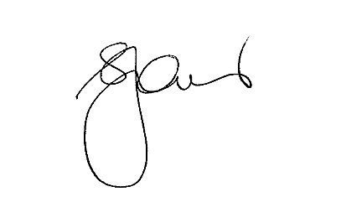

Serena Ovens
Executive Officer

