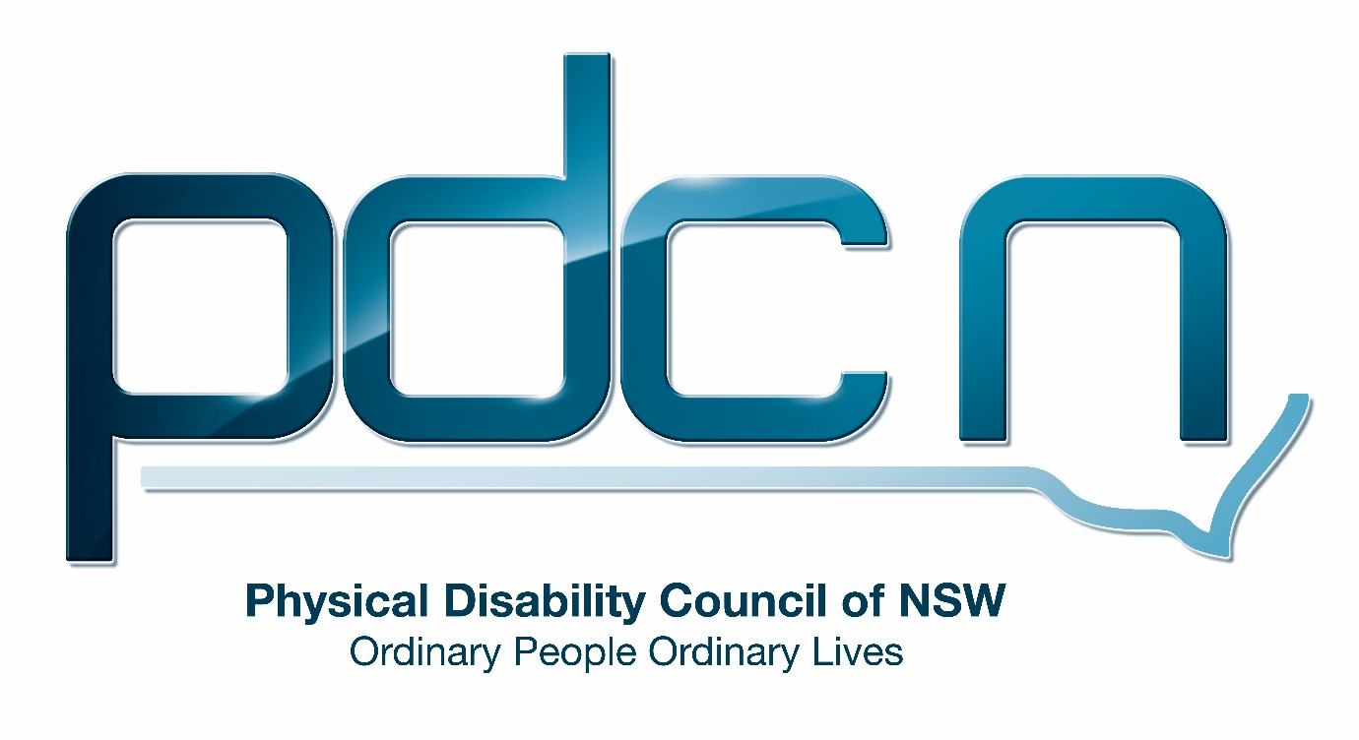

Submission for the NSW Law Reform Commission

Review of the Guardianship Act 1987; Draft proposals

Ellen Small

Physical Disability Council of NSW
3/184 Glebe Point Road, Glebe NSW 2037

02 9552 1606
www.pdcnsw.org.au
ellen.small@pdcnsw.org.au

Who is the Physical Disability Council of NSW?
The Physical Disability Council of NSW (PDCN) is the peak body representing people with physical disabilities across New South Wales. This includes people with a range of physical disability issues, from young children and their representatives to aged people, who are from a wide range of socio-economic circumstances and live in metropolitan, rural and regional areas of NSW.
Our core function is to influence and advocate for the achievement of systemic change to ensure the rights of all people with a physical disability are improved and upheld.

The objectives of PDCN are:
• To educate, inform and assist people with physical disabilities in NSW about the range of services, structure and programs available that enable their full participation, equality of opportunity and equality of citizenship.
• To develop the capacity of people with physical disability in NSW to identify their own goals, and the confidence to develop a pathway to achieving their goals (i.e: self-advocate).
• To educate and inform stakeholders (i.e: about the needs of people with a physical disability) so they are able to achieve and maintain full participation, equality of opportunity and equality of citizenship.

Introduction:
The Physical Disability Council of NSW (PDCN) appreciates the opportunity to provide comment to the NSW Law Reform Commission on the review of the Guardianship act 1987, draft proposals. Having previously provided feedback in an individual submission and as part of the NSW Disability Network Forum, PDCN is pleased to see the recommendations provided have been considered in the development of these proposals. PDCN will provide feedback on the proposals most relevant to our scope of expertise, where we feel we can contribute to the conversation.

Discussion
PDCN supports the reforms to the Guardianship Act 1987, principally the shift to a supported decision-making model in place of the model of substitute decision making currently operating in NSW. The new act is pertinent given that it coincides with a period in which there is significant change in the disability sector. The rollout nationally of the National Disability Insurance scheme (NDIS) has provided people with disabilities further opportunities to increase the decision-making capacity in their lives.
In addition, PDCN fully supports the incorporation of ideas that will ensure the act reflects the United Nations Convention of the Rights of People with Disabilities (UNCRPD) and promotes an empowered view of people with disability. PDCN enthusiastically supports the changes will make the law more reflective of an individual’s will and preference, instead of merely considering their views. This is essential to ensure the rights of people with disabilities in decision making in all aspects of their lives.

1. A new framework
1.8 Statutory Objects
PDCN commends the commitment in the proposals to placing a greater emphasis on the rights of people in need of decision making assistance and on highlighting the importance of recognising the UNCRPD. The proposals are in line with contemporary disability rights principles and PDCN is supportive of the act’s commitment to promoting personal and social wellbeing and providing safeguards in relation to the activities governed by the Act.
1.9 General principles
(e) They have the right to make decisions that affect their lives (including decisions involving risk) to the full extent of their ability to do so and to be assisted in making those decisions if they want or require assistance
(k) Their existing informal supportive relationships should be recognised.
PDCN supports these additions within the general principles section as we deem it essential that a person’s right to support when making decisions is explicitly stated in the guardianship act.
1.11 Determining a person’s will and preferences
(b) If these cannot be determined, to be guided by the person’s likely will and preferences. These may be determined by the person’s previously expressed will and preferences, and by consulting people who have a genuine and ongoing relationship with the person and who may be or have been aware of the person’s will and preferences.
PDCN suggests the proposals strongly guarantee that the supporter or enduring representative should have minimal conflict of interest, as this is likely to impair their ability to act on the represented persons will and preferences. Furthermore, elected representatives or supporters will require specific skills and experience when providing support to a person with a decision-making impairment, ensuring the person is supported rather than directed.
In addition, PDCN suggests, where possible, the enduring representative or supporter should have an ongoing relationship with the individual being represented, fostering an environment where the enduring representative or supporter is able to make a conscious commitment to set aside their own judgements to make support decisions based on the individual’s will and preferences.
1.13 Presumption of decision- making ability
PDCN is supportive of the inclusion in the proposal that the new act should provide for a rebuttable presumption that a person has decision- making ability. This is in line with disability rights principles and we believe is significant as it prevents any link being drawn between disability and presumption of capacity.

2. Personal Support agreement
2.3 Eligibility for appointment as a supporter
PDCN suggests stating within the act recommendations of types of persons who would be suitable appointments as supporters, such as employees of community advocacy organisations. We are concerned about conflict of interest and inadequate training of supporters and feel this would have an impact on the quality of support provided, as raised earlier in this submission regarding proposal 1.11.
Individual disability advocates would be well placed to provide assistance and would require less training and supervision due to their existing skills and experience working with people with disabilities.
The new Act should provide that a person is not eligible to be appointed as a supporter if: (b) they are to assist with financial decision making and they have been bankrupt or been found guilty of an offence involving dishonesty, unless they have recorded this in the support agreement
PDCN believes this safeguard is an important addition given that the proposals do not include limitations on supports and the appointment of paid care workers, volunteers and others involved in providing medical, accommodation or other daily services is permitted. PDCN is pleased to see the safeguards included in the proposals for support agreements are also present for tribunal support orders and enduring representation agreements, proposals 3.5 and 4.3 respectively.
PDCN is supportive of the proposals not limiting the supported persons autonomy to select and appoint a supporter who will assist in their decision making, however we have concerns about this proposal allowing for individuals who have been bankrupt or found guilty of an offence involving dishonesty, still being able to perform this role if it is recorded in the support agreement. We believe this creates an unacceptable risk that outweighs the benefits of freedom of choice for the supported person.
PDCN supports other safeguards that appear within the proposals, including simplification of the procedure for a supported person to revoke a support agreement and providing the supported person with greater discretion and autonomy in specifying the limitations of any support agreement which they enter.
PDCN appreciate the changes, ensuring supporters do not have an enduring right to make long term decisions for an individual in need of decision making support. Alongside the introduction of reviews of financial management orders, we feel these additions will limit abuses of power.

4. Enduring representation agreements
4.5 When an enduring representation agreement has effect
PDCN supports the adoption of this proposal as it reflects the principle that decision-making ability is specific to the decision being made, and only when the represented person does not have decision making ability for that decision at that time. PDCN feels acknowledgement in the proposals that decision making ability is not stagnant and will change over time is a necessary addition.

8. Restrictive practices
PDCN believes it is essential that restrictive practices are only used as an option of last resort and should be entirely phased out as soon as possible. PDCN believes that in circumstances where they are used it is essential that there are strict guidelines on their regulation and use. Consequently, we support the proposal that the NSW government should closely monitor the NDIS restrictive practices regulatory scheme as it will employ a stringent registration process linked to assessment processes, monitoring, practice standards and a code of conduct.

9. Advocacy and Investigative functions
Proposal 9.1: New Advocacy and Investigative Functions
PDCN is supportive of the establishment of a public authority that will undertake the advocacy and investigative functions proposed in 9, only if this authority’s implementation is in addition to the continued funding and support of the current NSW disability advocacy sector (at the community level.) It is also essential that this body is completely independent with set roles outlined within the act. Additionally, this statutory and administrative independence should include security of tenure, annual reporting to parliament and employment of their own staff. PDCN feels it would be extremely inappropriate for a newly established body to be administratively attached to the NSW Trustee.
PDCN would like to emphasise that the establishment of a public advocate will not negate the vital role performed by community advocacy organisations and it is essential that any advocacy functions be in addition to and complementary to those of community-based advocacy.
(3)(c)(i) seeking help for people who need decision - making assistance from government agencies (including the NDIS), institutions, welfare organisations and service providers, and negotiating on their behalf to resolve issues.
PDCN believes funding community-based advocacy should be a higher priority than empowering the public guardian or public advocate to perform advocacy functions. PDCN sees great benefit in having individual and systemic advocacy stay independent of government, including reducing the potential conflict of interest for advocates who may be challenging services or decisions made by government agencies. In the situation of individual advocacy, individuals may also feel more comfortable being supported by an independent advocate if they have had a previous poor experience with a government agency.
PDCN proposes that community advocacy organisations are better able to perform this role than a public guardian or public advocate, having significant experience negotiating on behalf of people who need assistance from government agencies. Addressing issues in the local domain would also have the effect of reducing the number of individual situations that may need to be elevated to the Public Advocate.
Furthermore, PDCN believes the guardianship act should recognise the important role external advocacy organisations will play in advancing community education about supported decision making for people with disabilities. Community education will be essential to ensure that individuals are able to utilise the opportunities the new guardianship act will provide to enhance their skills and experience making decisions.

